Week Commencing 22/2/21
Hello,
Welcome back. I hope you all had a relaxing half term with your families. This term our Learning Challenge is an exciting one: ‘Where will my golden ticket take me?’ During this Learning Challenge we will explore different countries including where we live. We will explore the different foods, language, stories, clothing, culture and history.
In Maths we are going to be doing lots of fun with shape… Miss Hollings was super impressed with all of your number work so she cannot wait to see how fabulous you are with 2D shapes this week ∆󠄀◊□󠄀󠄀o
As you will be aware in Nursery we aim to support and develop children’s play and learning. We allow the children to develop with their own initiative and learn at their own pace. We do this through stimulating and fun activities, which promote all areas of a child’s development.
In this pack you will find ideas, activities and resources that will help you to support and continue educating your children at home.
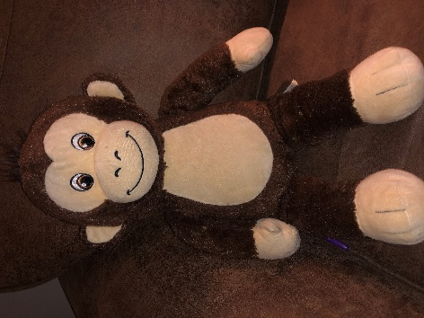
This week in our learning challenge we will be focusing on where we live, in England but first I would like you to meet someone. Meet Lucky. Lucky is Oscar’s teddy bear and he is going to explore the world with you. Over the holiday’s he received a special ticket… a GOLDEN TICKET!! Check out this week’s activities to see where Lucky is going to go. He is super excited to explore all the different countries with you.
I have split all the exciting activities up into days and done a timetable for you to follow .
If you need any help or advice please contact me via the class dojo. I am more than happy to help.
Useful websites:
Twinkl https://www.twinkl.co.uk/
Phonics play: https://www.phonicsplay.co.uk/

CBeebies: https://www.bbc.co.uk/cbeebies

BBC Iplayer: https://www.bbc.co.uk/iplayer

Youtube
Topmarks: https://www.topmarks.co.uk/
Crickweb: http://www.crickweb.co.uk/
Oxford Owl: https://www.oxfordowl.co.uk/for-home/
Letters and Sounds: http://www.letters-and-sounds.com/

Thank you
Miss Hollings

Timetable:
Elm Class
Thursday:
- Maths- Exploring and drawing shapes
- Phonics- Hoppy Poppy
- Literacy- Fact finding
- Learning Challenge- Underpants Flag
- Physical- Joe Wicks
Wednesday:
- Maths- Playdough and stick shapes
- Phonics- Pyjama Palaver
- Literacy- Postcard
- Learning Challenge- Making your own Afternoon tea
- Physical- Dance with shapes

Tuesday:
- Maths- Shape Monsters
- Phonics- Bubbles
- Literacy- Afternoon tea invitation
- Learning Challenge- Make a globe- Papier Mache
- Physical- Jack Hartman- Animal dance and freeze

Monday:
- Maths- Shape detectives
- Phonics- Let’s shake
- Literacy- Weekly news writing
- Learning Challenge- Make your own Golden Ticket
- Physical- Freeze Dance

Friday:
- Maths- Shape quiz- What am I?
- Phonics- Miss Hollings had a box, e,I,e,I,o
- Literacy- Your favourite place in the UK
- Learning Challenge- Junk modelling: Transport to get to the next country
- Physical- Cosmic Kids- up in the clouds

Monday Maths: Shape Detectives
I am a shape: https://www.bing.com/videos/search?q=i+am+a+shape+mister+maker&&view=detail&mid=67EFBFBA57FDFB2A679867EFBFBA57FDFB2A6798&&FORM=VRDGAR&ru=%2Fvideos%2Fsearch%3Fq%3Di%2Bam%2Ba%2Bshape%2Bmister%2Bmaker%26FORM%3DHDRSC4
Today we are going to be shape detectives. I would like you to go on a shape hunt around your house. I wonder what shapes you will find… can you name them?
(You can cut out the shape magnifying glass to help you spot all the different shapes. Don’t forget to send Miss Hollings a pictures of all the things you have found).

NUMBERBLOCKS!
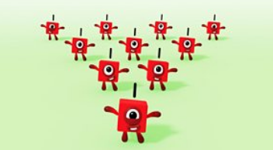

https://www.bbc.co.uk/iplayer/episode/b08q39b4/numberblocks-series-2-just-add-one
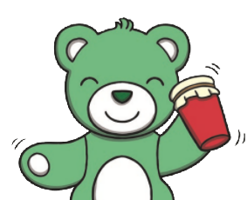
Monday Phonics: Let’s shake
Resources:
- Small containers e.g. empty bottles/containers
- Items to fill containers, e.g. dried pasta/peas/beans, leaves, stones, small sticks, material/ paper scraps
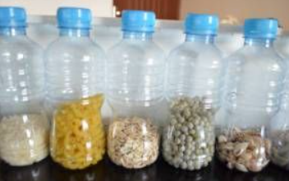
Today, I would like you to make shakers to make sounds and describe them.’ Encourage your child to explore the different sounds that each container makes.
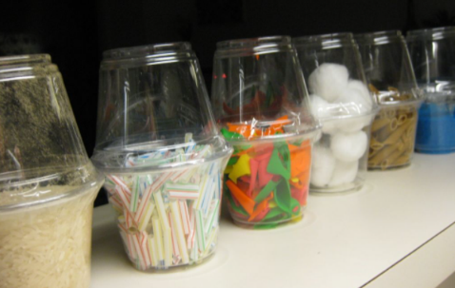
2. Model shaking each container. ‘What does your shaker sound like?’ Model using words to describe the sound, such as ‘loud’, ‘quiet’, ‘soft’, ‘hard’ or ‘noisy’.
3. Ensure your child has the opportunity to shake each container. Together discuss which sound each child likes or doesn’t like and why.

If your child wants to keep their shaker, maybe they could decorate it too
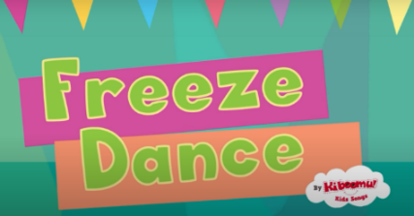
Monday Physical: Freeze Dance
https://youtu.be/2UcZWXvgMZE

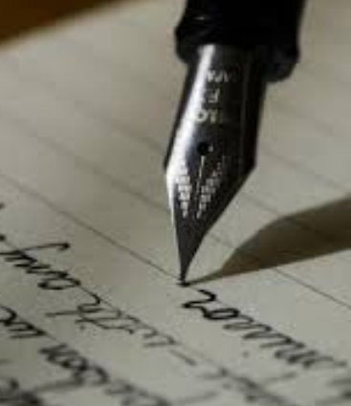
Monday Literacy: News writing
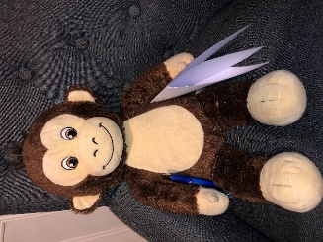
Today I would like you to write your news for Miss Hollings and Lucky to tell them all about what you have been up to during your week at home. They are very excited to hear about all your adventures.
Talk with your adult about what you did over the holiday. Allow your child to mark make and explain what they are writing along the way, you can then scribe for them. It is important they are given this freedom to express themselves, their ideas and thoughts through mark making. Really focus on pencil grip, holding it between your fingers (tri-pod grip rather than full fist grip).
Questioning throughout is key i.e. Where did we go/walk to? What was your favourite part of the holiday? How did it make you feel? What did we see along the way? Would you like to go again? And why?

Today I would also like you to listen to the story- A ticket around the world. https://www.youtube.com/watch?app=desktop&v=N6rD8UaVBic
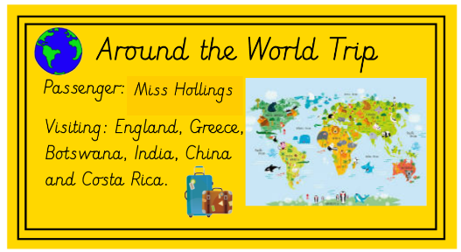
Monday Learning Challenge- Ticket around the world
Today Lucky has received his Golden Ticket. He is super excited to find out where he is going to go on his ‘Around the world trip’. Now you need your Golden Ticket too. I would like you to design your own ticket, so you can join Lucky on his adventures around the world.
You can make your ticket as wacky, as sparkly or as colourful as you would like!
Use the template below to make your own Golden Ticket. Lucky has put the different countries he would like to visit on his ticket. Maybe you could ask your adult to write one country that you would like to visit on your ticket!

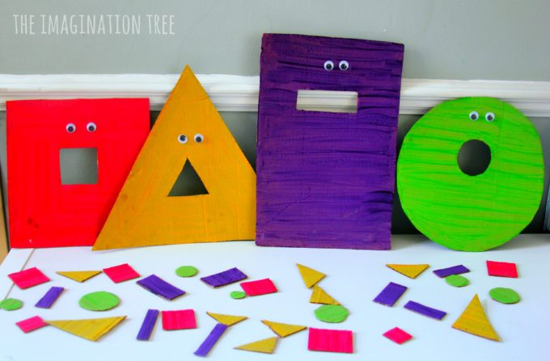
Tuesday Maths: Shape Monsters
Today I would like you to feed the hungry monsters.
To make this activity you will need:
- Pieces of cardboard
- Paints
- Googly eyes
- Glue
- scissors
Cut out your large shape first for the monster (make sure your monster has a mouth too, so it can eat the little monster shapes) next cut out the little shapes. Colour them/ paint them together with your child. Once they are dry… you can get sorting!! Remember to talk about the different properties of the shapes: name, number of sides and number of corners.
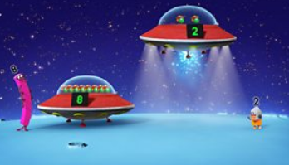
NUMBERBLOCKS:
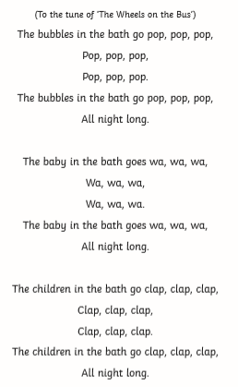
https://www.bbc.co.uk/iplayer/episode/b08q3zx7/numberblocks-series-2-blast-off

Tuesday Phonics: Bubbles
Resources:
Bubbles in the Bath Song Sheet
Water tray/ bowl with bubbles

1. ‘Today, we are going to pretend it is bath time.’
2. Using the water tray, model putting your hands in the water and splashing in the bubbles.
3. ‘We are going to sing a song. It might sound like one we know but it has different words.’
4. For each verse, can you make up different actions for the sounds- pop, clap, wa.
5. Sing Bubbles in the Bath Song, using the actions you have created. Create body and voice sounds for each verse.

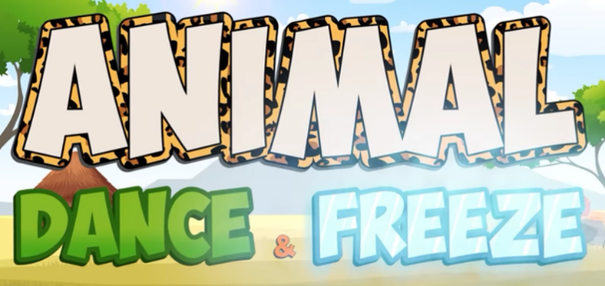
Tuesday: Physical: Jack Hartman- Animal dance and freeze.
https://youtu.be/HpOe8lngp_o

Tuesday Literacy: Invite for Afternoon Tea
Lucky’s favourite English meal is the good old Traditional Afternoon tea and today he is going for Afternoon Tea with the queen… yes the queen, can you believe it.
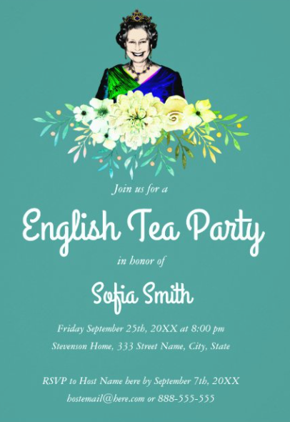
Your Learning challenge task tomorrow is to make your own Afternoon tea for you and your teddy bear (or your family). Today I would like you to write an invite, inviting them to afternoon tea. Use the template to make your invite. Discuss with your adult all the delicious English foods you are going have. Miss Hollings has done an invite to show you. You can use the template provided or you can make your own.

Join us for a
Afternoon Tea Party
With
Mr Lucky
Wednesday 24th February 2021
At 2pm
We will be serving:
Sausage Roll,
Cucumber Sandwiches
&
a Jam & Cream Scone
RSVP to Lucky

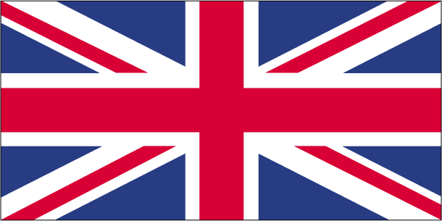
Afternoon Tea invitation template:

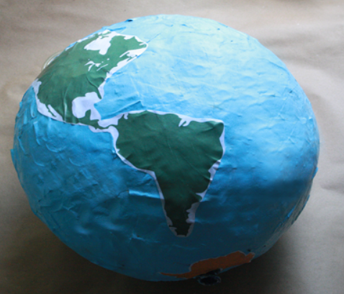
Tuesday- Learning Challenge: Papier Mache Globe.
Here is how to make it. You will need an adult to help you.
https://youtu.be/ZUuC6-8eMEY

What you will Need:
- Pot Medium-size container with airtight lid (to store the paste)
- Spoon or whisk
- Paintbrush
- 1 Round balloon (punch ball balloons work well)
- 1 Newspaper
- 4 cups Water
- 1 cup Flour
- 1/2 cup Resin glue powder/ PVA glue
- Acrylic paint

Instructions:

Prepare Your Work Area and Blow up the Balloon
Cover your work surface well, as paper mache can get pretty messy. It can be helpful to keep a bowl of water or a wet cloth nearby to clean your fingers.
Next, blow up and tie the balloon. Some people prefer to set the balloon on top of a bowl to use as a stand while working on forming the globe. If you want to do this, cover the bowl with plastic wrap, so the paper mache doesn't stick to it.

Tear Newspaper Strips
Tear your newspaper into strips that are about 1 inch wide and 4 to 6 inches long. You'll need a lot of newspaper strips for this project, so tear up several pages.
Start Your Paper Mache Paste
Now it's time to make the paper mache paste. Start by putting 3 cups of water in a pot and bringing it to a boil.

Mix the Flour and Resin Glue Powder
While waiting for the water to boil, combine 1 cup of flour and 1/2 cup of resin glue powder/ PVA in your medium-size container. Then, add 1 cup of warm water, briskly stirring to remove any lumps.

Add the Flour Mixture to the Boiling Water
Once the pot of water is boiling, stir in the flour mixture. Boil for two to three minutes or until it is clear and smooth. Then, remove the pot from the heat, and let it cool until it is safe to work with. Transfer the paste back to the medium-size container, in which you'll eventually store it.

Add Paste to a Newspaper Strip
Dip one newspaper strip into the paper mache paste until it's completely saturated. Hold the saturated strip over the paste container. Gently run it through your fingers to squeeze off any excess paste, being careful not to tear it.
Attach the Strip to the Balloon
Stick the newspaper strip on the balloon, and smooth it down with your fingers.

Continue Covering the Balloon
Carry on with this same process of adding paste to one strip at a time and sticking the strip to the balloon. Aim to adhere the strips so they're overlapping and running in different directions. Stop when the balloon is completely covered in one layer of newspaper strips.

Let the First Layer Dry
After one layer of newspaper strips is applied, let your paper mache globe dry completely. This can take up to 24 hours. Meanwhile, store your paper mache paste in its container with the airtight lid in the refrigerator.

Apply a Second Layer
Once the first layer is dry, apply a second layer of newspaper strips the same way you did the first layer. Then, let it dry completely. Once again, store the paste in the refrigerator.

Add a Third Layer
After the second layer has dried, repeat the paper mache process one more time for a third layer. Then, wait for it to dry completely. You no longer will need any leftover paper mache paste.

Decorate Your Globe
Once the paper mache is dry, use acrylic paint to decorate your globe. You can paint the continents and oceans in green and blue to look like an actual globe or go more abstract with the colours. Add as much detail as you'd like.

Wednesday Maths:
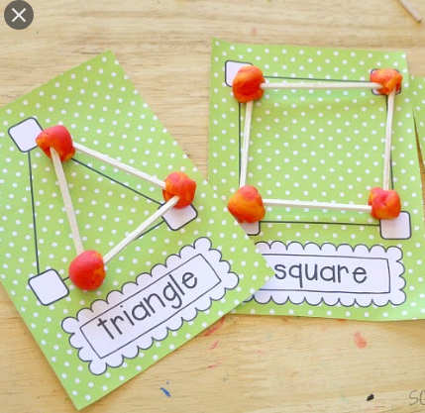
Today I would like you to make your own shapes using playdough and cocktail sticks/ cotton buds.
Use the templates to help if needed.
As you construct the shapes talk about the different characteristics of each shape, its sides, and corners etc.

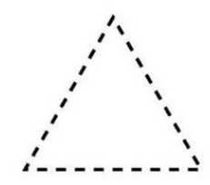

Challenge: What shapes can you find in the England Flag? Can you colour in the flag with the correct colours?
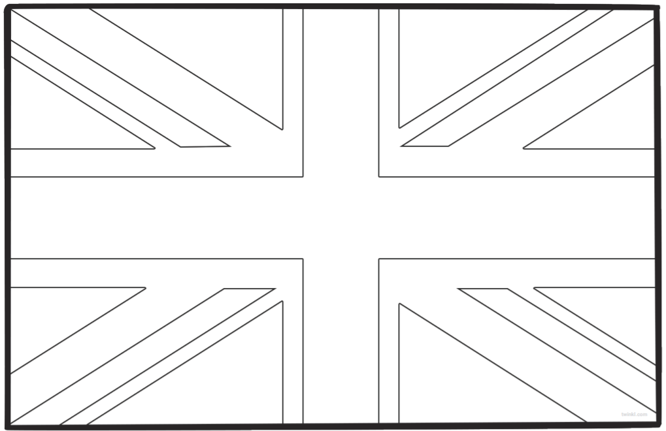
NUMBERBLOCKS
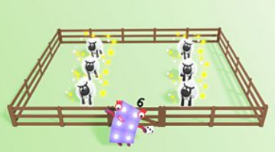

https://www.bbc.co.uk/iplayer/episode/b08q4g7y/numberblocks-series-2-counting-sheep

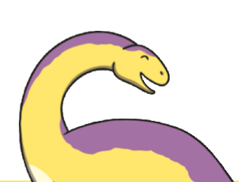
Wednesday Phonics: Pyjama Palaver
1. ‘Today, we are listening to the beginning sound in words with Dana Dinosaur.’ Practise spotting initial sounds, saying the children’s names and exaggerating their initial sounds, e.g. ‘S,S,S, Scarlett, L,L,L,L, Lucas.
2. ‘Shh! Dana says it’s time for bed. Time to pick out some pyjamas.’ Show the children the Pyjama Palaver Picture Cards. Before giving out the activity cards, go through each of the six sounds, naming the items on the pyjamas and modelling the initial sound, e.g. ‘a, a, a, apple’. Encourage your child to copy your sounds.
3. Give your child a card with pyjama bottoms on. Put the rest of the cards in the middle.
4. Ask your child to look at their own card and say the item on the pyjamas. Model and emphasise the initial sound, e.g. ‘m, m, m, monkey’.
5. ‘Now let’s find the rest of our pyjamas. Can you find your matching pyjamas in the middle?’ 6. Encourage your child to search for and collect a full set of cards.
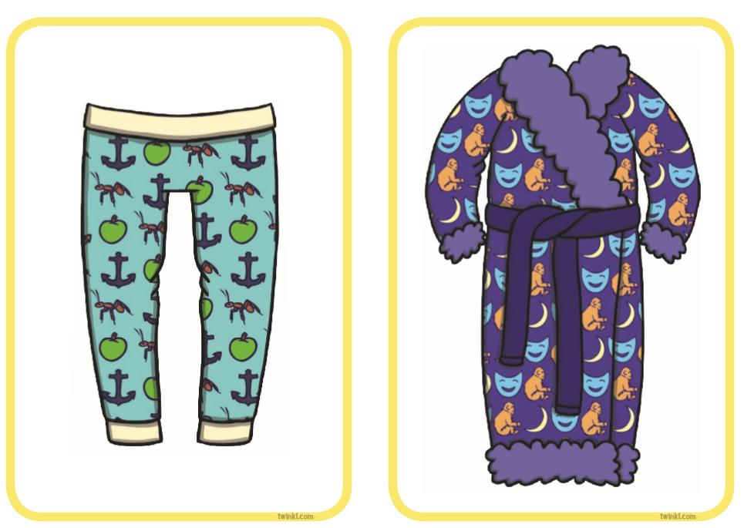
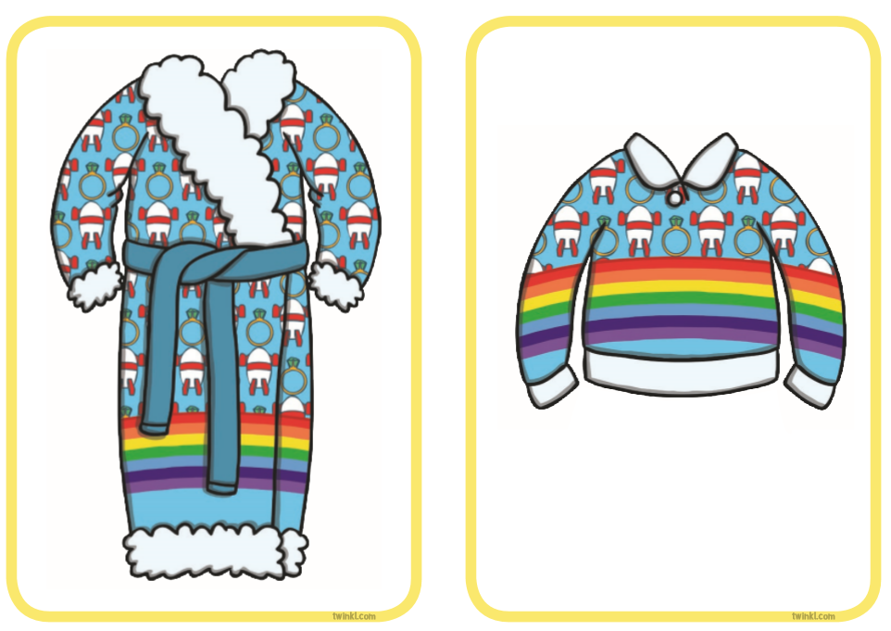

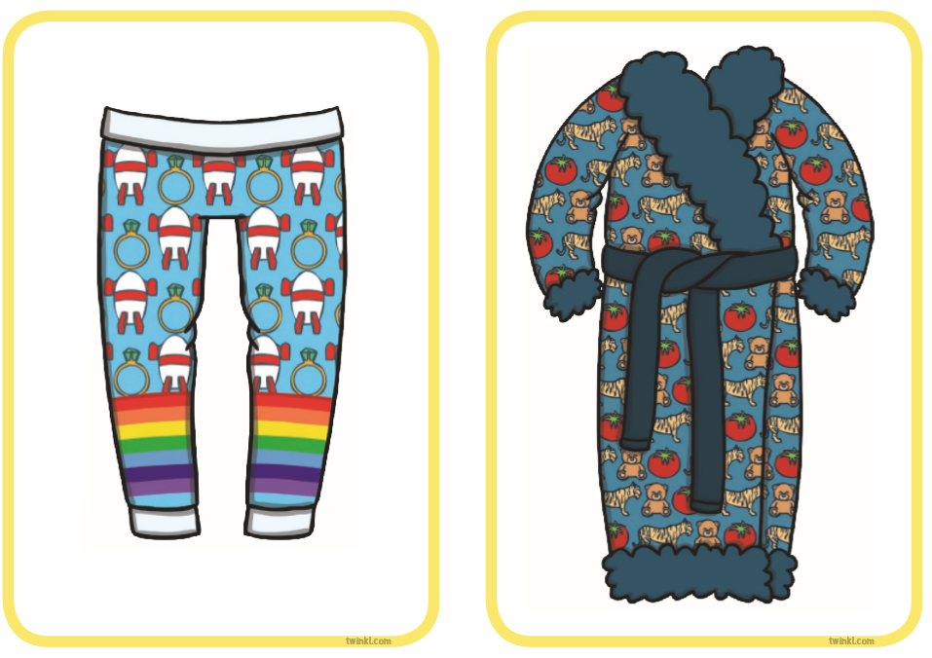
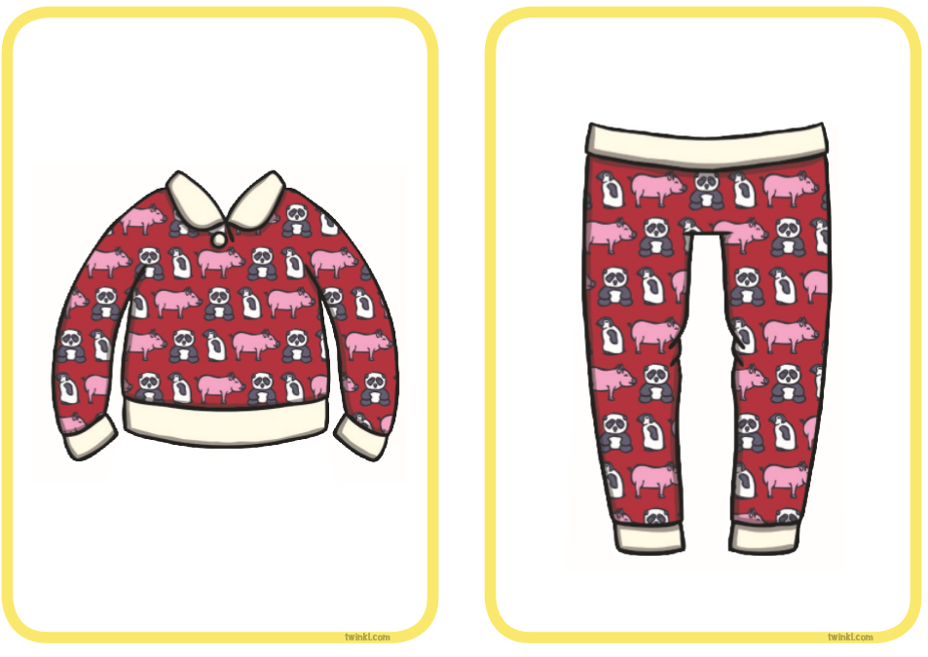

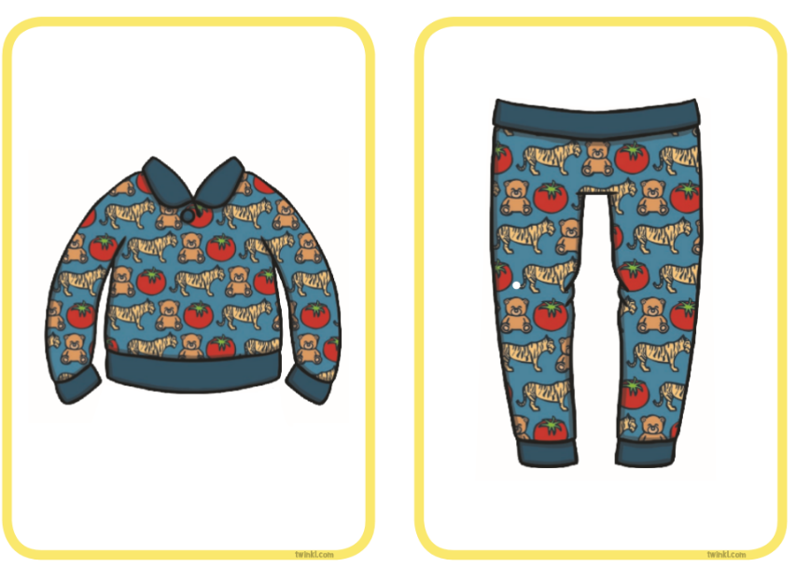
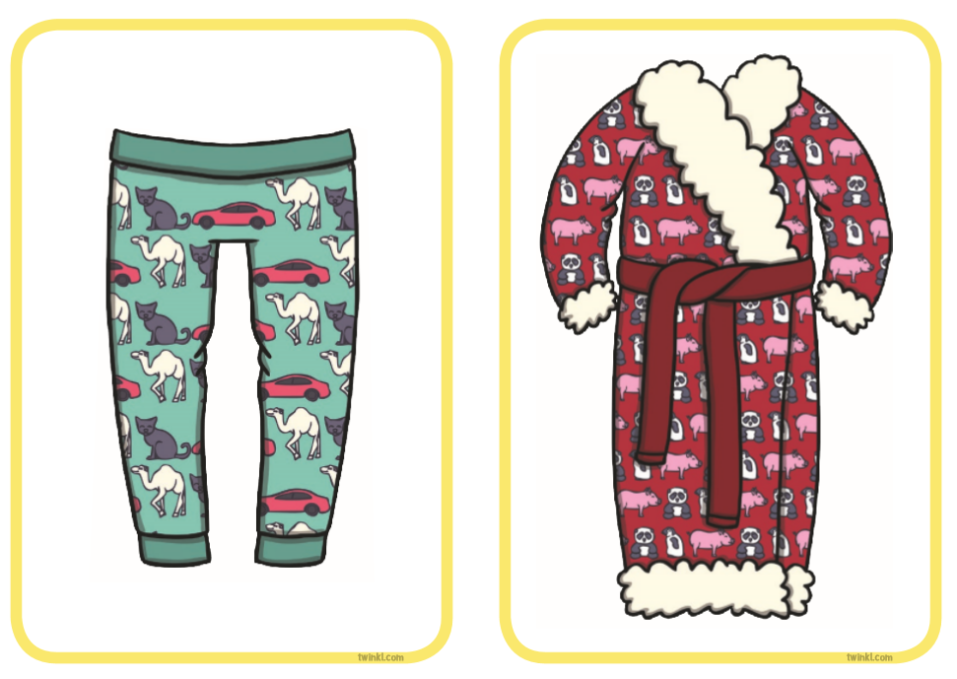

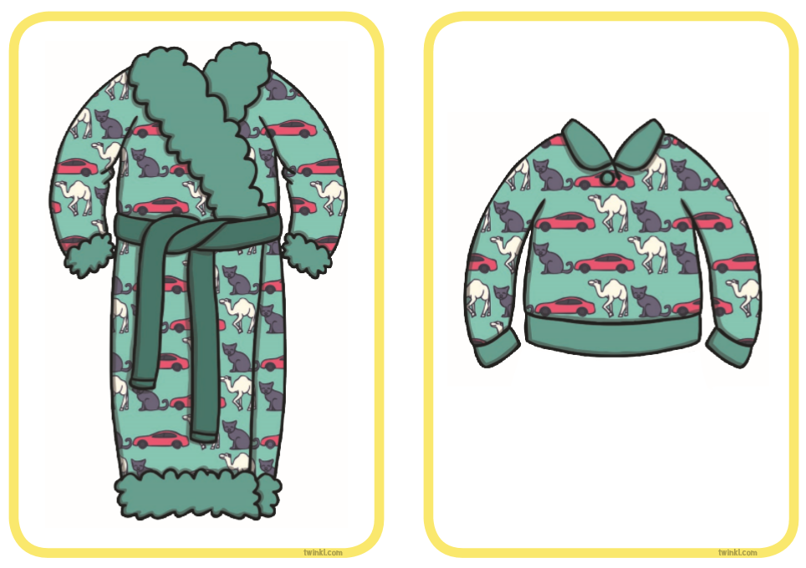
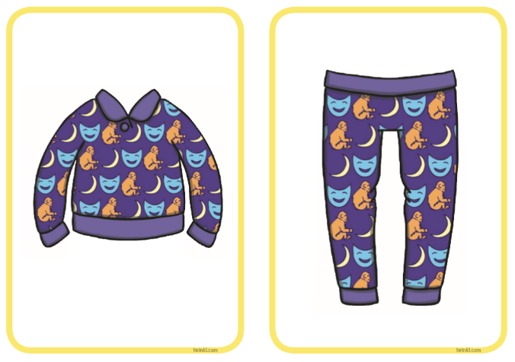

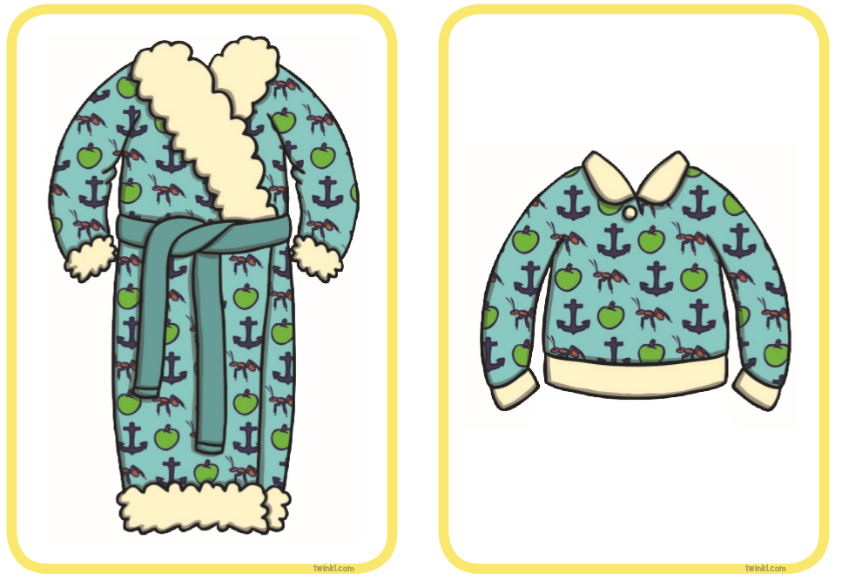

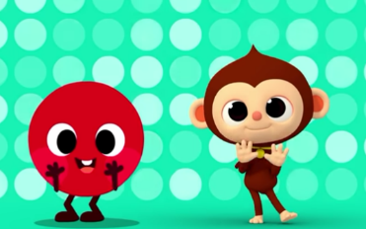
Wednesday Physical: Dance with shapes
https://youtu.be/G1GSI-2IoDg

Wednesday- Literacy: Postcard.
Lucky loves to send a postcard when he goes on his trips. Today after you have been on your walk, I would like you to write a postcard to a family member telling them all about your walk. Remember adults, lets your child mark make and you can scribe after. Discuss together who your postcard is for, what you are going to tell them, and then most importantly SIGN YOUR NAME at the bottom.
Don’t forget to turn your postcard around and draw a picture on the front. Maybe this could be what you saw on your walk

Wednesday- Learning Challenge- Making afternoon tea
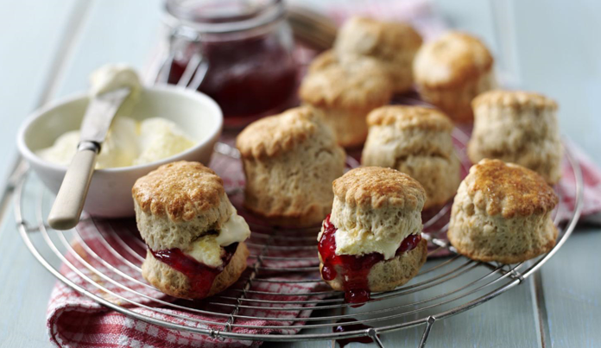

Ingredients
- 225g/8oz self raising flour
- pinch of salt
- 55g/2oz butter
- 25g/1oz caster sugar
- 150ml/5fl oz milk
- 1 free-range egg, beaten, to glaze (alternatively use a little milk)

Method
- Heat the oven to 220C/200C Fan/Gas 7 and lightly grease a baking tray.
- Mix together the flour and salt and rub in the butter. Stir in the sugar and then the milk to get a soft dough.
- Turn on to a floured work surface and knead very lightly. Pat out to a round 2cm/¾in thick. Use a 5cm/2in cutter to stamp out rounds and place on the baking tray. Lightly knead together the rest of the dough and stamp out more scones to use it all up.
- Brush the tops of the scones with the beaten egg. Bake for 12-15 minutes, or until well risen and golden-brown.
- Cool on a wire rack and serve with butter and good jam and maybe some clotted cream.

Thursday Maths: Exploring and drawing shapes.
Today I would like you to explore the different 2D shapes on the shape mat. Focus on the number of sides and corners. Also talk about how some are similar and some are different.
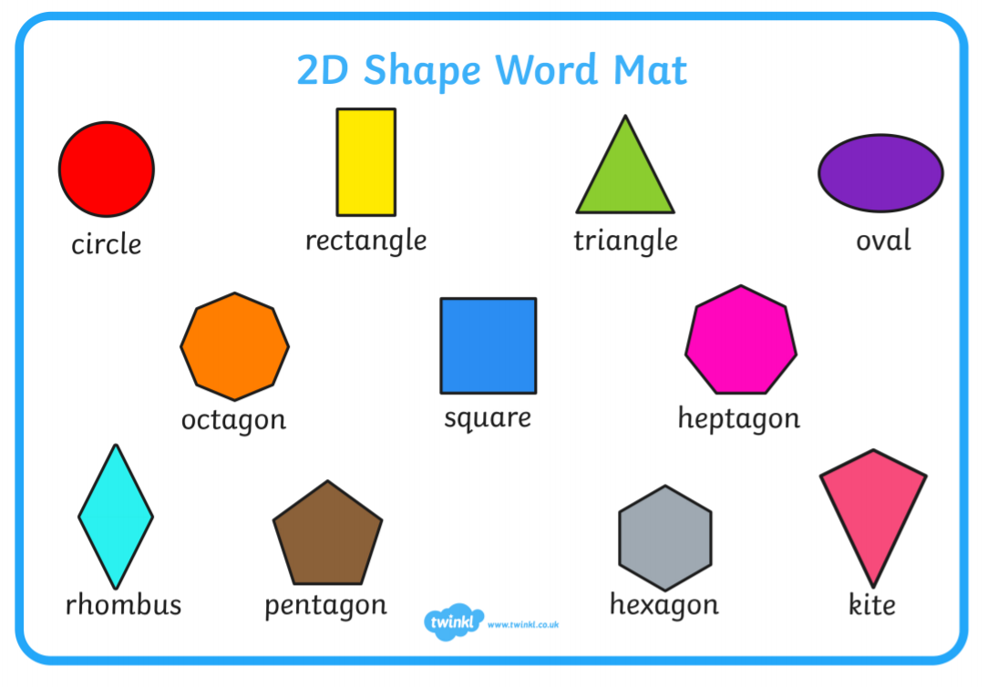

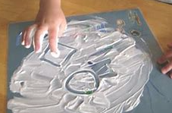
Once you have looked at all the different shapes, why not get a flat tray with a thin layer of shaving foam/ flour/ conditioner and let you child practice drawing the different shapes with their index finger. Whilst your child is drawing discuss the shapes- name of the shape, how do we know it is that shape… number of sides and corners etc.
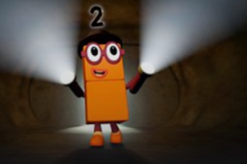

NUMBERBLOCKS:

https://www.bbc.co.uk/iplayer/episode/b08q4jkq/numberblocks-series-2-double-trouble
READ, READ, READ!!
Bedtime Story: Once tucked up in bed, read your teddy a bedtime story.
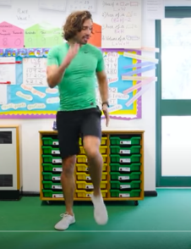
Thursday Physical: Joe Wicks
https://youtu.be/d3LPrhI0v-w

Thursday Literacy: Fact Finding
Lucky loves the Royal Family.
Today I would like you to do some research about the Royal Family. Can you find me 3 Facts about the Royal Family?
Next I would like you to design your own Royal Stamp (you can make this as crazy as you would like- colour, glitter, pom poms etc )

Thursday Phonics:
1. ‘Today, we are going to read a story about Hoppy Poppy.’ Read the Rabbit Rock and Roll Story.
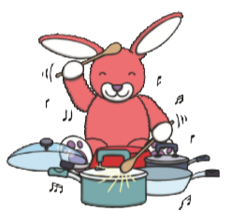
2. ‘Hoppy Poppy has found some things around her house. Can you find things around your house to make music with?
3. Take turns to bang on the items, listening to the sound each makes.
4. Ask your child to place their beaters on the floor. Demonstrate a simple rhythm while they listen.
5. Continue to tap on your instrument and ask, ‘Can you copy me with your drum?’
6. Repeat with different rhythms, encouraging you child to listen and copy. You may need to model and practise each rhythm a few times.
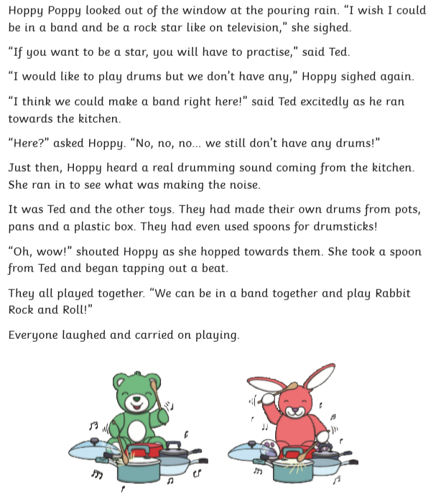

Thursday: Learning Challenge:
Watch the Queens underpants: https://www.youtube.com/watch?v=DlKtVg0GXAc
Lucky would like you to make a Flag for the Queen using pants/ knickers. You can use the template or if you really want to, you can use a pair of your own pants and decorate them. I can’t wait to see how wacky and wonderful your pants turn out!! Maybe you can find a stick on your walk to attach your flag too

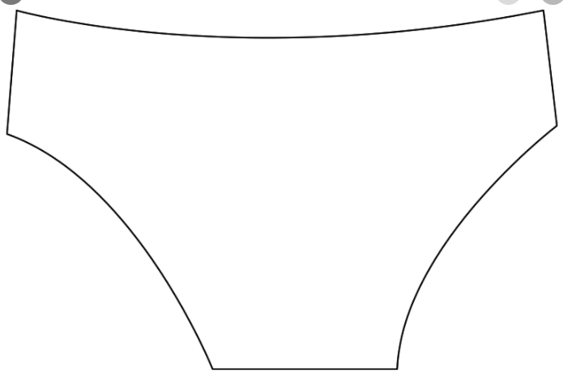

Friday Maths: Shape quiz
What am I?
Have a go at the quiz. Your adult will need to read out the clues.
Once you have guessed the right shape have a go at drawing it in the box provided. I wonder how many you can get right! Good Luck!
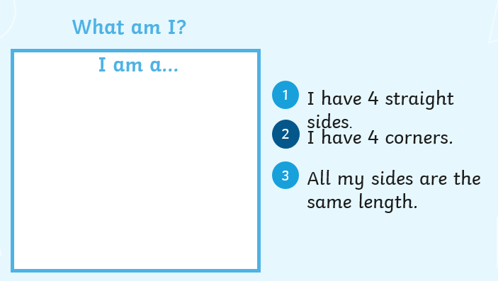

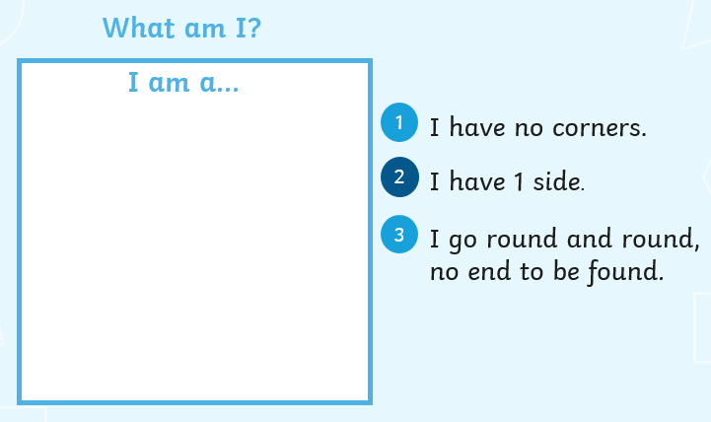

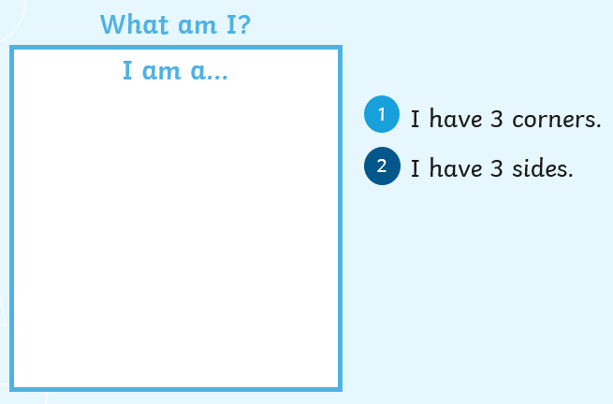

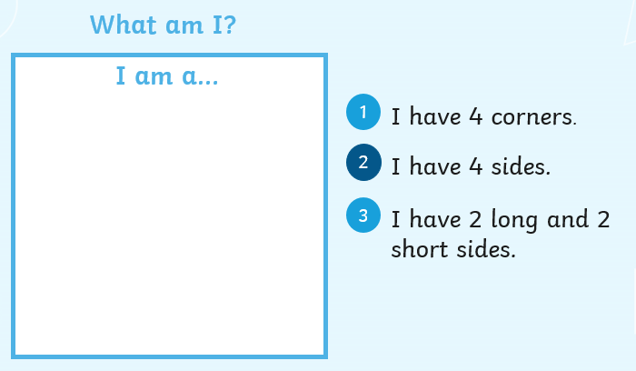

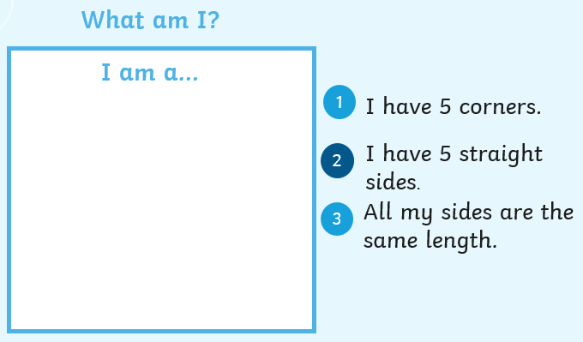

Challenge: Today on your daily walk, I want you to put on your ‘shape detective’ heads, take your magnifying glasses and see what shapes you can find in the outdoor area.
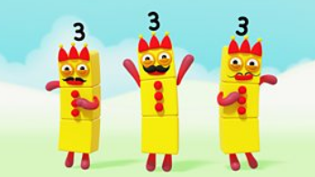
NUMBERBLOCKS

https://www.bbc.co.uk/iplayer/episode/b08q4mkf/numberblocks-series-2-the-three-threes
Friday- Physical- Cosmic Kids- Up in the clouds
https://youtu.be/4q252Wnp4oM

Friday Phonics:
For this activity you will need a box with lots of familiar items in.
Let you child pick an item out of the box and sing the song. Today I want you to turn this song into your own.
So… Oh ____________ had a box, e,I,e,I,o…
We sing this song in class to the tune of Old McDonald.

Oh Miss Hollings had a box, e,I,e,I,o,
And in that box she had a … dog… e,I,e,I,o (Choose a different item each time)
With a ‘d,d’, here and a ‘d,d’ there, here a d, there a ‘d’, everywhere a ‘d,d’
Oh Miss Hollings had a box, e,I,e,I,o
(We put emphasis on the initial sound).

Friday Literacy: Your favourite place in the United Kingdom.
Lucky absolutely loves going to Filey. He enjoys staying in a caravan, going to the beach there and building sandcastles. He also loves getting Fish and chips with mushy peas and sitting by the sea.
Discuss with your adult about your favourite place in the United Kingdom. It might be somewhere you have been on holiday, somewhere near where you live, it might just be the park down the road from your house. It doesn’t matter, as long as that is your favourite place in the UK. Tell your adult all about it and they can write it all down. Next I want you to draw me a picture of it.

Next I would like your adult to write your favourite place on the United Kingdom, and I want you to colour it in, cut it out and stick it onto your Globe.
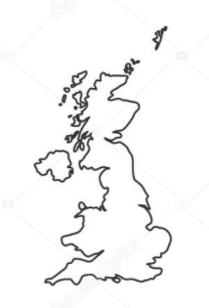

Friday Learning Challenge:

I wonder where we will go next on our travels.
BUT… first we need to make something to travel in… hmmm I wonder.

Lucky has decided he would like to travel by Hot Air Balloon… but you can travel however you would like, maybe an aeroplane or boat? You decide!

So… your learning challenge for today is to make your form of transport using junk modelling. Have fun with it, you can paint and decorate your model too. Lucky cannot wait to see your creations!
