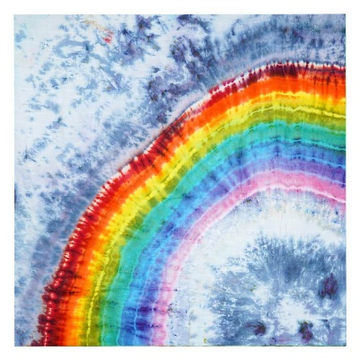
Week Commencing 1/2/21
Hello,
Its February already, can you believe it. Here is pack number 4. You are all doing amazing. I am so impressed with the work produced so far. Keep it up Make sure you are getting out into the fresh air at least once a day.
In this pack you will find ideas, activities and resources that will help you to support and continue educating your children at home.
As you will be aware in Nursery we aim to support and develop children’s play and learning. We allow the children to develop with their own initiative and learn at their own pace. We do this through stimulating and fun activities, which promote all areas of a child’s development.
We are continuing our ‘Why is it always cold in winter’ topic. This topic will enable children to explore the natural world around them, focusing on the weather and how we can keep warm, water safety, what can we do with water and the different animals we might see in winter. This week we will continue to work on our fine motor skills and our numbers to 5.
Here are some activities for you to have a go at during your time at home. I have split them up into days and done a timetable for you to follow. Miss Hollings will also be setting daily challenges on class dojo so make sure you look out for them. .
Useful websites:
Twinkl https://www.twinkl.co.uk/
Phonics play: https://www.phonicsplay.co.uk/

CBeebies: https://www.bbc.co.uk/cbeebies

BBC Iplayer: https://www.bbc.co.uk/iplayer

Youtube
Topmarks: https://www.topmarks.co.uk/
Crickweb: http://www.crickweb.co.uk/
Oxford Owl: https://www.oxfordowl.co.uk/for-home/
Letters and Sounds: http://www.letters-and-sounds.com/

If you need any help or advice please contact me via the class dojo. I am more than happy to help.
Thank you
Miss Hollings

Timetable:
Elm Class
Friday:
- Maths- Number hunt
- Phonics- Syllables
- Literacy- Secret letters
- Creative – Penguin cookies
- Physical- Adventures with Andy

Thursday:
- Maths- Penguin number matching
- Phonics- Odd one out
- Literacy- Paint writing
- Creative – Heavy clouds
- Physical- Joe Wicks
Wednesday:
- Maths- Peg fun
- Phonics- Challenges
- Literacy- Brick letters
- Creative – Toilet roll penguins
- Physical- Baby Shark

Tuesday:
- Maths- Number jigsaws
- Phonics- Who do you see?
- Literacy- Penguin Research
- Creative – Penguin potato printing
- Physical- Penguin Dance

Monday:
- Maths- Number pebbles
- Phonics- Old Mac Donald
- Literacy- Diary writing
- Creative – Kinetic Sand
- Physical- Cosmic Kids- Hungry Caterpillar

Monday Maths:
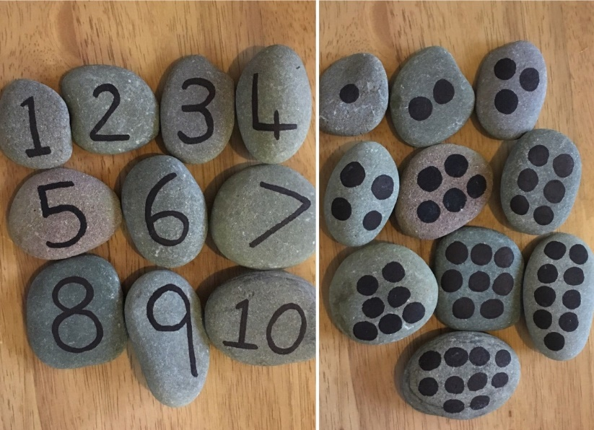
Today whilst on your walk I would like you to collect 20 pebbles (of a good size, but not too big). Once you get your pebbles home and they are dry, I would like you to write numbers 1-5 on your pebbles, then ask an adult to help you write 6-10 (A sharpie open is best for this). On the other 10 pebbles draw the correct amount of dots for numbers 1-10 . Your adult can help you with this.
Once your pebbles are dry, can you place them in order- work on 1-5 first and then see if you can do 6-10 as well. Try with both numeral and dots. Keep your pebbles safe as we will use them over the next couple of weeks

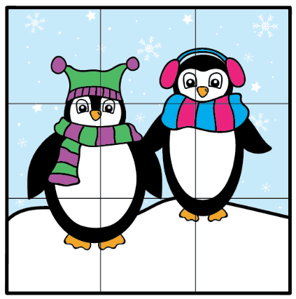
Just for fun:

Cut along the lines to make your own jigsaw. Can you put the jigsaw back together?

NUMBERBLOCKS!
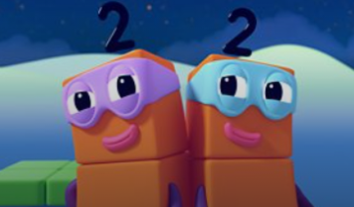

https://www.bbc.co.uk/iplayer/episode/b08dmhm6/numberblocks-series-1-the-terrible-twos
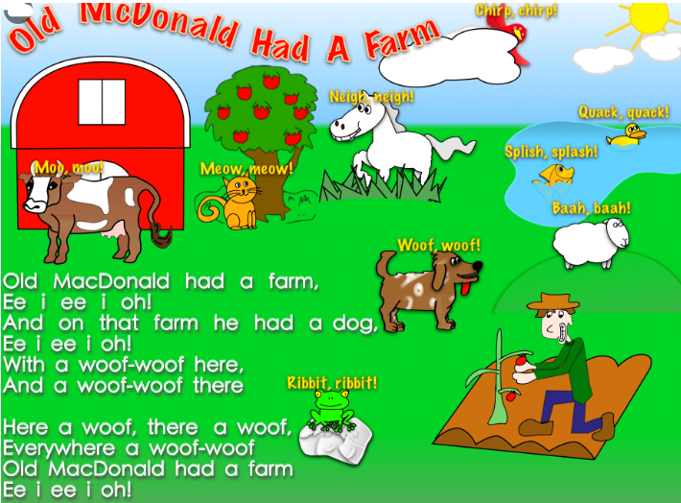
Monday Phonics:
Can you sing the ‘Old MacDonald’ Song- can you make the sounds for all the animals?

Monday Literacy:
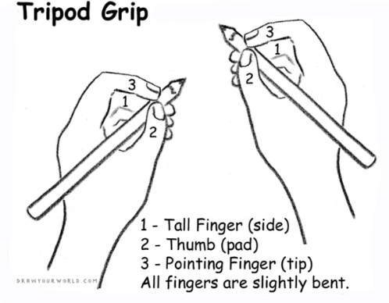
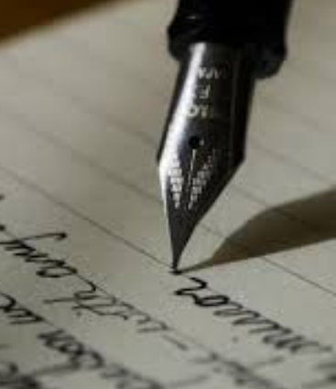
Diary Writing:
Miss Hollings loves to hear all about your adventures over the weekend… so today I would like you to continue writing your daily news. Talk with your adult about what you did over the weekend. Continue to allow your child to mark make and explain what they are writing along the way, you can then scribe for them. It is important they are given this freedom to express themselves, their ideas and thoughts through mark making. Really focus on your pencil grip, holding it between your fingers rather than full fist grip.
Questioning throughout is key i.e. Where did we walk to? What was your favourite part of the day? How did it make you feel? What did we see along the way? Would you like to go again? And why?
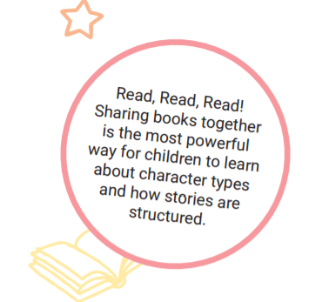
READ, READ, READ!!!!
Choose your favourite story for your adult to read to you. Once you have read the story use the pictures to retell the story to your adult.

Monday Physical:
Cosmic Kids: The very hungry caterpillar
https://www.youtube.com/watch?v=xhWDiQRrC1Y

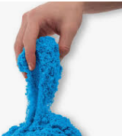
Monday Creative:
Kinetic sand
Materials
- 2 cups fine sand
- 1 tablespoon corn-starch
- 2 teaspoons dish soap
- Water, as needed
- Food colouring of choice

Instructions:

1) In a large bowl whisk together fine sand and cornstarch. Add dish soap and 1/4 cup water. Mix until fully combined. If necessary, add more water, 1/4 cup at a time. Continue stirring until desired consistency is reached.
2) Divide sand into separate bowls and add food colouring, mixing until desired colour is reached.
3) Let sand dry for 2 hours.
4) Play and have fun!

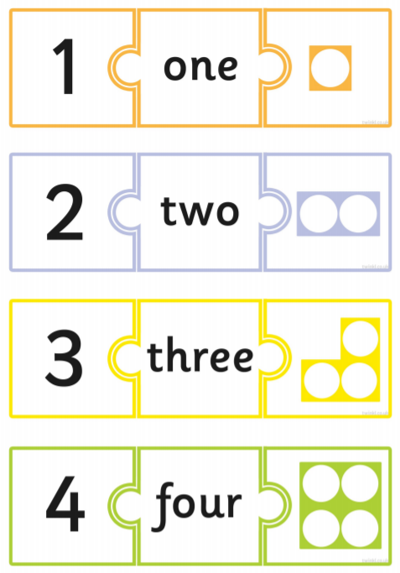
Tuesday Maths: Number matching

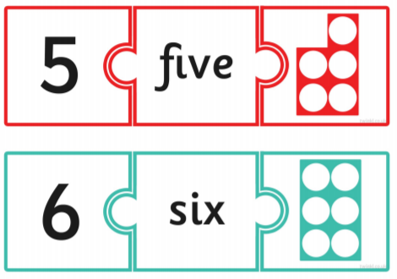

Have a go at making your own 1-5
matching jigsaws using the blanks
templates.

NUMBERBLOCKS:
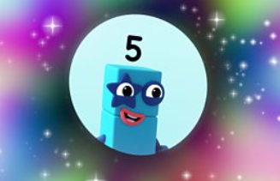

https://www.bbc.co.uk/iplayer/episode/b08dmjsk/numberblocks-series-1-holes

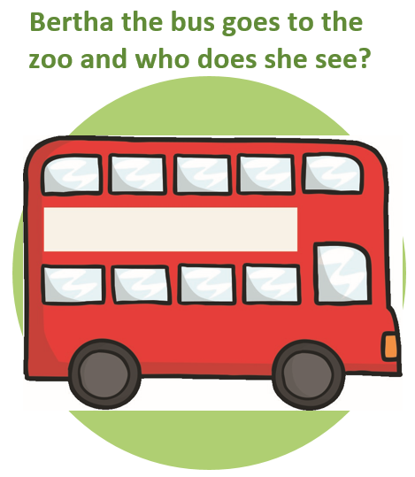
Tuesday Phonics:
Using all the letters from the alphabet can you name an animal that might go on Bertha’s bus to the zoo? A for Advark, B for Beaver etc

Tuesday Literacy: Research.
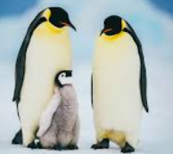
Today I would like you to research Penguins. You will already have some knowledge of Penguins as we conducted some research in class. What can you remember? What other information can you find out? Look at lots of different pictures.
When you have done your research, find your favourite penguin picture and draw it. Don’t forget to colour it in and maybe you could ask your adult to add your favourite fact about penguins.

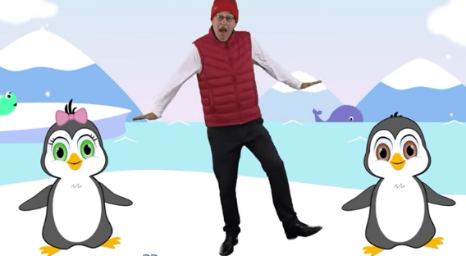
Tuesday: Physical- Penguin Dance

https://youtu.be/uf0uKmKwnKs

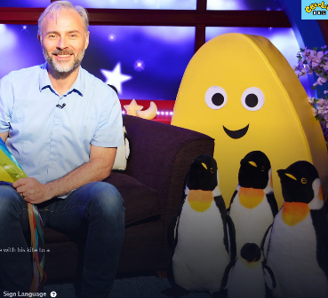
Cbeebies bedtime story- Blown Away https://www.bbc.co.uk/iplayer/episode/b09jky53/cbeebies-bedtime-stories-607-mark-bonnar-blown-away

Tuesday- Creative: Potato printing/ Fruit pictures
Today I would like you to create a penguin picture using potato printing. I have attached some examples for you. Don’t forget to include eyes, a beak and feet for your penguin. Maybe you could use your finger for this… you might even want to add snow. If you don’t have a potato maybe you could use a different piece of fruit/ vegetable.
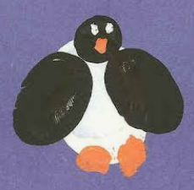
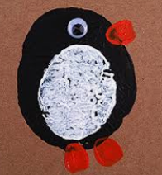

=

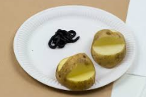

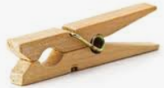
Wednesday Maths: Peg fun. Cut out each card. Count the items on each card and match with the numeral. Use a peg to clip on the correct numeral. This activity will also support your fine motor skills too
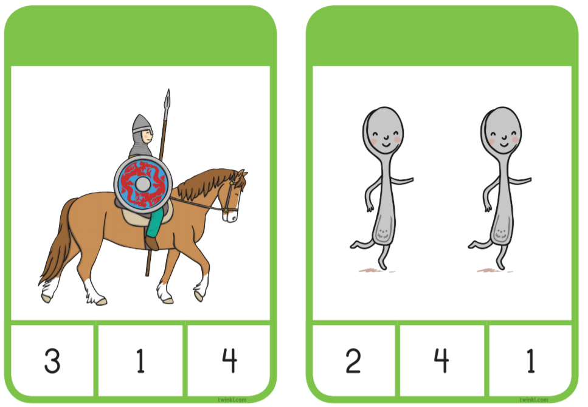

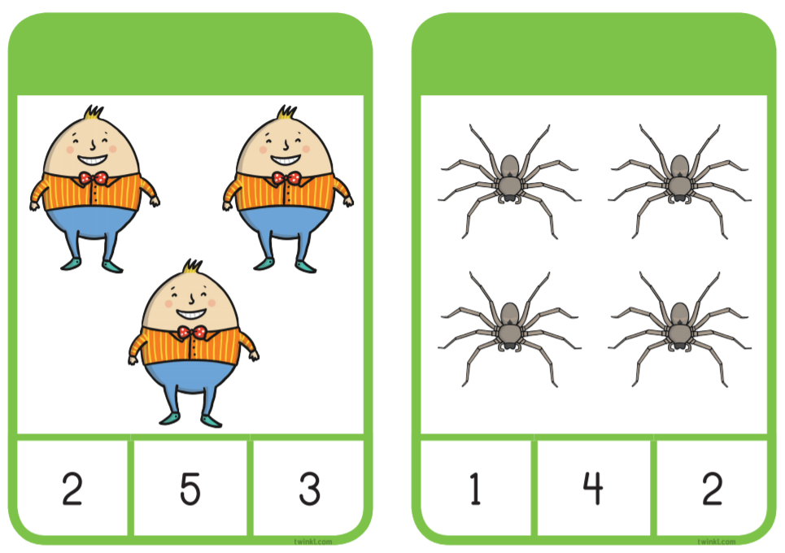

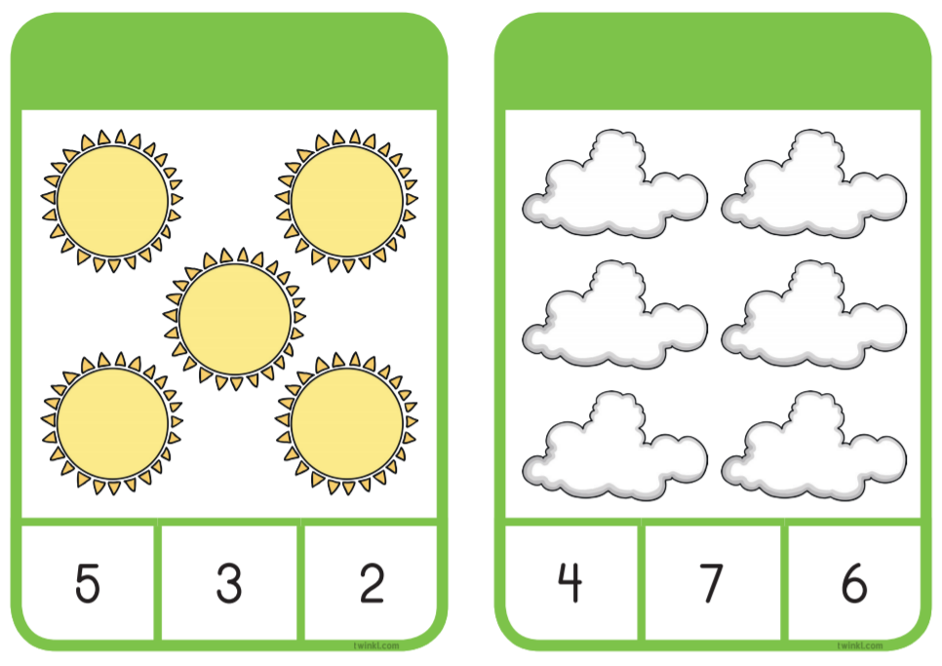

NUMBERBLOCKS
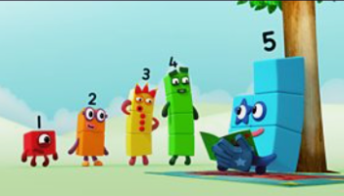
https://www.bbc.co.uk/iplayer/episode/b08dmn88/numberblocks-series-1-hide-and-seek

Wednesday Phonics: Challenges
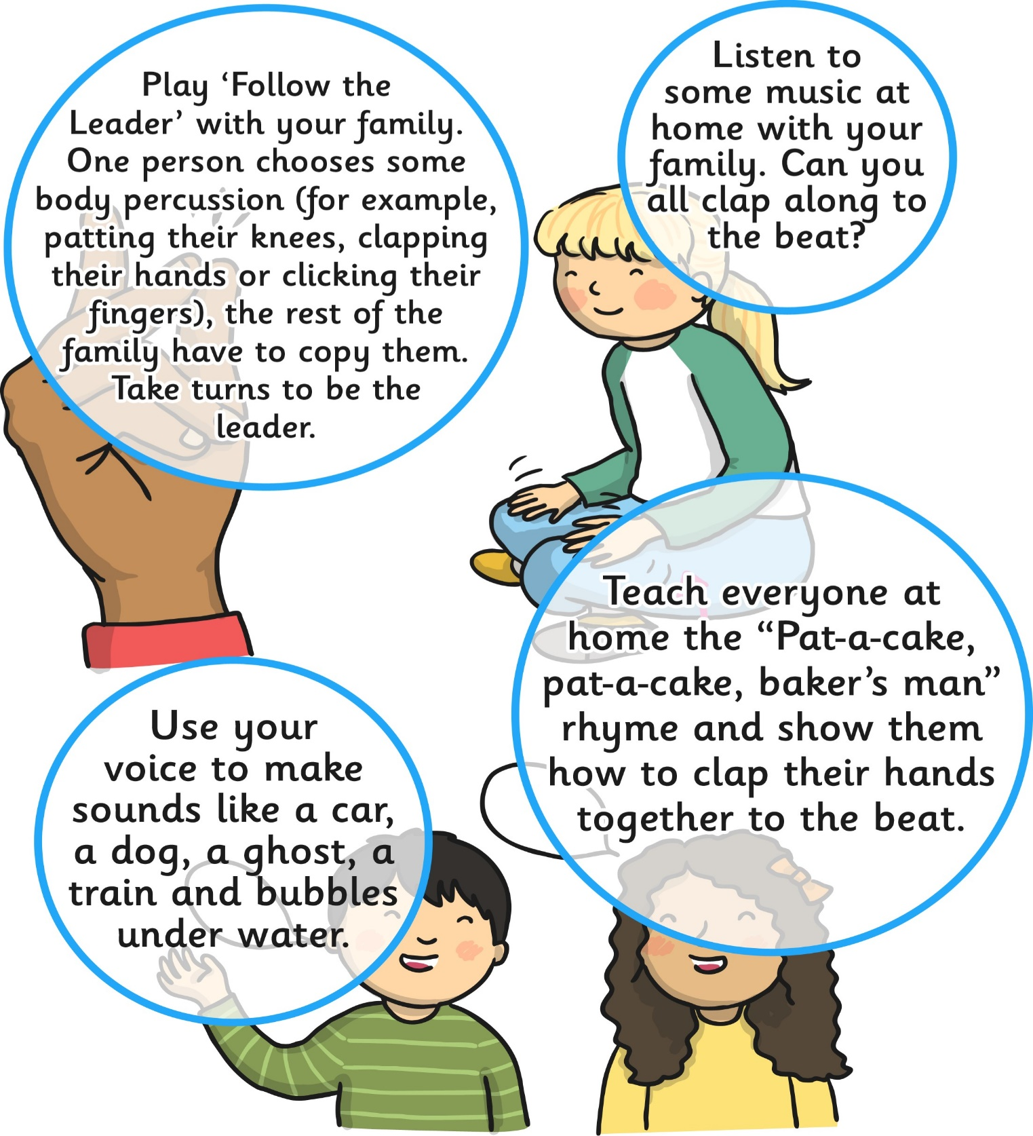

Wednesday Physical:
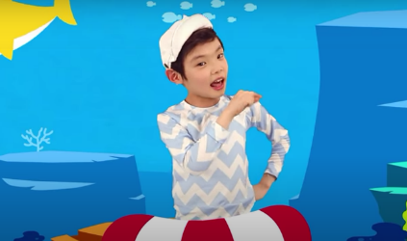
Baby Shark (Sorry mums and dads)
https://youtu.be/XqZsoesa55w

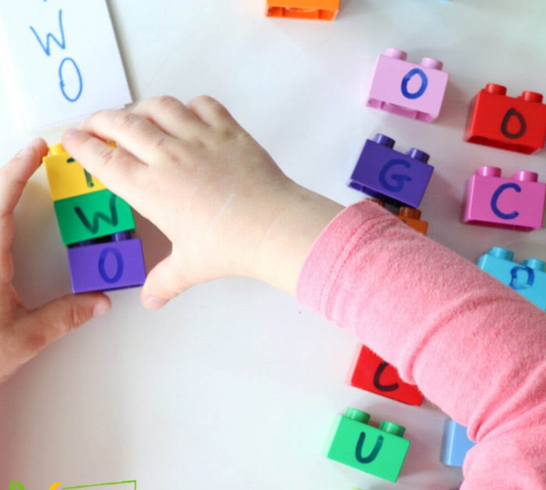
Wednesday- Literacy:
Name Writing:
Write your name on some bricks. Ask your adult to write the letters from your name on some lego/ duplo (one letter per brick). Mix them up. Can you make your name again?
If you don’t have bricks, you can use other items (pebbles, counters, or simply write the letters on a piece of paper).

Wednesday- Creative- Toilet Role Penguins
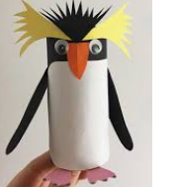
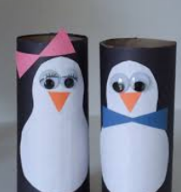
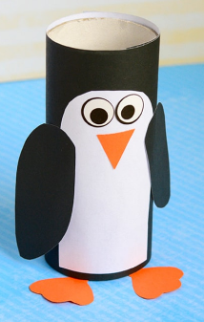

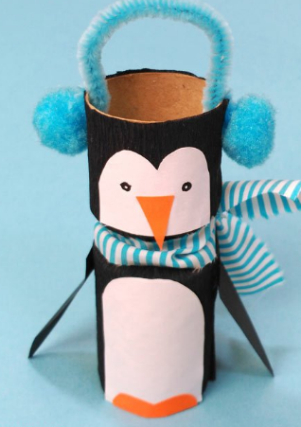
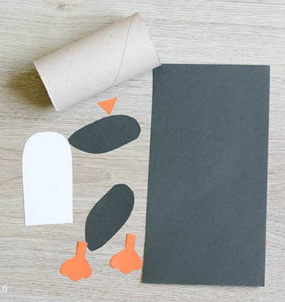

What you need:
- paper roll
- black paper (or black paint)
- orange paper
- scissors
- glue
- wiggle eyes stickers

Thursday Maths: Cut out each section and match them up, just like a jigsaw
1 | 2 | 3 | 4 | 5 | 6

Now have a go at making your own. Draw your penguin, cut it out and match it back up
1 | 2 | 3 | 4 | 5 | 6

NUMBERBLOCKS:
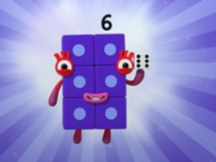
https://www.bbc.co.uk/iplayer/episode/b08pgksd/numberblocks-series-2-six

READ, READ, READ!!
Bedtime Story: Once tucked up in bed, read your teddy a bedtime story.

Thursday Physical:
Joe Wicks 5 minute workout
https://www.youtube.com/watch?v=d3LPrhI0v-w

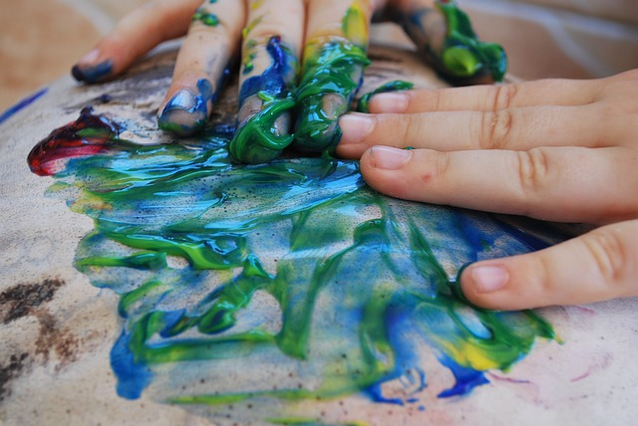
Thursday Literacy: Paint writing
Put some paint in a tuff tray/ flat surface. Allow your children to make marks/ write in the paint. It’s messy but so much fun and great for their fine motor skills. Encourage mark making with index finger. Take pictures of their writing.

Thursday Phonics:
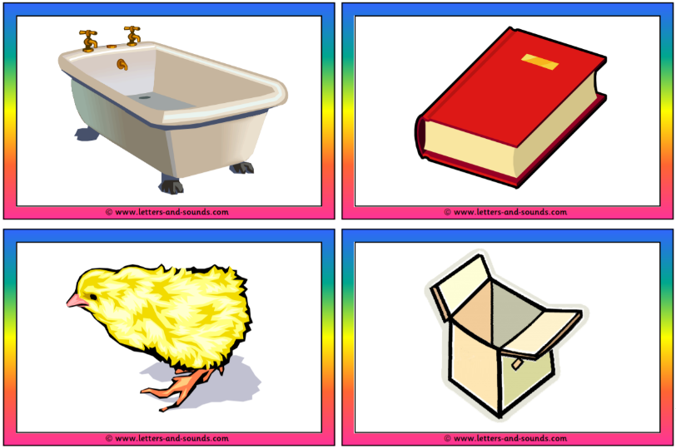
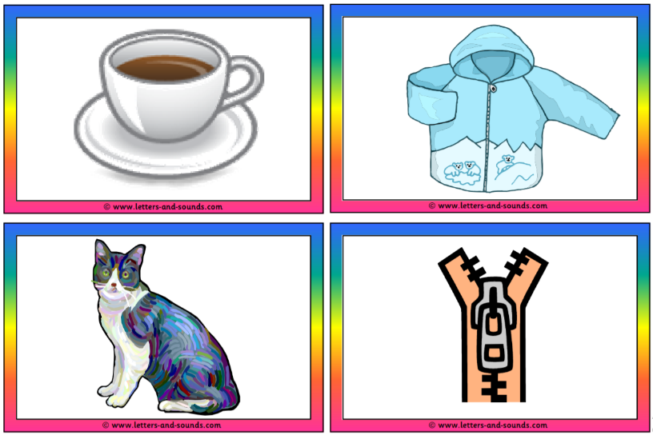
Odd one out- Starting sound. Three of the four pictures begin with the same sound. Pick the odd one out.

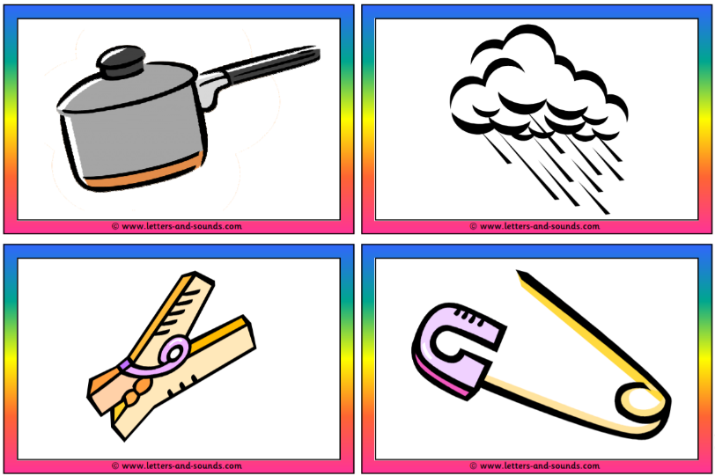
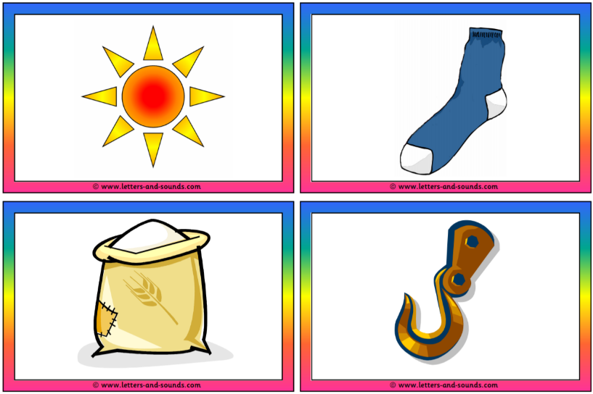

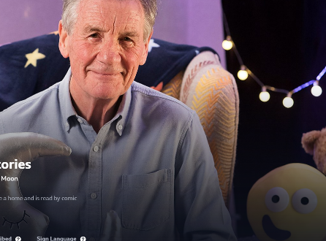
Cbeebies bedtime story/song- By the light of the moon

https://www.bbc.co.uk/iplayer/episode/m000715w/cbeebies-bedtime-stories-716-sir-michael-palin-by-the-light-of-the-moon
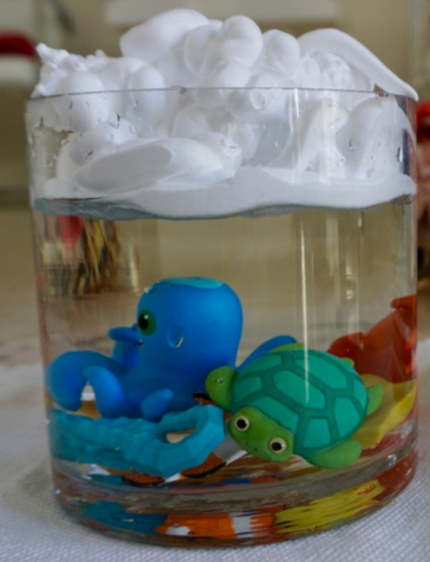
Thursday: Creative
Heavy clouds
What you will need:
- Water
- Pipette/ Medicine Dispenser
- Shaving Cream
- Food Colouring
- Large Bowl
- Small Bowls
- Bath Toys (optional)
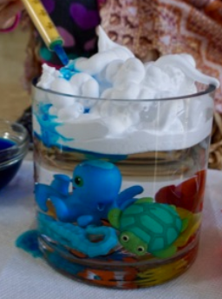
Instructions:
STEP 1: Add water to a tall bowl (preferably with a small opening) and add bath toys (optional).
STEP 2: Spray the shaving cream on top of the water as if it was icing on a cake covering the whole top of the water.
STEP 3: Mix a couple of drops of food colouring with water. Repeat for every colour desired.
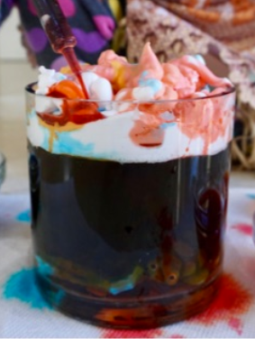
STEP 4: Using a pipette/ medicine dispenser, have your child squeeze in the mixture of food colouring and water. Then, have the child squeeze out the mixture on top of the shaving cream trying their best to not touch the shaving cream. Watch the colouring seep into the water as the "cloud" gets heavier.

Friday Maths: Number hunt.
Ask your adult to write numbers 1 to 10 on pieces of paper and hide them around your house. You need to go and find the different numbers. When finding the numbers I want you to recognise the numeral and show me the number on your fingers. Once you have found all 10, put them in order.
Maybe you could swap with your adult, and you could hide them for your adult to find
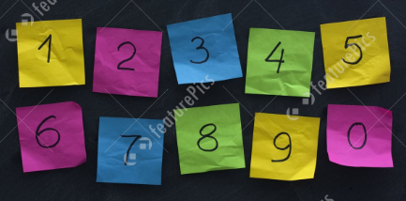

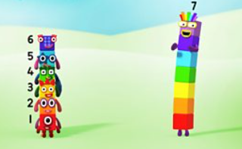
NUMBERBLOCKS
https://www.bbc.co.uk/iplayer/episode/b08pgqt4/numberblocks-series-2-seven

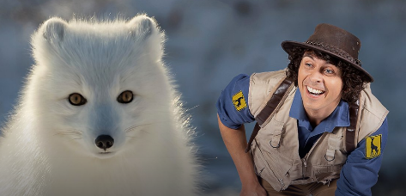
Friday- Physical- Andy and the Artic Fox
https://www.bbc.co.uk/iplayer/episode/b09s39xl/andys-safari-adventures-series-1-4-andy-and-the-arctic-fox

Friday Phonics: The cards show words and pictures that contain between one and four syllables. Cut the cards out and select a few. Ask your child to name the picture and talk about their own experiences of the item, for example Dog, some children might have a dog. Next introduce syllables by clapping as you say each one. Ask your child to clap and count with you.
(Buc_ket = 2 syllables= 2 claps)
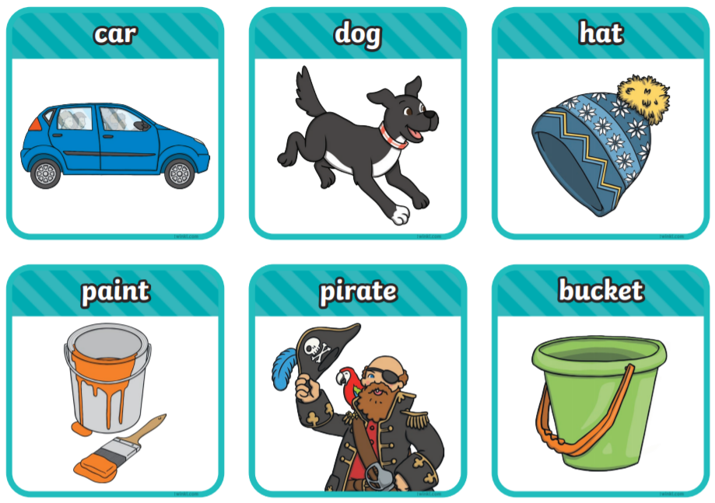
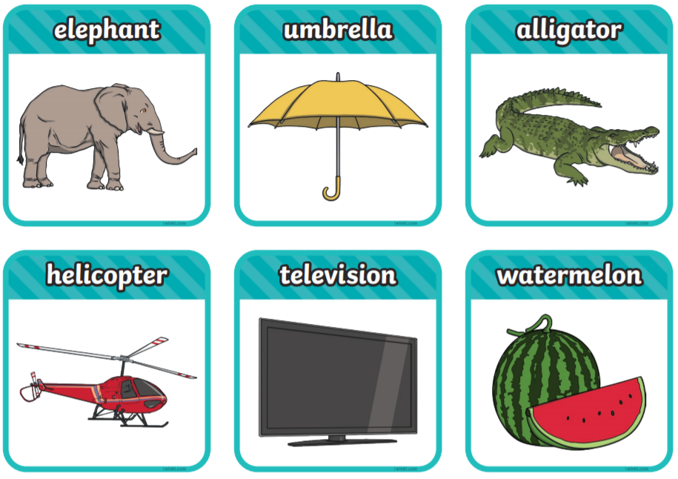
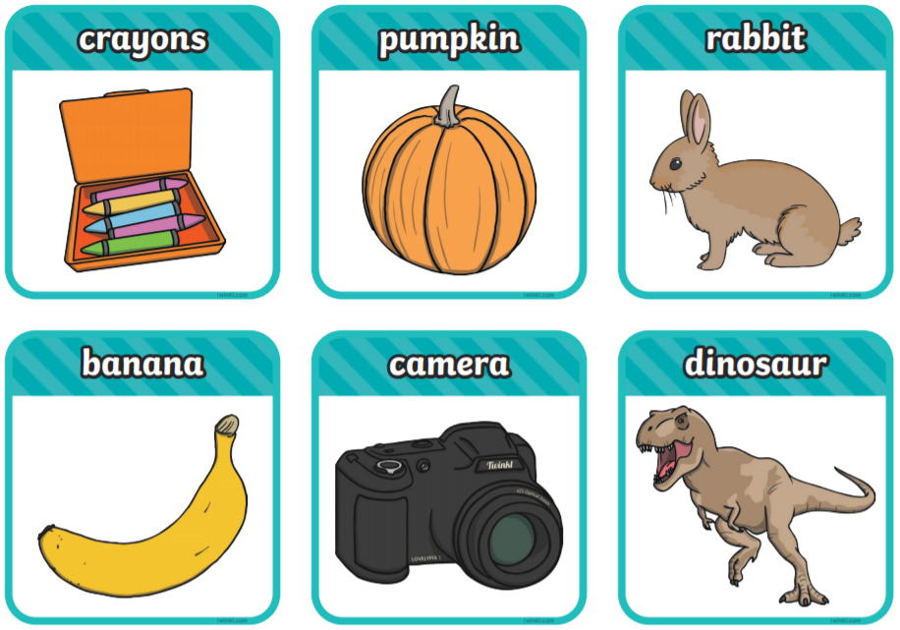

Friday Literacy: Secret Letters
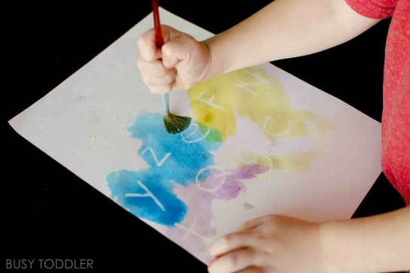
You will need:
White paper
White crayon
Watercolour paint

Using the white crayon to print letters firmly onto the paper. Allow your child to paint over the letters. Can they find their name? What other sounds/letters can they find?

Challenge: Let your child write some letters and let their adult find them.

Friday: Creative- Chocolate Penguin Cookies
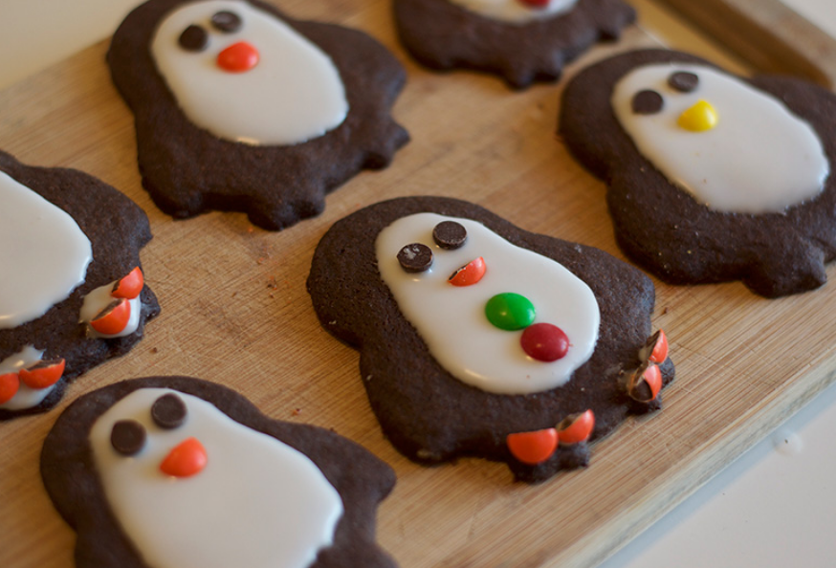
Ingredients:
- 1 1/2 cups all purpose flour
- 3/4 cups cocoa powder
- 1 1/4 teaspoon baking powder
- 3/4 cup butter
- 1 1/4 cup white sugar
- 1 egg
- 1 tsp vanilla essence
- 1/2 cup chocolate chips for the penguin's eyes!
- 1 cup m & m's for beaks, waistcoat buttons etc.

Instructions:
- Have all ingredients at room temperature. Sieve the flour cocoa powder and baking powder into a mixing bowl.
- Cream together the butter and sugar in a separate bowl. Stir in the egg and vanilla essence.
- Mix together the wet and dry ingredients to form a dough.
- Wrap cookie dough in food wrap and place in the fridge for 2 hours.
- Preheat the oven to 375 degrees F (190 degrees C). Roll out the cookie dough on a floured surface, to around 1/4 inch in thickness. Add more flour as needed. Dough is sticky, so you can add plenty of flour without fear of the dough drying out.
- Use penguin cutter to cut cookie shapes and place on a greased baking tray.
- Bake for 8-10 minutes.
- Allow to cool for a few minutes before transferring to a wire rack to cool fully.
- For the icing, simply mix 1 cup icing/powdered sugar with 4 tbs of milk. We just used a spoon to ice, but you could also use an icing bag - or a food bag with the corner snipped off!
- Add icing and m&m’s to your cookies. Allow to dry.

