Week Commencing 1/2/21
Hello,
Here is pack number 5, we’ve nearly made it to half term. Keep going, you are all doing amazing. I continue to be impressed with the work produced so far. Keep it up Make sure you are getting out into the fresh air at least once a day.
In this pack you will find ideas, activities and resources that will help you to support and continue educating your children at home.
As you will be aware in Nursery we aim to support and develop children’s play and learning. We allow the children to develop with their own initiative and learn at their own pace. We do this through stimulating and fun activities, which promote all areas of a child’s development.
This is the last week of our ‘Why is it always cold in winter’ topic. It is also Chinese New Year on the 12th February and I have included some fun creative ideas for Valentine’s Day (14th February) and Shrove Tuesday (16th February) for you to have a go at during your time at home. I have split them up into days and done a timetable for you to follow. Miss Hollings will also be setting daily challenges on class dojo so make sure you look out for them. .
Useful websites:
Twinkl https://www.twinkl.co.uk/
Phonics play: https://www.phonicsplay.co.uk/

CBeebies: https://www.bbc.co.uk/cbeebies

BBC Iplayer: https://www.bbc.co.uk/iplayer

Youtube
Topmarks: https://www.topmarks.co.uk/
Crickweb: http://www.crickweb.co.uk/
Oxford Owl: https://www.oxfordowl.co.uk/for-home/
Letters and Sounds: http://www.letters-and-sounds.com/

If you need any help or advice please contact me via the class dojo. I am more than happy to help.
Thank you
Miss Hollings

Timetable:
Elm Class
Thursday:
- Maths- Missing Numbers & Number blocks
- Phonics- Rhyming
- Literacy- Read teddy bear a story
- Creative – Fruity creatiuons
- Physical- Kids Bop
Wednesday:
- Maths- Winter I spy & Number blocks
- Phonics- Describing challenge
- Literacy- List Writing
- Creative – Pancake making
- Physical- I am the music man

Tuesday:
- Maths- Snowman Dice Game & Number blocks
- Phonics- Repeating the Rhythm
- Literacy- Jigsaw name
- Creative – Valentine’s Day handprint frame
- Physical- Andy’s Adventures

Monday:
- Maths- Feed the penguin & Number blocks
- Phonics- What sounds do they make
- Literacy- Diary writing
- Creative – Sponge painting
- Physical- Super fun kids workout

Friday:
- Maths- Chinese New Year- colour by numbers and numicon dragon
- Phonics- What can you hear?
- Literacy- Playdough writing
- Creative – Chinese Dragon
- Physical- Joe Wicks- Spiderman workout

Monday Maths: Cut out the penguin’s mouth and fish on the next page. Count the dots on the fish, put them in order smallest to biggest then feed the penguin. I wonder if the penguin can eat all of the fish.

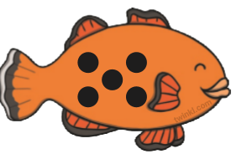
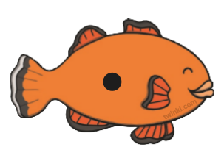

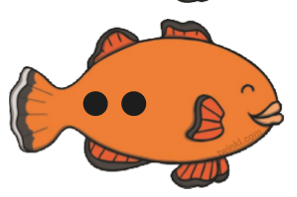

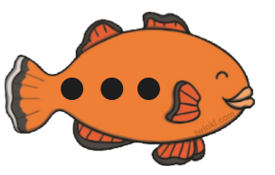

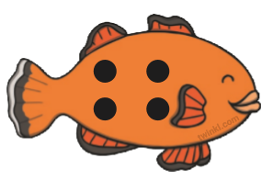

NUMBERBLOCKS!
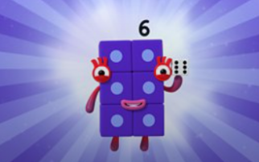

https://www.bbc.co.uk/iplayer/episode/b08pgksd/numberblocks-series-2-six
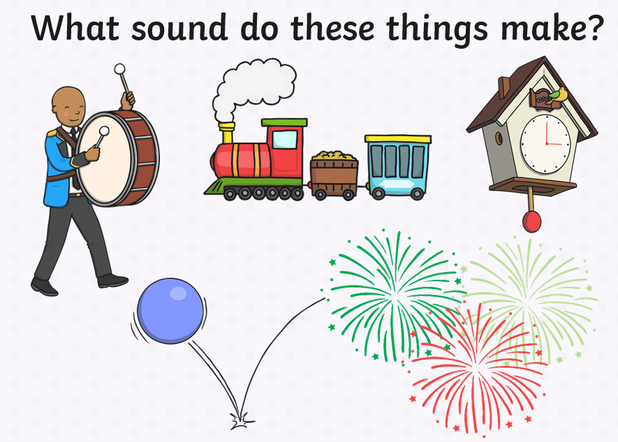
Monday Phonics: Use your voices to make the different sounds.

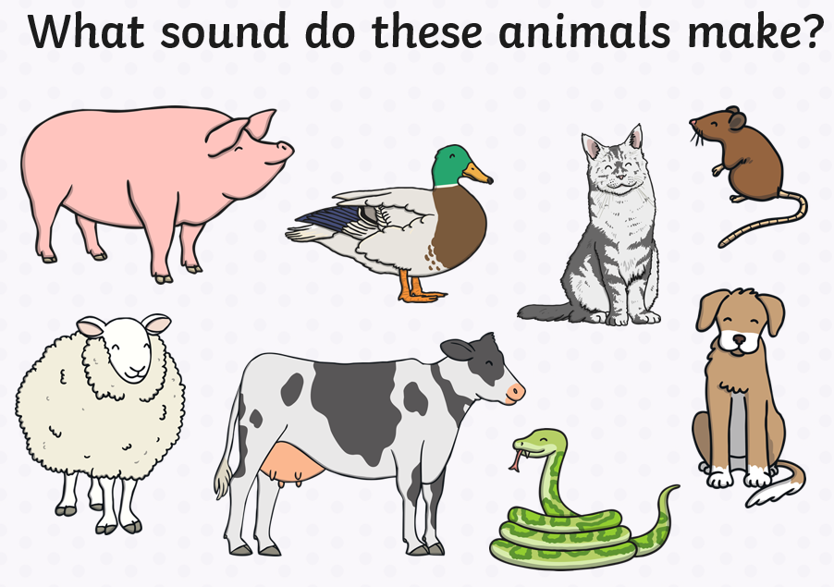

Monday Literacy:
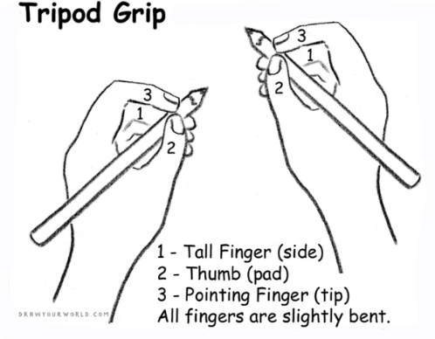
Diary Writing:
Miss Hollings loves to hear all about your adventures over the weekend… so today I would like you to continue writing your daily news. Talk with your adult about what you did over the weekend. Continue to allow your child to mark make and explain what they are writing along the way, you can then scribe for them. It is important they are given this freedom to express themselves, their ideas and thoughts through mark making. Really focus on your pencil grip, holding it between your fingers rather than full fist grip.
Questioning throughout is key i.e. Where did we walk to? What was your favourite part of the day? How did it make you feel? What did we see along the way? Would you like to go again? And why?
Monday Creative: Sponge printing

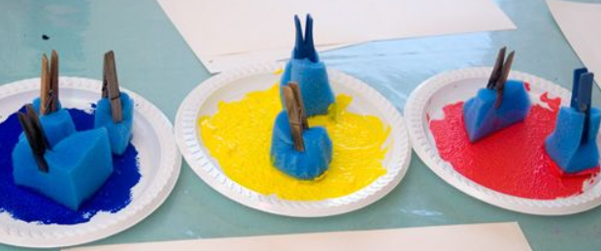
You will need:
- Sponges (cut into different shapes)
- Pegs (To clip onto the sponges. Try and do this yourself… will help with your fine motor )
- Different coloured paints

Create a picture using sponges and different coloured paints. You could cut your sponges up into different shapes. I want you to use your imagination, you can create any picture you like

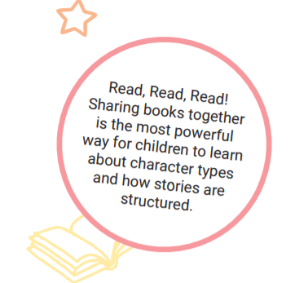
READ, READ, READ!!!!
Choose your favourite story for your adult to read to you. Once you have read the story use the pictures to retell the story to your adult.

Tuesday Maths: Number matching

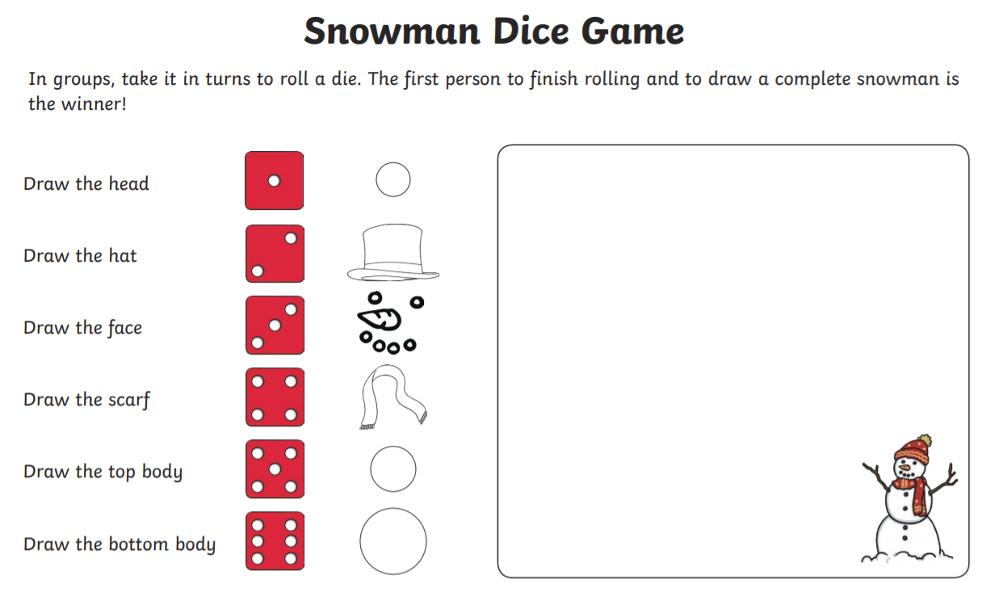

NUMBERBLOCKS:
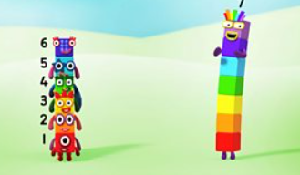
https://www.bbc.co.uk/iplayer/episode/b08pgqt4/numberblocks-series-2-seven

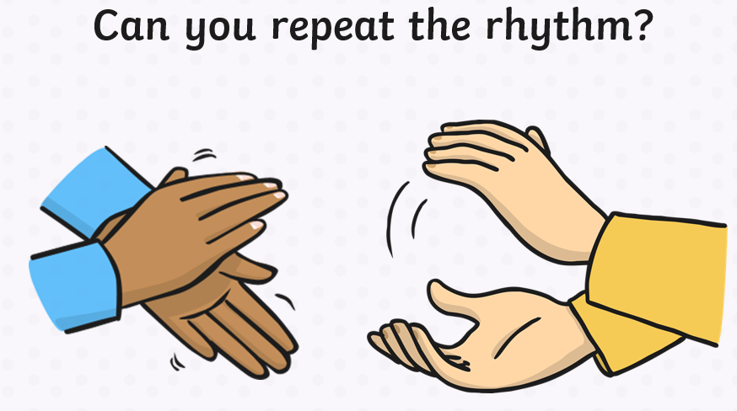
Tuesday Phonics: Practice making sounds with your hands. Can you repeat the patterns?

Tuesday: Physical

Andy's Safari Adventures | Whales, Penguins and other friends!
https://www.youtube.com/watch?v=MuDgWOky7lc

Tuesday Literacy: Recognising/ Name writing
Cut up the jigsaw. Write the letters from your name on each piece of jigsaw (your adult can help with this). Mix up the letters. Can you recognise the letters from your name and make your name.
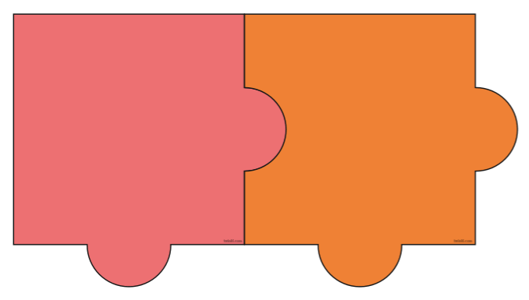
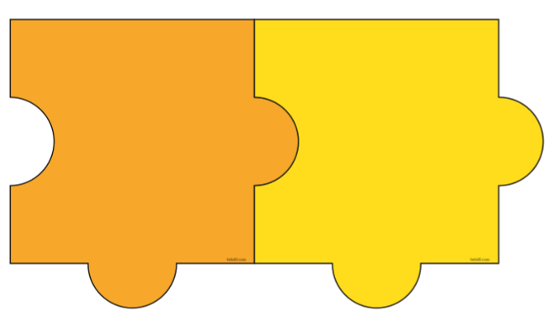

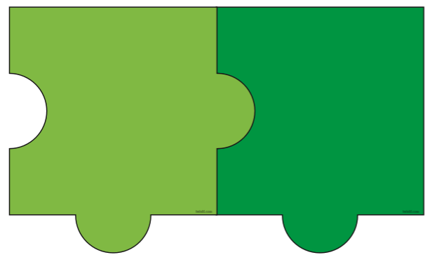

Cbeebies bedtime story- Robins Winter Song
https://www.bbc.co.uk/iplayer/episode/m000bqbx/cbeebies-bedtime-stories-729-idina-menzel-robins-winter-song

Tuesday- Creative: Salt dough handprint frame
In Nursery we always love to make our adults a Valentines gift. This year will be no exception… it will just be at home.
- Firstly make the Salt dough- You will need:
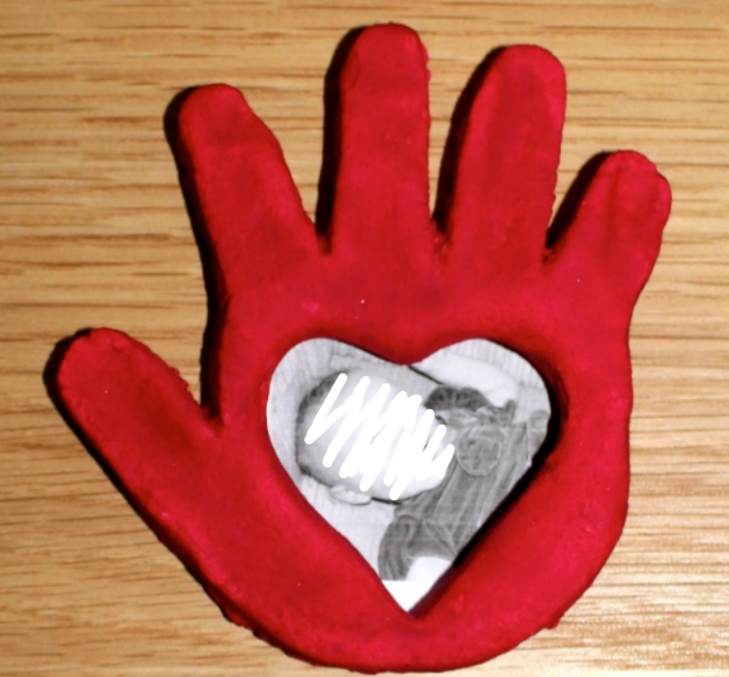
-2 cups of plain flour (all purpose flour)
-1 cup of salt
-1 cup of water (you may need less)
- Salt dough instructions:
- Mix 2 cups of plain flour and 1 cup of salt together in a large bowl.
Your picture here
- Add 1 cup of water. Add it in slowly as you may need less.
- Knead the mixture into a dough.
- Get creating!

- You will also need:
- A heart shaped biscuit cutter
- Mod Podge all in one glue and sealer
- A sharp knife
- Small photographs
- Paint

Instructions:
- Mix up a batch of salt dough using the recipe above.
- Flatten your salt dough until it’s about 1cm thick.
- Press your child's hand into the salt dough.
- Carefully cut around the handprint with a sharp knife.
- Cut a heart shape out of the handprint using a heart biscuit cutter.
- Leave your salt dough to dry. You can dry the salt dough out by putting it in the oven at a low temperature for a few hours or you can leave it in a warm room for a couple of days (the oven does work best).
- Once the salt dough is completely dry paint your handprint frame if you wish. I painted one and left one natural.
- Seal your creation. We used mod podge all in one glue and sealer. (This is important if you want your keepsake frame to last)
- Glue a small photograph behind the heart cut out.
- You might want to glue on a picture hook if you want to hang your photo frames up or add a strong magnet if you want them to go on your fridge.
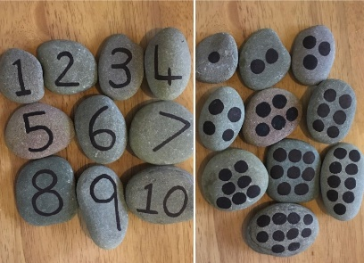
Wednesday Maths: You will need your pebbles for this too. How many of each picture can you find? Once you have counted, can you find the correct number pebble?
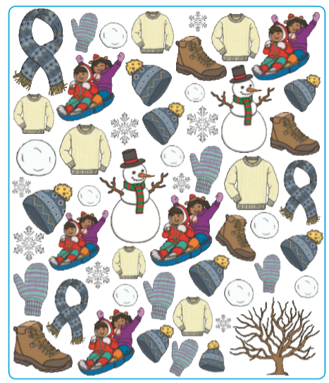
Ie. 3x scarfs- Find your number 3 pebble.

NUMBERBLOCKS
https://www.bbc.co.uk/iplayer/episode/b08pgvmb/numberblocks-series-2-eight

Wednesday Phonics: Challenges

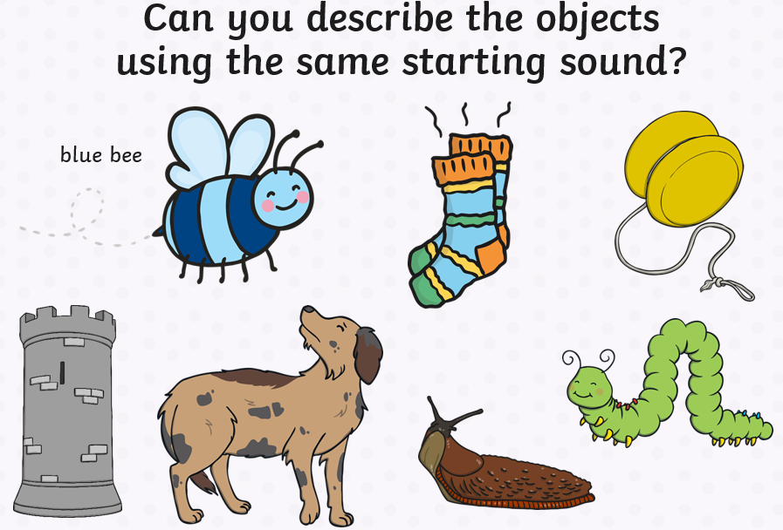

Wednesday Physical: I am the music man

https://www.youtube.com/watch?v=22kqia2ibVU

Wednesday- Literacy:
List writing
Can you write Miss Hollings a list of all the things you miss about Nursery?
(Adults, allow your children to mark make and put meaning to their marks by telling you what they have written. Just like you do with the diary writing, you can then scribe for them).

Maybe they could draw a picture of everything they miss too.
Allow your child to write on large pieces of paper, felt tips, crayons, chalk etc. Whatever they desire to make them comfortable when writing.

Wednesday- Creative- Pancakes!
I know it’s not Pancake Day until next week but we always make them in class so why not make them at home and send in your pictures.
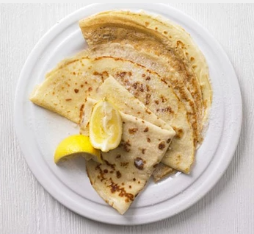
Here are a few recipes:
Simple Pancakes:
- 100g plain flour
- 2 large eggs
- 300ml milk
- 1 tbsp sunflower or vegetable oil, plus a little extra for frying
- lemon wedges to serve (optional)
- caster sugar to serve (optional)

Method
- Put 100g plain flour, 2 large eggs, 300ml milk, 1 tbsp sunflower or vegetable oil and a pinch of salt into a bowl or large jug, then whisk to a smooth batter.
- Set aside for 30 mins to rest if you have time, or start cooking straight away.
- Set a medium frying pan or crêpe pan over a medium heat and carefully wipe it with some oiled kitchen paper.
- When hot, cook your pancakes for 1 min on each side until golden, keeping them warm in a low oven as you go.
- Serve with a choice of topping

American Pancakes:
- 1 cup (120g) all-purpose flour
- 2 Tablespoons sugar
- 2 teaspoons baking powder
- 1 pinch of salt
- 1 cup (240 ml) milk
- 2 Tablespoons melted butter or vegetable oil
- 1 large egg
- Assorting toppings such as maple syrup, fresh berries, etc.

Instructions
- Preheat the oven to 200°F (90°C), with a heatproof platter ready to keep cooked pancakes warm in the oven.
- In a small bowl, whisk together flour, sugar, baking powder, and salt. Set aside.
- In a medium bowl, whisk together milk, butter (or vegetable oil), and egg.
- Pour the dry ingredients to the milk mixture, and stir (do not overmix).
- Heat a large skillet or griddle over medium heat, and coat generously with vegetable oil.
- For each pancake, spoon 2 or 3 tablespoons of batter onto skillet. Cook until the surface of pancakes have some bubbles, about 1 minute. Flip carefully with a thin spatula, and cook until brown on the underside, 1 to 2 minutes more.
- Transfer to the heatproof platter, cover with foil and keep warm in the oven until serving. Serve warm, with desired topping such as maple syrup, fresh berries or banana slices.

Thursday Maths: Can you input the missing numbers?
Once you have input the missing numbers try making your own missing numbers pattern for your adult to complete and then swap and let them make one for you.
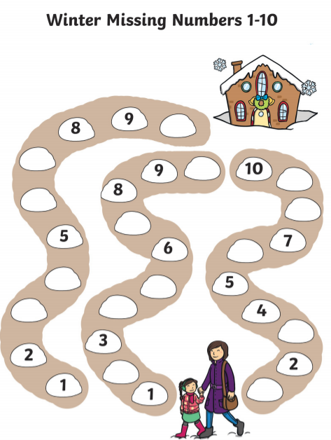

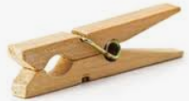
Peg Fun: Can you add the correct amount of pegs to each number? Cut out each number and clip on the correct number of pegs.
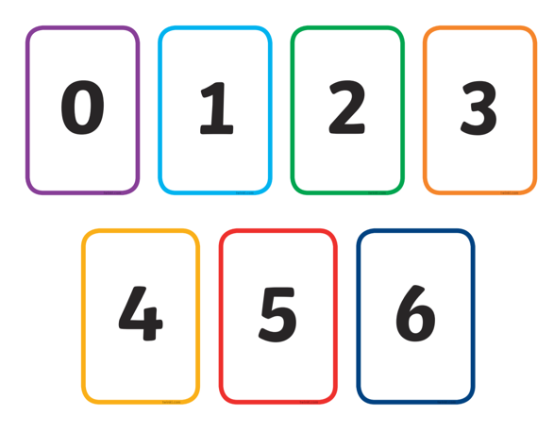

NUMBERBLOCKS:
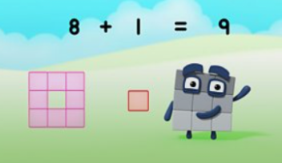
https://www.bbc.co.uk/iplayer/episodes/b08bzfnh/numberblocks?seriesId=b0bl5v3r
READ, READ, READ!!
Bedtime Story: Once tucked up in bed, read your teddy a bedtime story.

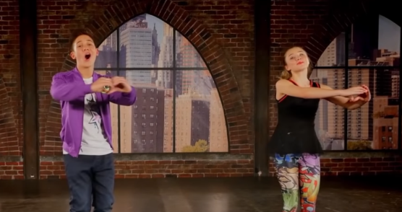
Thursday Physical: Kids Bob
https://www.youtube.com/watch?v=sHd2s_saYsQ

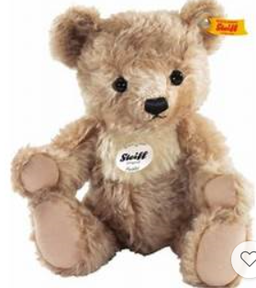
Thursday Literacy:
Can you tell a story to your teddy? Choose your favourite story and tell it to your teddy bears. Miss Hollings will be telling the story ‘The Emperors Penguin’… I wonder what you will read. Maybe your grown-up could record you doing this.

Challenge: Can you draw a picture about your book.

Cbeebies bedtime story/song- Littlest dreamer a bedtime adventure
https://www.bbc.co.uk/iplayer/episode/m0001vyh/cbeebies-bedtime-stories-679-orlando-bloom-littlest-dreamer-a-bedtime-adventure

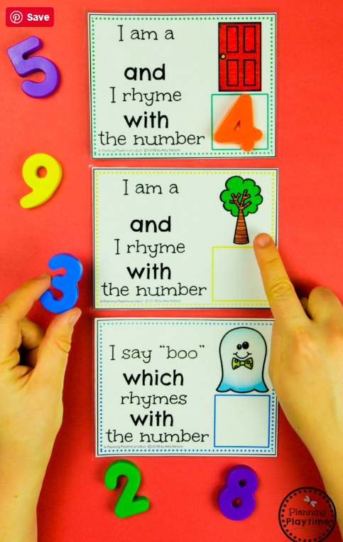
Thursday Phonics:
Practice the different Rhymes filling in the missing number.

CHALLENGE:
Can you think of a rhyme for numbers: 5, 6, 7, 8, 9 and 10

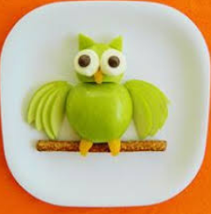
Thursday: Creative- Fruity creations

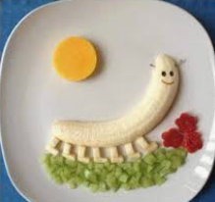
Can you make a masterpiece using different pieces of fruit?
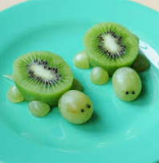
Once you have made your creation don’t forget to take a picture and upload it to our class Dojo!

Friday Maths: Fun with numbers and pegs.
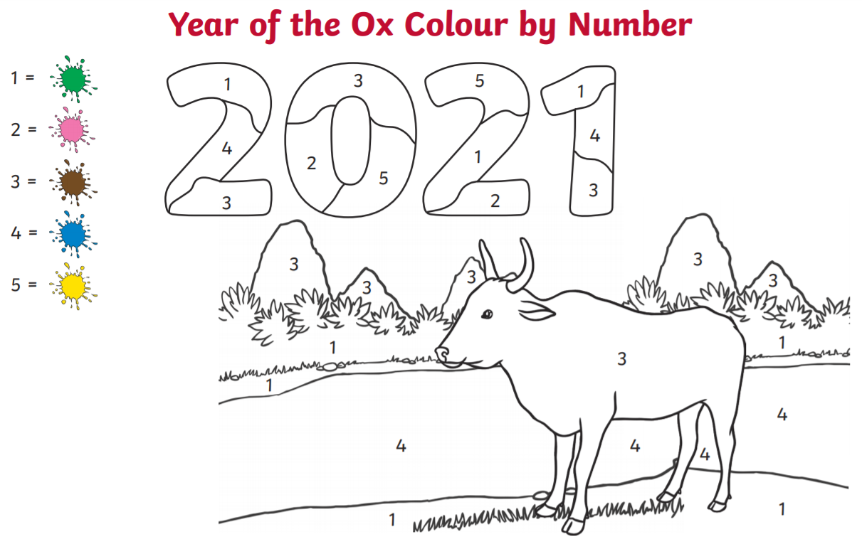
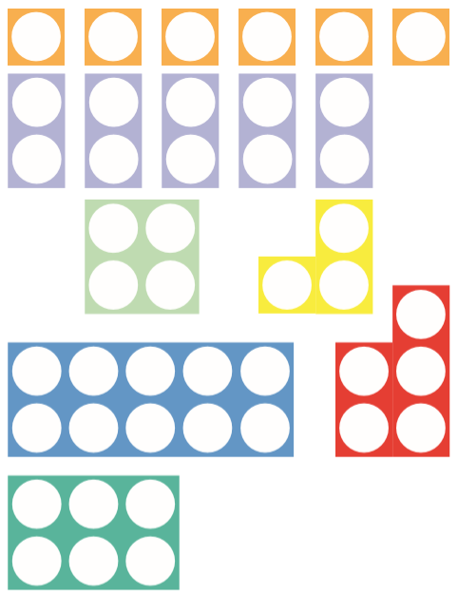
Chinese Dragon: Cut out the different numicons and stick them in the correct shapes on the Chinese Dragon.
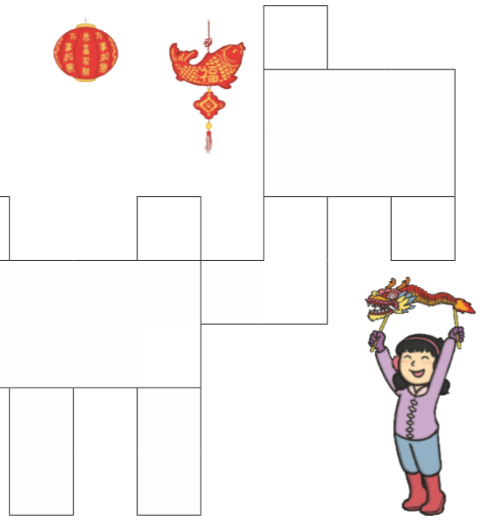

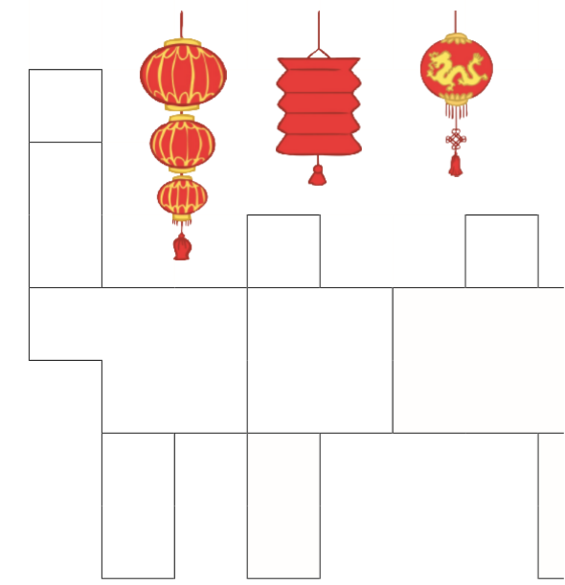

NUMBERBLOCKS
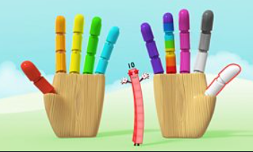
https://www.bbc.co.uk/iplayer/episode/b08phr1g/numberblocks-series-2-ten
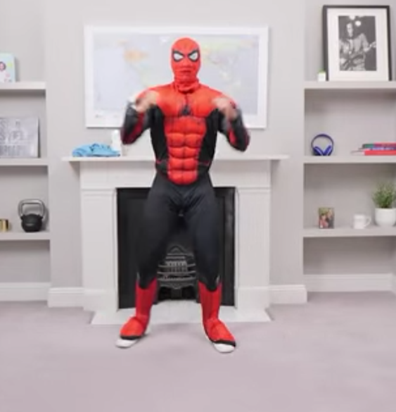
Friday- Physical- Joe Wicks- Spiderman workout

https://www.youtube.com/watch?v=2X1p0Yd6WAo

Friday Phonics: What can you hear?
On your walk today, stop and listen… what noises can you hear?
When you get home talk about the different noises with your adult. Have a go at drawing the different noises you heard.

Friday Literacy: Playdough writing
Write your name using playdough. Use the playdough to create the different letters of your name. Could you use the playdough to make some numbers too? Don’t forget to upload your creations to our class dojo!
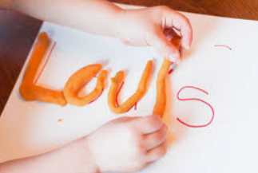
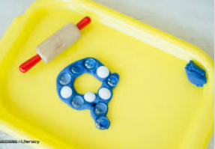

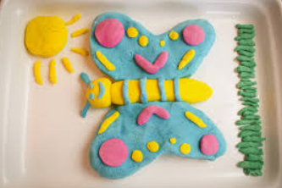
CHALLENGE: Can you create a picture using playdough.

Friday: Creative- Have a go at making your own Chinese Dragon

