Key Information About the School’s Performance
Outcomes at the end of primary school (Key Stage 2 / Year 6)
Percentage of pupils achieving the expected standard in reading, writing and maths (combined)
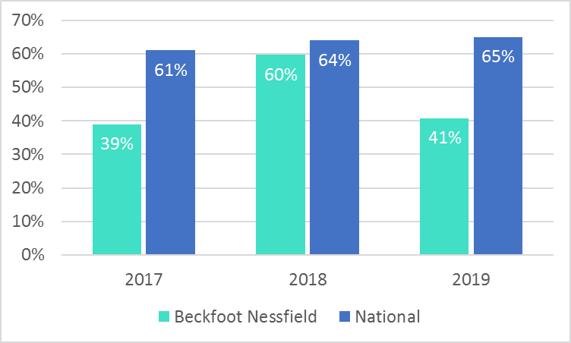
Percentage of pupils achieving the higher standard in reading, writing and maths (combined)
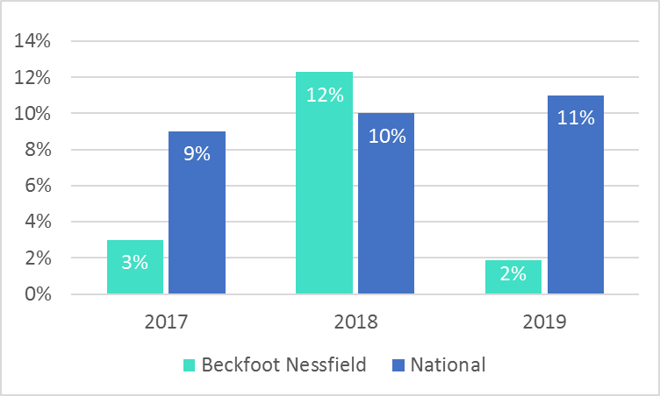
Percentage of pupils achieving the expected standard in each of reading, writing and maths (2019)
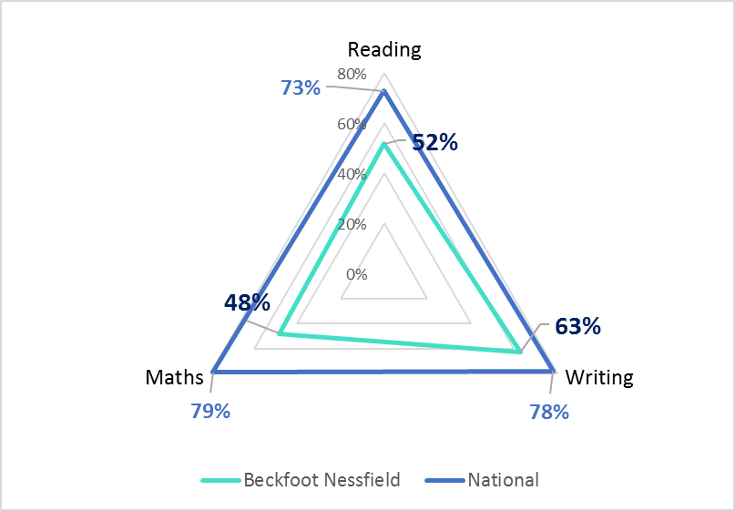
Outcomes at the end of Key Stage 1 (Year 2)
Percentage of pupils achieving the expected standard in each of reading, writing and maths (2019)
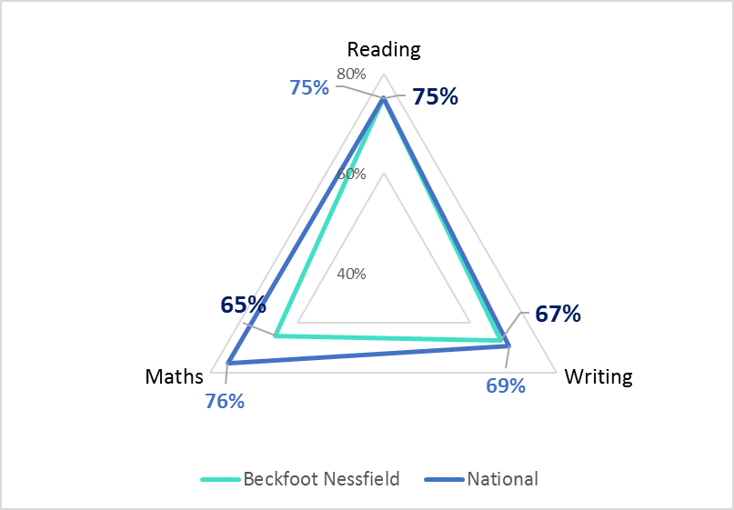
Percentage of pupils achieving the expected standard in reading
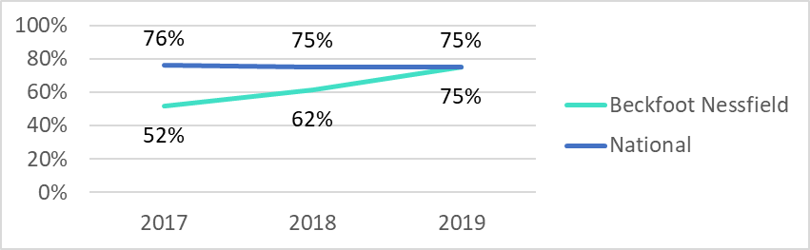
Percentage of pupils achieving the expected standard in writing
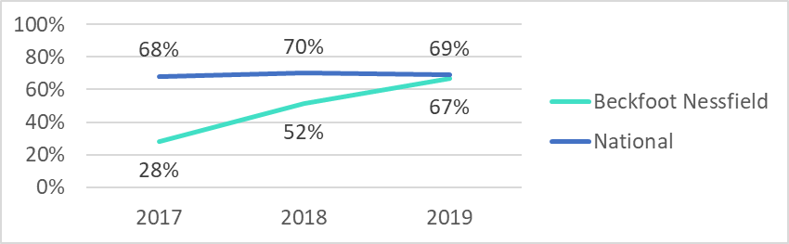
Percentage of pupils achieving the expected standard in maths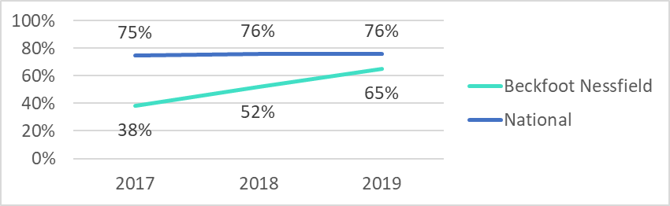

Early Years Foundation Stage Outcomes (Reception)
Percentage of children achieving a Good Level of Development, 2017 to 2019
