Week Commencing 1/3/21
Hello,
Wow, I can’t believe we are in March already!
This week we are continuing our Learning Challenge ‘Where will my golden ticket take me?’ During this Learning Challenge we will explore different countries including where we live. We will explore the different foods, language, stories, clothing, culture and history.
In Maths we are going to continue with shape… Miss Hollings has been super impressed with all of your work so she cannot wait to see how fabulous you are with shapes this week ∆󠄀◊□󠄀󠄀o
As you will be aware in Nursery we aim to support and develop children’s play and learning. We allow the children to develop with their own initiative and learn at their own pace. We do this through stimulating and fun activities, which promote all areas of a child’s development.
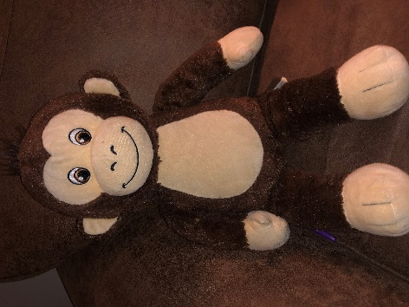
In this pack you will find ideas, activities and resources that will help you to support and continue educating your children at home.
Meet Lucky. Lucky is Oscar’s teddy bear and he is going to explore the world with you. Over the holiday’s he received a special ticket… a GOLDEN TICKET!! Check out this week’s activities to see where Lucky is going to go. He is super excited to explore all the different countries with you.

This week in our learning challenge Lucky is going to use his Golden Ticket to travel to Greece. I wonder if any of you have been to Greece before. Lucky is excited to find out all about Greece.
I have split all the exciting activities up into days and done a timetable for you to follow . If you need any help or advice please contact me via the class dojo. I am more than happy to help.
Useful websites:
Twinkl https://www.twinkl.co.uk/
Phonics play: https://www.phonicsplay.co.uk/

CBeebies: https://www.bbc.co.uk/cbeebies

BBC Iplayer: https://www.bbc.co.uk/iplayer

Youtube
Topmarks: https://www.topmarks.co.uk/
Crickweb: http://www.crickweb.co.uk/
Oxford Owl: https://www.oxfordowl.co.uk/for-home/
Letters and Sounds: http://www.letters-and-sounds.com/

Thank you
Miss Hollings

Timetable:
Elm Class
Thursday:
- Maths- Shape printing
- Phonics- Roll a ball
- Literacy- Read your teddy a story
- Learning Challenge- Clay pot
- Physical- Shake your sillies out/ Days of the week
Wednesday:
- Maths- Shape pictures
- Phonics- Listening Walk
- Literacy- Hello/ Goodbye in Greek
- Learning Challenge- Make your own Greek Dish
- Physical- Dance Party
Tuesday:
- Maths- Natural Shapes.
- Phonics- Everybody do this
- Literacy- Research Greek Gods
- Learning Challenge- Crown/ mythological object
- Physical- Get fit with Maurice/ Days of the week

Monday:
- Maths- I spy and count
- Phonics- Talking Stick
- Literacy- News Writing
- Learning Challenge- Greek Flag
- Physical- Trolls- Can’t stop the feeling

Friday:
- Maths- Shape writing tray
- Phonics- Can you find…
- Literacy- Name writing
- Learning Challenge- Olympic Games
- Physical- Cosmic Kids

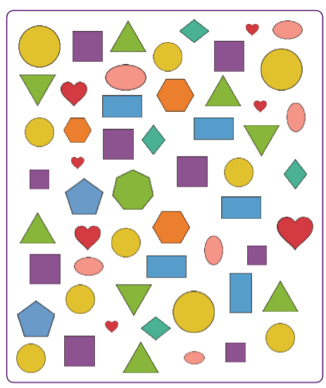
Monday Maths: I spy and count to 10- What shapes can you find and how many of each are there?

NUMBERBLOCKS!
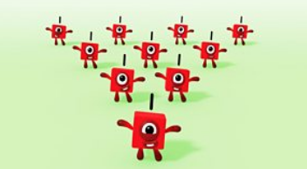

https://www.bbc.co.uk/iplayer/episode/b08q39b4/numberblocks-series-2-just-add-one

CHALLENGE: Can you practice drawing the shapes for yourself?
Monday Phonics: Talking Stick- a great way of teaching turn- taking, listening skills and speaking skills.
Take it in turns to say something. Turn taking in these games could be supported with the use of a talking stick: Your child can only say something when they are holding the ‘talking stick’ (any object could be used as a ‘talking stick’).
My name is... and I like... (Could be a given category, e.g. fruit or something from any category)
My name is Happy Helen (the group members think of a word with the same sound as their own name)
My favourite animal is... (Could be any category)
My favourite animal is... because...
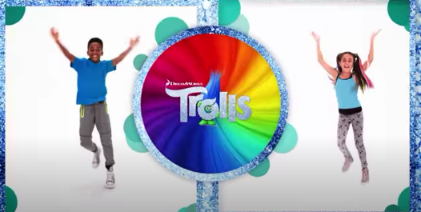
Monday Physical: Trolls- Can’t stop the feeling
https://youtu.be/KhfkYzUwYFk

Monday Literacy: News writing
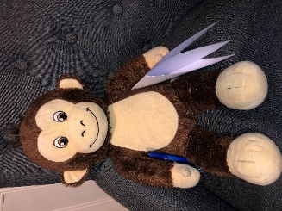
Today I would like you to write your news for Miss Hollings and Lucky to tell them all about what you have been up to during the weekend. They are very excited to hear about all your adventures. You could also write about what you are most looking forward to when we return back to school next week.
. Allow your child to mark make and explain what they are writing along the way, you can then scribe for them. It is important they are given this freedom to express themselves, their ideas and thoughts through mark making. Really focus on pencil grip, holding it between your fingers (tri-pod grip rather than full fist grip).
Questioning throughout is key i.e. Where did we go/walk to? What was your favourite part of the holiday? How did it make you feel? What did we see along the way? Would you like to go again? And why? etc

Monday Learning Challenge-
Today I would like you to create your own Greek Flag Collage. You can use lots of different materials for this, you don’t just have to colour it in.
Here are a few examples:
Pebbles
Tissue paper
Shiny paper and glitter
A really good one would be to use salt and then dye the salt with blue colouring.
I wonder what you will use.
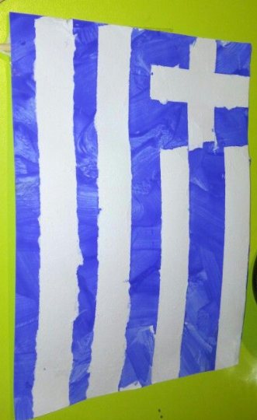
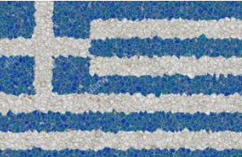
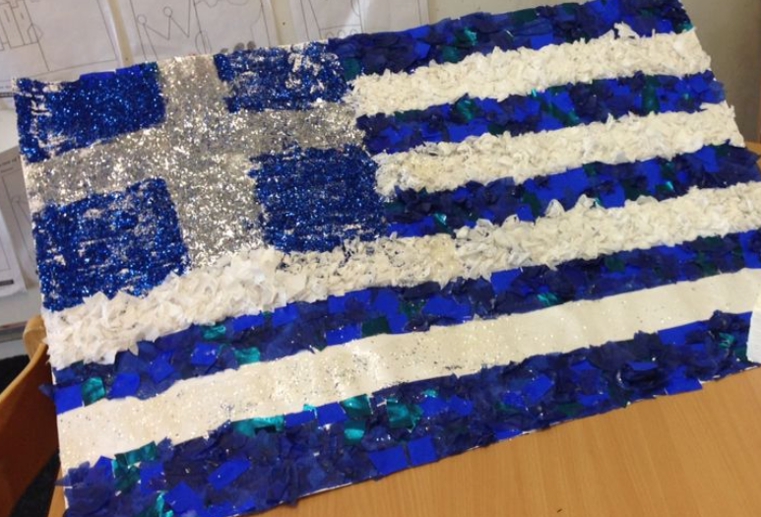

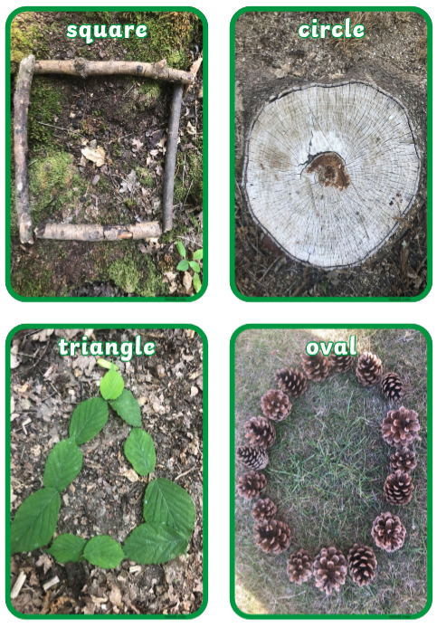
Tuesday Maths: Outdoor nature shapes.
Today I would like you to make nature shapes outside. Using natural materials. Here are some examples:

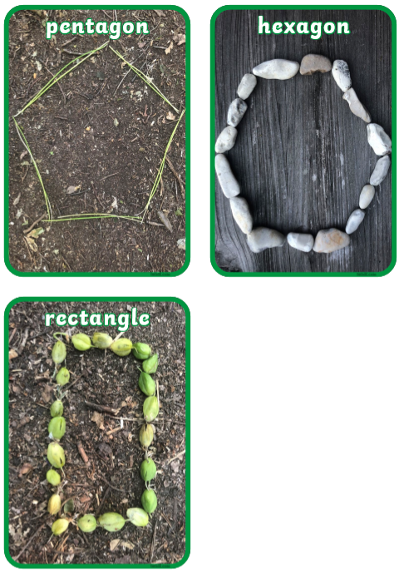

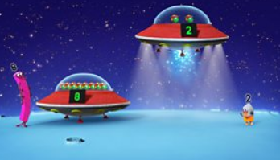
NUMBERBLOCKS:
https://www.bbc.co.uk/iplayer/episode/b08q3zx7/numberblocks-series-2-blast-off

Tuesday Phonics: Everybody do this, do this…

Everybody Do This This can be sung by the parent/ Adult e.g. “Everybody do this, do this, do this, everybody do this, just like me!”
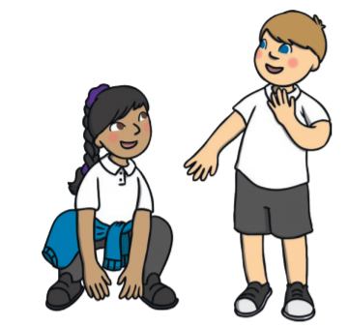
The adult then completes an action, for example, clapping their hands. This is then copied by the child. You can take turns in thinking up an action to complete. This game can be made easier by using a picture with actions on to support the verbal instruction given or to use as support in thinking of an instruction. The difficulty can be increased by giving more complex instructions e.g. “Touch your nose and then touch the floor.”

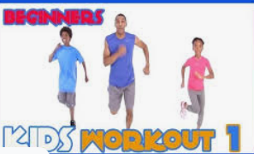
Tuesday: Physical:
Get fit with Maurice
https://www.youtube.com/watch?v=L_A_HjHZxfI

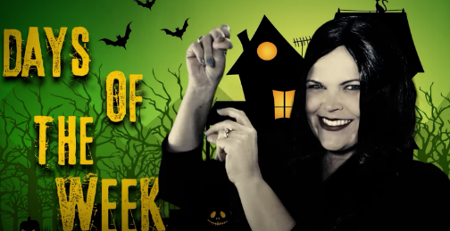
Days of the week song:
https://www.youtube.com/watch?v=8GKmCQOy88Y

Tuesday Literacy: Research
Today I would like you to conduct some research with your adult. Can you find me some information about Greek Gods? 2 facts about a god of your choice would be great.
Next I would like you to tell me:
What god would you be and what special powers would you have. Your adult can write this down for you, but maybe you could draw a picture
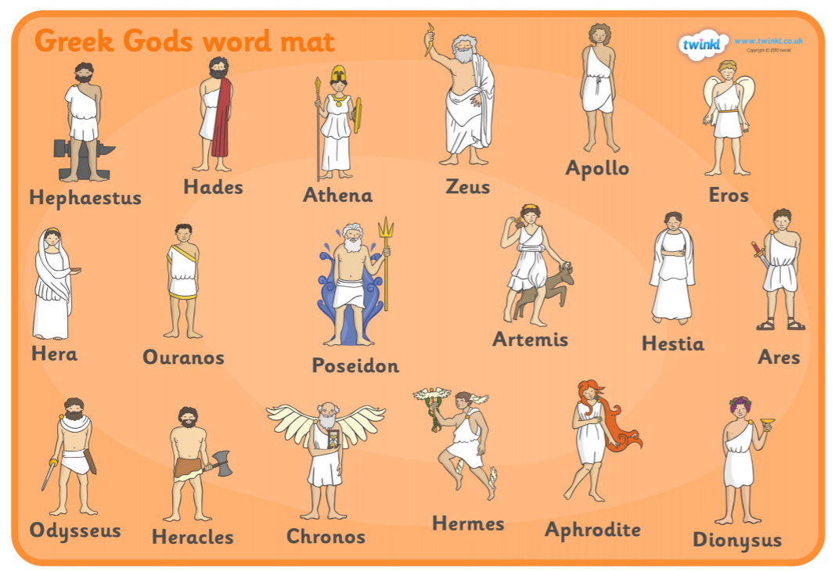

Tuesday- Learning Challenge:
After conducting your research I would like you to design and make, using junk modelling, your God (yourself) their very own Crown or Mythological object… or both if you wish
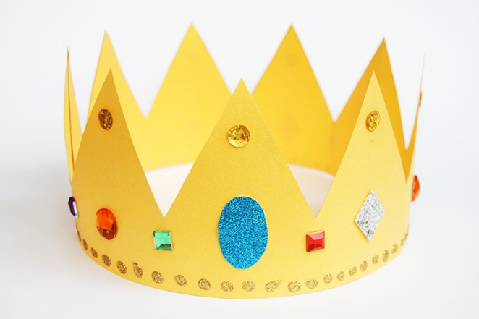
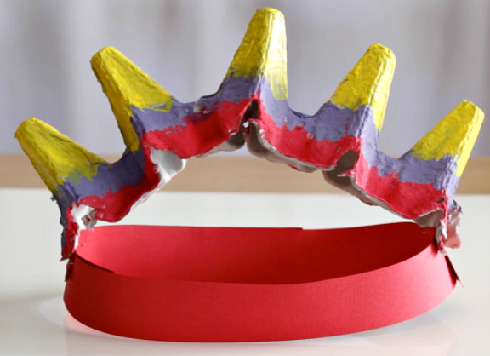

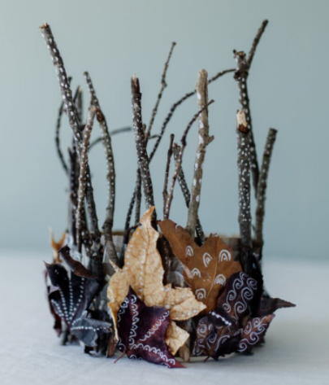

Wednesday Maths: What can you make using the different 2D shapes. Don’t forget to count the sides of the shapes and name them as you use them. Maybe you could make a house, a sunshine and a boat.

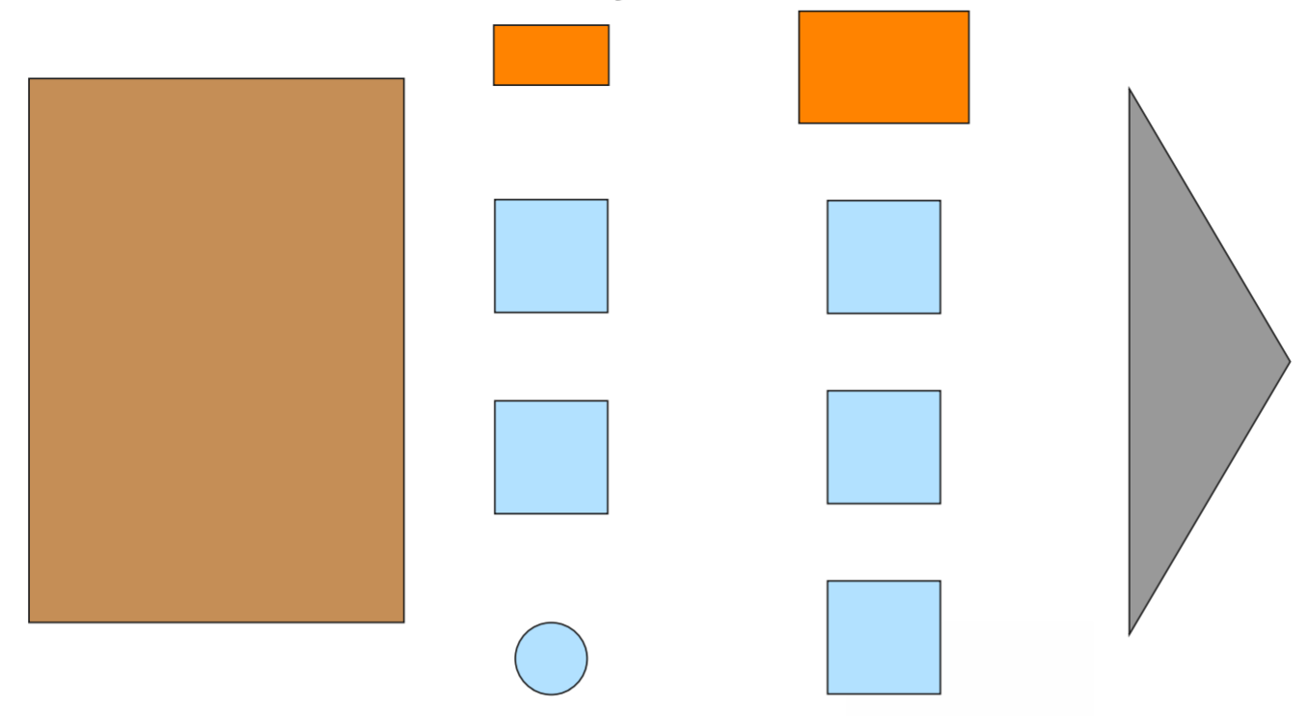

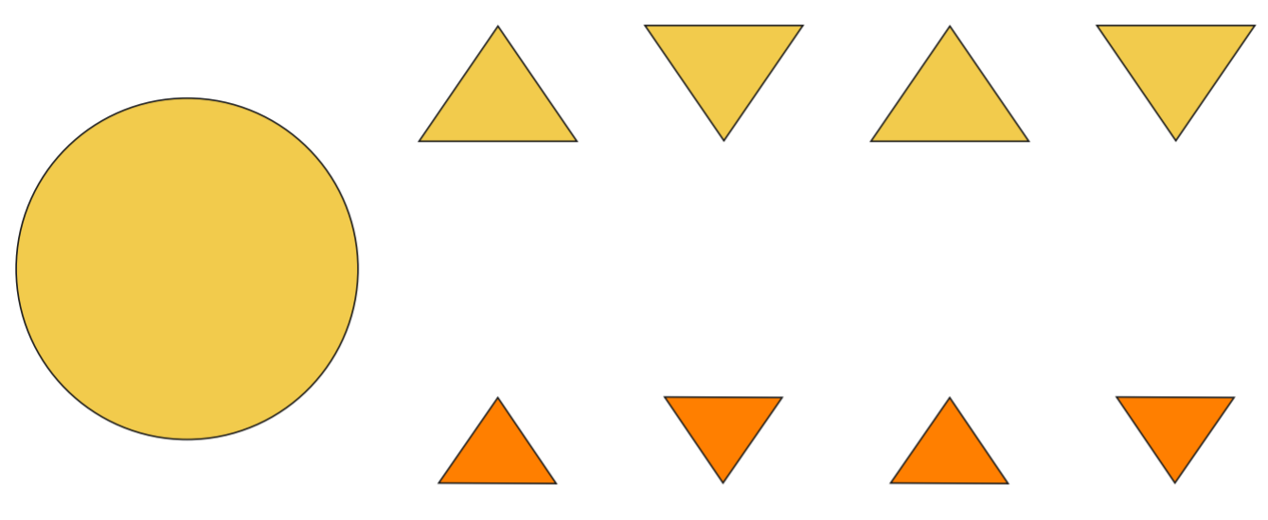

NUMBERBLOCKS
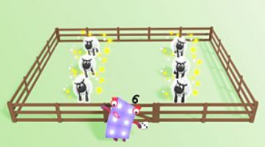

https://www.bbc.co.uk/iplayer/episode/b08q4g7y/numberblocks-series-2-counting-sheep

Wednesday Phonics: Listening Walk
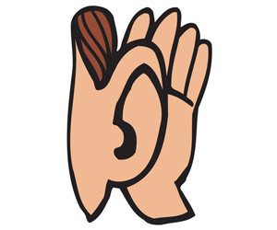
Today I would like you to go somewhere new/ different on your walk... Be creative/ imaginative.
Go on a listening walk. Walk around the park, river or street and listen out for sounds. What can you hear? Discuss with your adult all the different noises you heard.

Wednesday Physical: Dance Party
https://www.youtube.com/watch?v=6R0v0ovq1hs
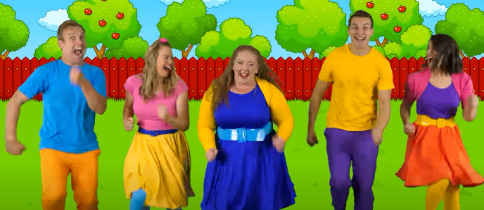

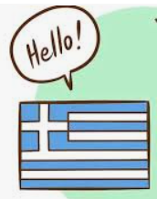
Wednesday- Literacy
Today I would like you to learn ‘Hello’ and ‘Goodbye’ in Greek. Once you have learnt these I would like you to video yourself saying these for Class Dojo. I am excited to hear your fantastic Greek accents

Wednesday- Learning Challenge- Greek Dish
Tzatziki: is made simply with yogurt, drained cucumber, olive oil, fresh herbs (usually mint or dill), garlic, lemon juice and salt. It’s a refreshing chilled sauce, dip or spread.
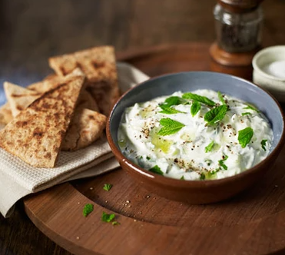
Ingredients:
- 2 cups grated cucumber (from about 1 medium 10-ounce cucumber, no need to peel or seed the cucumber first, grate on the large holes of your box grater)
- 1 ½ cups plain Greek yogurt
- 2 tablespoons extra-virgin olive oil
- 2 tablespoons chopped fresh mint and/or dill
- 1 tablespoon lemon juice
- 1 medium clove garlic, pressed or minced
- ½ teaspoon fine sea salt
Instructions:
- Working with one big handful at a time, lightly squeeze the grated cucumber between your palms over the sink to remove excess moisture. Transfer the squeezed cucumber to a serving bowl, and repeat with the remaining cucumber.
- Add the yogurt, olive oil, herbs, lemon juice, garlic, and salt to the bowl, and stir to blend. Let the mixture rest for 5 minutes to allow the flavours to meld. Taste and add additional chopped fresh herbs, lemon juice, and/or salt, if necessary (I thought this batch was just right as-is).
- Serve tzatziki immediately or chill for later. Leftover tzatziki keeps well, chilled, for about 4 days.
Great with:
- Toasted pitta wedges
- Crisp raw vegetables
- Olives
- Cheese and crackers

Thursday Maths: Shape printing.
Ask your adult to cut out sponges into different shapes (square, rectangle, circle, triangle etc), you might want to use other objects to.

Can you create a picture by printing? I wonder what patterns you can make.

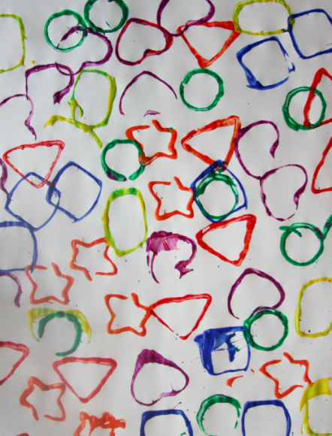
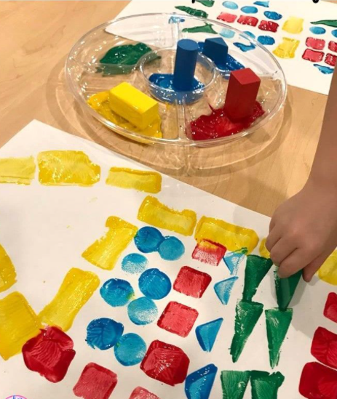

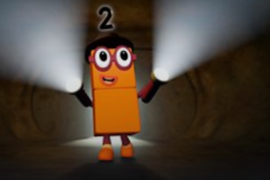

NUMBERBLOCKS:

https://www.bbc.co.uk/iplayer/episode/b08q4jkq/numberblocks-series-2-double-trouble
READ, READ, READ!!
Bedtime Story: Once tucked up in bed, read your teddy a bedtime story.

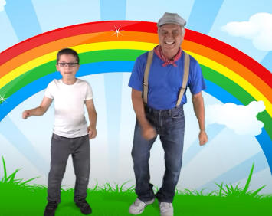
Thursday Physical: Shake your sillies out
https://www.youtube.com/watch?v=NwT5oX_mqS0

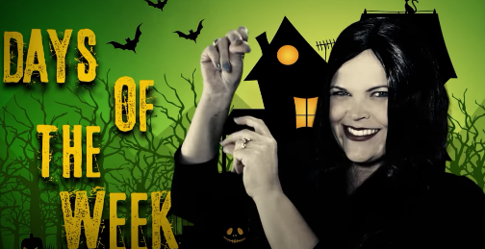
Days of the week song:
https://www.youtube.com/watch?v=8GKmCQOy88Y
Thursday Literacy:
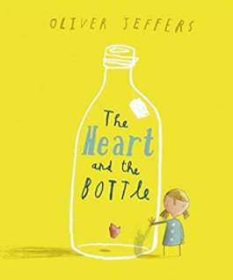
Can you tell a story to your teddy? Choose your favourite story and tell it to your teddy bears. Miss Hollings will be telling the story ‘The heart in a bottle’ By Oliver Jeffers… I wonder what you will read. Maybe your grown-up could record you doing this.

Challenge: Can you draw a picture about your book.

Thursday Phonics:
Roll a ball: You may find that a ball that makes a noise/lights up when you roll it is stimulating. This in turn can support their attention to the game.
This game can be played individually with a child or in a small group. In this game, the group members must look at the person they are rolling the ball to.
• Rolling the ball to each other
• Rolling the ball to each other saying, “I’m rolling the ball to...”
• When your child receives the ball, your child has to say, “My name is... and I like...”
• When your child receives the ball, your child has to name an animal, name a food item, name a mode of transport etc.
• As the adult you give your child an instruction, e.g. “Roll the ball to...”, “Roll the ball to someone wearing blue” or “Roll the ball to someone with brown hair”.

Thursday: Learning Challenge Salt dough pot
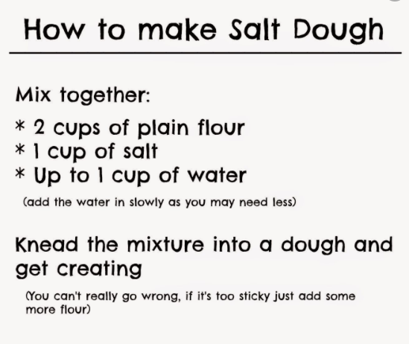
Today I would like you to make a clay (Salt dough) pot. Using the recipe, make you pot, it can be as big as you like and any shape. I also want you to add a pattern to your pot, like the ones below.
Once you have made your pot, cook it on a very low heat until it hardens. Once cooled you can paint your pot
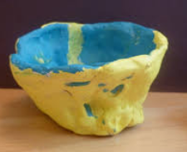
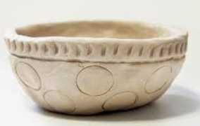
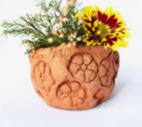

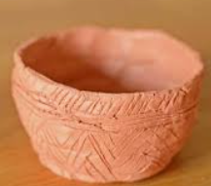

Friday Maths: Shape writing tray
Have a go at drawing all the different shapes you have learnt, using your finger in salt, sugar, sand, flour etc. It’s fun and messy . If you need some help ask your adult to draw them on a piece of paper first to help you. Don’t forget to discuss the different shapes, name them and talk about their different features.
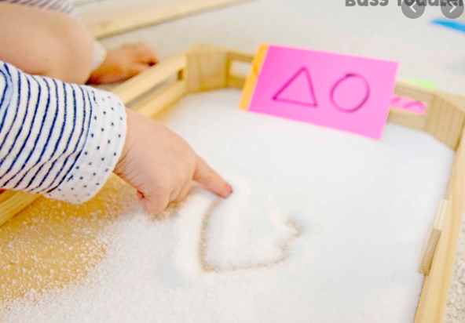
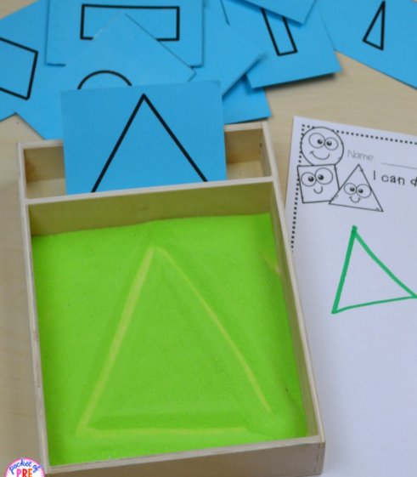

NUMBERBLOCKS
https://www.bbc.co.uk/iplayer/episode/b08q4mkf/numberblocks-series-2-the-three-threes

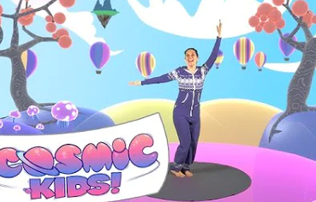
Friday- Physical- Cosmic Kids

https://www.youtube.com/watch?v=dtQ72qRpVVE

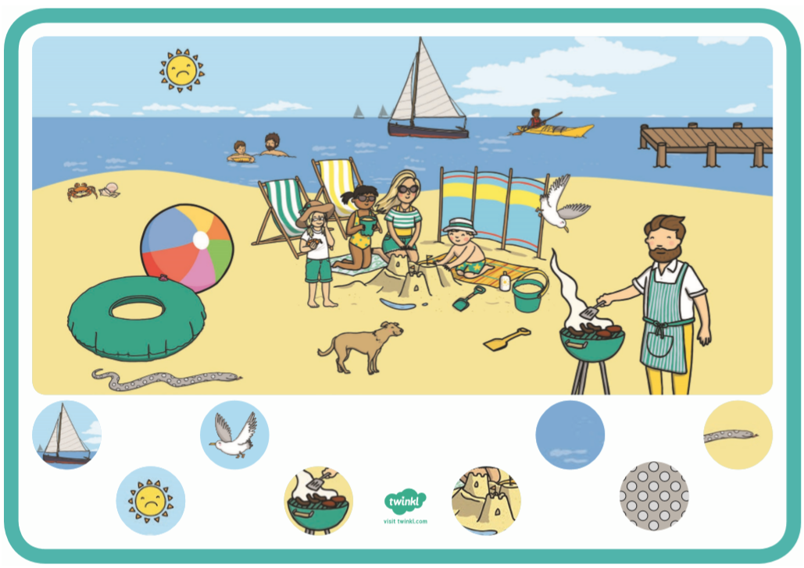
Friday Phonics: Can you find…

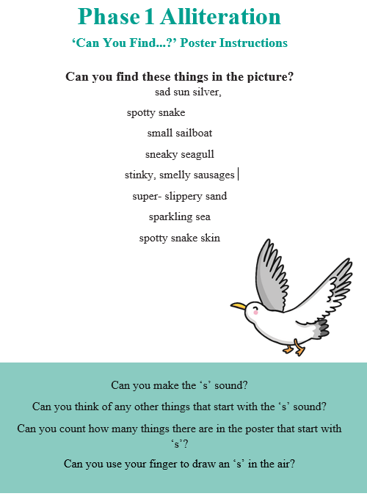

Friday Literacy:
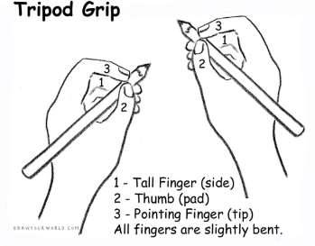
Name Writing: Please continue to recognise and practice writing your name (Please only use capitals for the first letter of each name). It is important that your child is able to recognise their own name before they begin to write it. Allow your child to use their name card to write practice writing their name. Your child’s name card is wipe-able so allow them to trace over the letters. They love using the whiteboards so let them write on them too Ensure your child is using the tripod grip.

Next I want you to colour in Greece, cut it out and stick it onto your Globe.
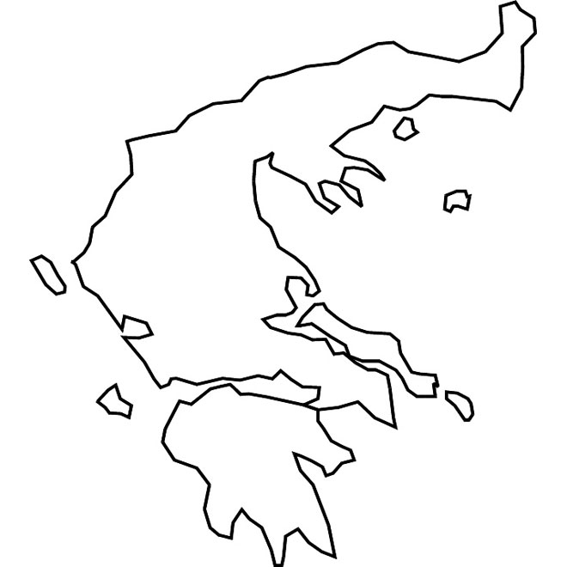
Friday Learning Challenge:

Create your own Olympic Games:

In this I want you to choose 5 sporting events that you are going to take part in

For example:
5X Star Jumps
5x sit ups
Jog on the spot for 20 seconds
5x push ups
5x squats

Next I would like you to take part in these activities with your adults, brothers, sisters etc… Who will win??

Maybe you could make some Flags for your Olympic games or a poster
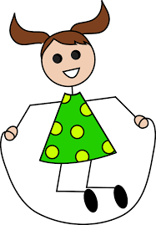
Don’t forget to take a video to put onto Class Dojo

