Version |  |  | 1.0
Date |  |  | September 2021
Approved by Board of Directors
Version | Date | Description |  | Revision author
1.0 | September 2021 |  |  | L Howard
2.0 | September 2023 |  |  | L.Howard

Beckfoot nessfield relationships, sex and health education policy

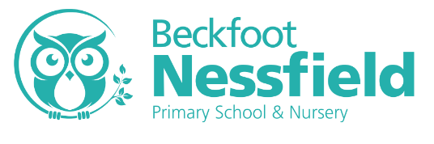

Relationships, Sex and Health Education Policy 2020

Our responsibilities as a school
This policy reflects the Beckfoot Nessfield Primary School aims for our pupils. We recognise that as a school we have a legal responsibility under The Relationships Education, Relationship & Sex Education and Health Education (England) Regulations 2019, made under sections 34 & 35 of the Children & Social Work Act 2017, to provide comprehensive Relationship Education and Health Education for all pupils receiving primary education.
We acknowledge that in order for children to embrace the challenges of creating a happy and successful adult life, pupils need knowledge that will enable them to make informed decisions about their wellbeing, health and relationships and to build their self-efficacy.
We understand that high quality, evidence-based and age-appropriate teaching of these subjects can help prepare pupils to develop resilience, to know how and when to ask for help.
As part of the Education Act 2002/Academies Act 2010 all schools must provide a balanced and broad based curriculum which promotes the spiritual, moral, cultural, mental and physical development of pupils at the school and of society, whilst also preparing pupils for the opportunities, responsibilities and experiences of later life.
We recognise that we have a responsibility under the Equality Act 2010 to ensure the best for all pupils irrespective of disability, educational needs, race, nationality, ethnic or national origin, sex, gender identity, pregnancy, maternity, religion, sexual orientation or whether they are looked after children. As a result RSE needs to be sensitive to the different needs of individual pupils and may need to adapt and change as the pupils of the school change. Not only does the teaching need to be sensitive of these needs, but also to help the pupils realise the nature and consequences of discrimination, teasing, bullying and aggressive behaviours or prejudice-based language.
Whilst as a school we are aware we need to be mindful of and respectful to a wide variety of faith and cultural beliefs, and we will make every attempt to be appropriately sensitive; equally it is essential that young people still have access to the learning they need to stay safe, healthy and understand their rights as individuals. This must include clear, impartial scientific and factual information on matters such as; naming their body parts, puberty, menstruation, the variety of family structures, gay marriage, gender identity and gender equality.
Schools should be alive to issues such as everyday sexism, misogyny, homophobia and gender stereotypes and take positive action to build a culture where these are not tolerated, and any occurrences are identified and tackled. Furthermore, all teaching should reflect the law as it applies to relationships, marriage, adoption and care. We acknowledge that all young people deserve the right to honest, open and factual information to help better form their own beliefs and values, free from bias, judgement or subjective personal beliefs of those who teach them.

How do we define relationships?
The Department for Education defines relationships education as, teaching the fundamental building blocks and characteristics of positive relationships, with particular reference to friendships, family relationships and relationships with other peers and adults. However, we believe comprehensive relationship education is designed to help children to develop the skills to recognise and manage healthy relationships both online and in the real world. It is designed to build self-esteem and to explore personal identity. It is about helping children understand and make sense of the world they are growing up in; to recognise the differences and similarities between their peers and their families; to understand the fact every human being is unique and has the right to be respected. There are many different family structures and all children have the right to feel safe. Comprehensive relationship education has been shown to help keep children safe by allowing them to understand appropriate and inappropriate touching, to realise that their body is fantastic and belongs to them. It is about building the foundations of an understanding of consent and personal boundaries; in that no one has the right to touch you in a way you don’t like but also the difference between public and private behaviours.
It is important for children to know the names and functions of their body and to be reassured it is natural to be curious about them. Indeed, by teaching children the correct terms for their private parts, children are proven to be safer from abuse. In addition, we believe comprehensive relationship education helps children to develop their vocabulary and emotional literacy to enable them to talk about and manage their feelings. It helps children build their own support networks and the confidence to ask for help when they feel unsafe. This is a required element of the Health Education Guidance.
Although The Relationships Education, Relationship & Sex Education and Health Education (England) Regulations 2019, made Relationship Education compulsory in all primary schools, Sex education is currently not compulsory. However, the Department for Education continues to recommend that all primary schools should have a sex education programme tailored to the age and maturity of the pupils. As set out in the guidance, it is up to individual schools to determine whether they need to cover any additional content on sex education to meet the needs of their pupils. We, like many other schools already choose to teach some aspects of sex education and will continue to do so. We recognise that some parents may be uncomfortable with the thought of their children receiving sex education in primary school. Equally, we recognise it is completely natural for children to have questions about sex, their bodies and to be curious about where they came from. In the age of information where children in primary school have access to the internet through mobile technology, we believe it is better that children receive age appropriate answers from us than it being left to their peers or the internet.
In our school, sex education is an opportunity to answer children’s questions about where they came from, an opportunity to explore their own stories and to be clear about how a baby is conceived and formed as set out in human life cycle set out in the national curriculum for science. Furthermore, it should ensure that all children are prepared for both the physical and emotional changes of puberty including menstruation. Children need to understand how both girls and boys bodies function and change as they grow into adults. We believe that sex education should allow children a safe space to ask the questions they may have without shame or judgement. Evidence states that a graduated age-appropriate spiral curriculum is the best way of preventing the topic of sex, reproduction and private body parts of becoming taboo and children from becoming embarrassed by the topic.
We believe it is the duty of our school to give our young people the learning that will enable them to live safe, fulfilled and healthy lives. This includes ensuring that they have the skills to keep themselves safe from harm and develop positive and healthy relationships, free from exploitation pressure or abuse.
Statutory and Non-Statutory Guidance
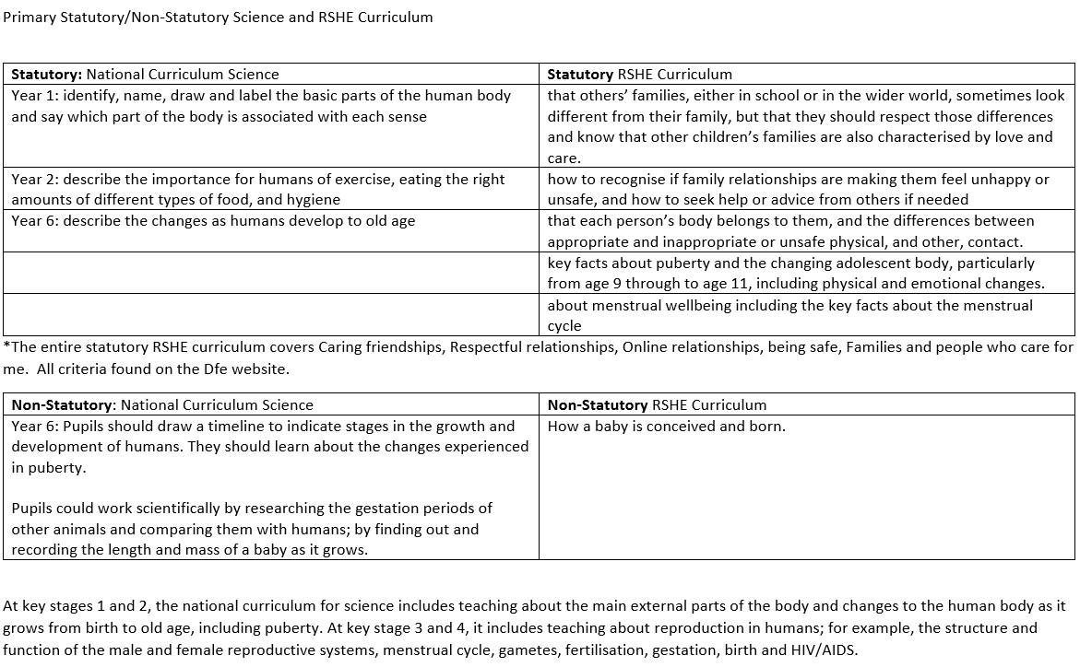
Our RSE Curriculum
In school we meet the learning objectives as set out in the Relationships Education, Relationship & Sex Education and Health Education (England) Regulations 2019 for primary schools with a whole school approach. Sex Education is taught discreetly in the Summer Term using the PSHE Association Programme of Study. This programme, identifies the key concepts and skills to be taught through PSHE education and a broad range of topics through which these can be developed, expanded and rehearsed.
Year 1 (Statutory)
Pupils may have been using a variety of different words to name the male and female genitalia/sex parts, but in Year 1 we teach the correct terminology (penis and vagina). It is important for younger pupils to know how to name their body parts correctly as this contributes to safeguarding—helping them to take care of their bodies and keep themselves safe. This is built on later in key stage 2, when pupils learn about puberty and the changes when growing from children to adults. It is suggested that this lesson is taught within the context of other learning about similarities and differences (e.g. growing and changing, people and animals).

Year 5: Puberty (Statutory)
Time to change: The first lesson focuses on some of the external changes that happen to the body such as menstruation, menstrual wellbeing, erections and wet dreams. The second lesson focuses in more detail on some of the external and internal changes that happen to the human body.
Personal hygiene: This lesson helps pupils to recognise the importance of personal hygiene during puberty, and to consider some of the questions young people may have about the physical changes at puberty.
Emotions and feelings: This lesson focuses in more detail on some of the emotional changes that may take place during puberty and outlines some of the changes that may occur in friendships and other relationships. It teaches pupils where and how to get help and support.
Year 6: Puberty (Statutory)
Change and becoming independent: This lesson extends pupils’ thinking about puberty and the concept of change throughout our lives. It explores in more detail, some of the feelings associated with change. It helps pupils to consider changes that might occur alongside puberty, including moving to secondary school and the new roles and responsibilities that this might bring.
Positive, healthy relationships: Increasing pupils’ understanding of what is meant by a positive, healthy and loving relationship is an important part of safeguarding their health and wellbeing. This lesson looks at different kinds of relationships, and the values, expectations and responsibilities within healthy, positive relationships. The lesson also explores some ways that changing relationships can be managed—ensuring behaviour is respectful, even when things do change.
How babies are made (Non-Statutory)
By year 6, it is likely that pupils will have some idea about how babies are made through sexual intercourse. Although it is possible they may have some misconceptions, very few pupils will still believe myths or make-believe stories. Having an understanding of what is meant by sex is an important foundation for the RSE they will receive at secondary school. This lesson emphasises that having sexual intercourse or the decision to have a baby is something for when they are much older. It also emphasises the importance of consent in this context. The lesson enables pupils to reflect on the values and responsibilities within healthy adult relationships and is therefore set clearly within RSE— as part of the wider PSHE education curriculum
A whole curriculum approach to RSE will also be covered in computing lessons. This will include teaching pupils how to be safe online, and about cyberbullying. There will be coverage of RSE in other areas of the curriculum where appropriate.
Answering Children’s Questions:
1. We are aware that children are likely to have many questions that may occur at any time. Children tend to ask whatever is on their mind. We see this as a positive point and a sign that we have created a safe environment where children feel empowered to feed their natural curiosity and learn about themselves, their bodies and the world around them. However, we acknowledge that some parents may feel uncomfortable about how particular questions may be dealt with in class.
2. We believe children are better off receiving honest, open answers from safe adults in their lives, rather than it being left to the internet or older children with a smart phone. In the age of information, where children in primary have access to tablets, smart phones and the internet (often unsupervised) it is essential that we help children to recognise they are able to ask questions without judgement rather than searching for answers on the internet.
3. By tackling the topic in a matter of fact manner, without embarrassment means that we take the mystic allure out of the topic, making sex no longer the secret taboo. However uncomfortable a proposition that may be, it is far better than the alternative. For children these questions are not rude, they are simply signs of a healthy and natural curiosity. We can stop the topic becoming taboo and embarrassing and removing the stigma before it has had chance to form.
4. We believe that if children ask a question they deserve an answer. If ignored they merely build unnecessary barriers, making children think they have done something wrong; they are unlikely to ask again, and are instead left to seek their answers from less reliable or child friendly sources, due to shame. However uncomfortable the question may be, the thought is already in their head. It is much better that we, as safe adults, take responsibility and tackle the question safely and age appropriately.
5. Staff have received training as to how to deal with children’s questions age appropriately. This will be done consistently across the school as follows:
- Children will be praised for asking questions. We wish to encourage children to seek answers from safe adults.
- If a question is relevant to the whole class, we will answer it to the whole group.
- However, as with any other subject, there may occasionally, be the need to differentiate depending on children’s knowledge and experience. Some children may need additional information or support compared to others.
- If a child asks a question that is not necessarily suitable for the entire class, we will respond, by saying: “that is fantastic question, hold that thought, I am going to set everyone some work and I will come and talk to you and answer your question in a minute when everyone else is working.”
- If the member of staff doesn’t have an answer or doesn’t know, they will say so. There is no shame in not knowing the answer but the member of staff should make an effort to help the child to find the answer later.
- If the member of staff is not sure how best to answer a particularly tricky question, our suggested response is: “That is a brilliant question, I would like to give you an equally brilliant answer, so let me have a think about it and once I know the best way to explain it clearly I will come back to you”
- This will allow teaching staff time to think, seek help, advice or support from colleagues, or to speak to senior management.
- If a child asks a question we know parents may be uncomfortable with, staff may choose to delay answering the question (as above) until they have spoken to the parent/carer if possible and talk through their response.
- Teachers will answer questions, openly, honestly, scientifically and factually without relying on their own personal beliefs. Teachers will not be expected to answer personal questions about themselves or to ask direct personal questions of their students that could make either parties vulnerable.

Parents and parental rights to withdraw:
We believe that successful teaching around RSE can only take place when parents and school work together. Especially as we both want children to grow up safe and happy in healthy relationships, with the ability to manage their emotions and speak up when they feel unsafe. Therefore, we are committed to working together with parents. We endeavour to be transparent and give parents information about all the programmes and lessons we deliver around RSE as we recognise it can be a sensitive subject for some families for a number of reasons. We recognise the importance of parents knowing about the content of the lessons so they can carry on the conversations at home and have an opportunity to talk to their children about their own families, beliefs and values. We recognise under the new draft guidance for Relationship Education, Relationship & Sex education and Health Education (DfE 2018), parents retain the right to request their child is removed from some or all of the elements of sex education which go beyond the national curriculum for science. Maintained schools are required to teach about the main external body parts and changes to the human body as it grows from birth to old age, including puberty. There is no right to withdraw from the national curriculum. Should a parent decide that they do not wish their child to take part in lessons, we would ask that they first speak to their classroom teacher to discuss their concerns. Our teachers will happily show parents all the teaching material and context of any of our lessons and explain the reasons why any material is included in the programme. We will also highlight that whilst parents have the right to withdraw their child from these lessons, they do not have the right to withdraw other children from receiving these lessons. We believe it is better for children to hear from safe adults than to hear second hand from their class-mates at break-time. If parents do decide to withdraw their child, they should inform the head who will find other provision for the child to engage in during the lesson.

Policy on Menstruation
We recognise that the onset of menstruation can be a confusing or distressing time for children if they are not prepared. As a school we acknowledge we have a responsibility to prepare children for menstruation and make adequate and sensitive arrangements to help children manage their period. Especially children whose family may not be able to afford or will not provide sanitary products. We recognise that period poverty exists in the UK and that some children are forced to avoid attending school if they are on their period, when they are unable to manage it sensitively. We do not want that to be the case in our school and will make every reasonable effort to support children to access their education and enjoy school.
Puberty is occurring earlier than ever before, and it is now not uncommon for children to start their periods whilst in primary school even in year 5. For this reason we deliver puberty lessons to all children in year 5 & 6. As part of these lessons children will be told about menstruation and there will be discussion of what periods are, explanation of other symptoms associated with periods, how they can be managed hygienically, and sensitively. Menstruation in a healthy biological function for 50% of our school. It should not be something that a person is made to feel embarrassed, shameful or be teased about. As a school we need to treat each other with respect and empathy and this includes changes that take place during puberty such as menstruation. During lessons where puberty and menstruation are discussed, we will take the opportunity to highlight the location of sanitary bins available in school, and how these are to be used. In school we have a menstruation kit available in school, which contains sanitary products, spare underwear and plastic bags to wrap up underwear should there have been any accidents. Children will be made aware of where these are kept and how they can be accessed through designated members of staff, including lunchtime supervisors. When school trips or residential visits are arranged for years 4, 5 &6 provisions to deal with a child’s period needs to be considered and added to the risk assessment and planned for.

Safeguarding Children
When teaching any sensitive topic, such as RSE which deals with family life, safe and appropriate touching, personal body parts and healthy relationships, we recognise the potential to uncover incidents of abuse through children’s disclosures. All members of staff who deliver any of our Relationship or Sex Education Programme, have statutory training around safeguarding children and are all aware of our school’s safeguarding policy and procedures in the case of a disclosure or suspicion of a safeguarding concern. It is our practice to review safeguarding procedures in team meetings before either programmes are delivered. Furthermore, if relevant, there may be conversations around protecting and supporting children for whom some of this work may make them vulnerable due to previous safeguarding concerns, past child protection investigations, ongoing concerns or changes in family or living situations if these may be triggered by scenarios or topics in their planned lessons. We recognise that for children who may be vulnerable due to past or present abuse or changes in family situations, this type of work, whilst it may be sensitive, there may be needs to adapt the programme or offer additional support. It is also a protective factor in preventing further abuse, to help them make sense of their experiences and essential to help them develop skills and resilience to keep them safe in future.

