Week Commencing 18/1/21
Hello,
I hope you are keeping well. Here is Pack number 2
In this pack you will find ideas, activities and resources that will help you to support and continue educating your children at home.
As you will be aware in Nursery we aim to support and develop children’s play and learning. We allow the children to develop with their own initiative and learn at their own pace. We do this through stimulating and fun activities, which promote all areas of a child’s development.
This week we are continuing our ‘Why is it always cold in winter’ topic. This topic will enable children to explore the natural world around them, focusing on the weather and how we can keep warm, water safety, what can we do with water and the different animals we might see in winter.
Here are some activities for you to have a go at during your time at home. I have split them up into days and done a timetable for you to follow. Miss Hollings will also be setting daily challenges on class dojo so make sure you look out for them. .
If you need any help or advice please contact me via the class dojo. I am more than happy to help.
Useful websites:
Twinkl https://www.twinkl.co.uk/
Phonics play: https://www.phonicsplay.co.uk/
Username: March
Password: home

CBeebies: https://www.bbc.co.uk/cbeebies

BBC Iplayer: https://www.bbc.co.uk/iplayer

Youtube
Topmarks: https://www.topmarks.co.uk/
Crickweb: http://www.crickweb.co.uk/
Oxford Owl: https://www.oxfordowl.co.uk/for-home/
Letters and Sounds: http://www.letters-and-sounds.com/

Thank you
Miss Hollings

Timetable:
Elm Class
Friday:
- Maths- Number blocks ordering
- Phonics- Challenge
- Literacy- Squishy Bag
- Creative – Baking Brownies
- Physical- Cosmic kids Yoga

Thursday:
- Maths- Number Formation and singing
- Phonics- Alliteration
- Literacy- Playdough Writing
- Creative – Collage
- Physical- Freeze Dance

Wednesday:
- Maths- Number line writing to 5
- Phonics- Bingo
- Literacy- Diary Writing
- Creative – Winter wonderland with playdough
- Physical- Dance and brain songs

Tuesday:
- Maths- Matching
- Phonics- Listen and Play
- Literacy- Finger painting
- Creative – Ice painting
- Physical- Snow Ninja Challenge

Monday:
- Maths- I spy number 5/ Number writing to 5
- Phonics- Follow the leader
- Literacy- Name writing
- Creative – Make your own playdough
- Physical- Penguin Dance

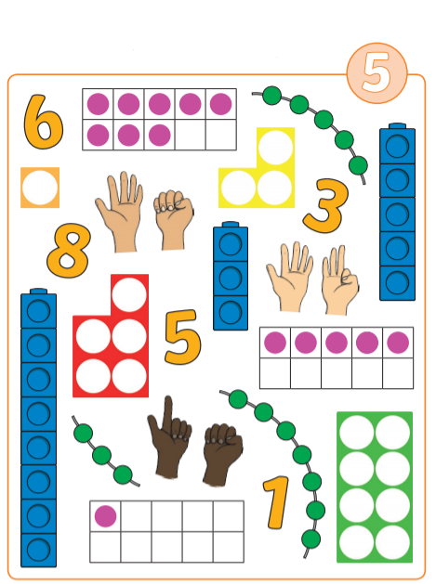
Monday Maths: I spy- can you find all the items that represent number 5?

Challenge: Practice writing your numbers 1 to 5 independently.
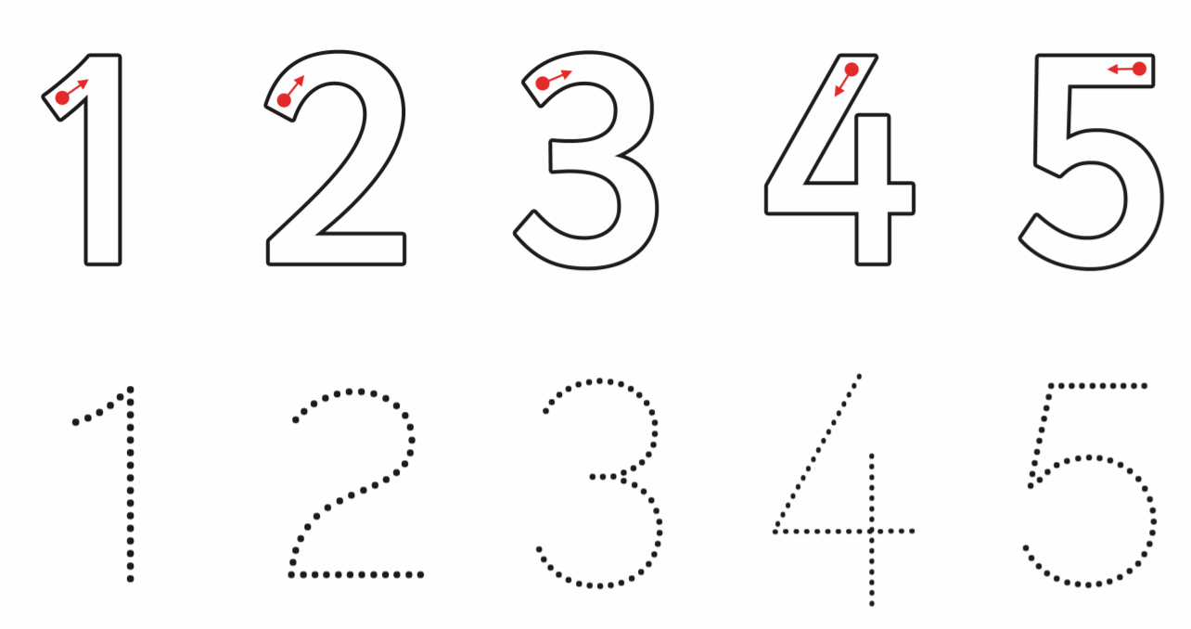

NUMBERBLOCKS! https://www.bbc.co.uk/iplayer/episode/b08bzzns/numberblocks-series-1-one

Monday Phonics:
Follow the leader: Play follow the leader with your family. One person chooses a body percussion (for example patting their knees, clapping their hands or clicking their fingers), the rest of the family have to copy them. Take turns to be the leader. Maybe you could count the claps etc along the way.

Monday Literacy:
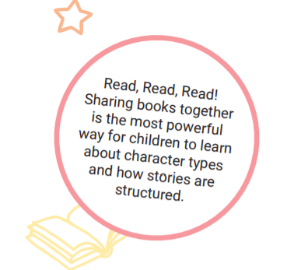
Name Writing: Please continue to recognise and practice writing your name (Please only use capitals for the first letter of each name). It is important that your child is able to recognise their own name before they begin to write it. Allow your child to use their name card to write practice writing their name. Your child’s name card is wipe-able so allow them to trace over the letters. They love using the whiteboards so let them write on them too

READ, READ, READ!!!!
Choose your favourite story to read with your adult. Once you have read the story use the pictures to retell the story to your adult.

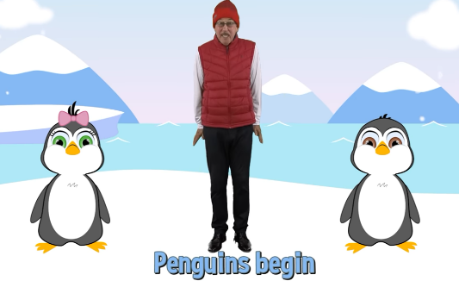
Monday Physical:
Penguin Dance and song- https://www.youtube.com/watch?v=uf0uKmKwnKs

Monday Creative:
DIY Playdough
You’ll need:
- 1 cup flour
- ½ cup table salt
- 2tbsp cream of tartar
- 1tbsp oil
- 1 cup boiling water
- Food colouring (Winter colours- blue/ white/ glitter)
Instructions:
- In a bowl, combine the flour, salt, cream of tartar. Mix well.
- Add the oil
- Mix a few drops of food colouring into the boiling water and add to the bowl.
- Mix everything very well and massage with your hand until it is no longer sticky.
Make sure you keep the playdough as this will come in handy later in the week

Tuesday Maths: Practice writing your numbers 1 to 5, then find and cut out the numicon which represents the number and match it to the numeral.

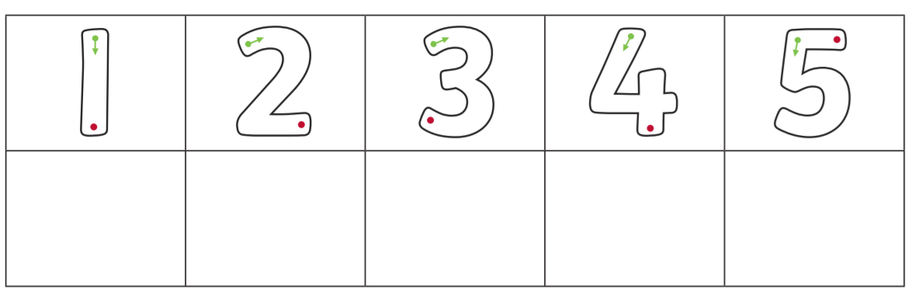

Challenge: Find 5 items in your house that are blue.
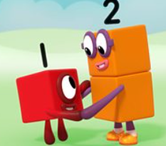
NUMBERBLOCKS: https://www.bbc.co.uk/iplayer/episode/b08bzgt8/numberblocks-series-1-two

Tuesday Phonics:
Listen and play:
Using a small set of instruments and noise makers. Play a sound for the other person to copy. Try creating loud and quiet sounds and some simple sound patterns. Remember, you need to listen carefully so you can copy the sound correctly. Don’t worry if you don’t have any instruments, you could always make your own, like a simple shaker!

Tuesday Literacy: Paint Writing
Finger print your name- If your child knows the letters that make up their name, allow them to do this independently, if not, let them use their name card to support them. As adult support use your own finger to go over the letters of their name demonstrating the correct way to write them.

Tuesday- Creative:
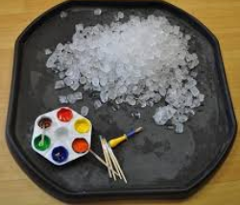
Ice cubes are a fun alternative surface to paint on! Provide your child with ice and some ready mixed paint and some paintbrushes. Allow your child to watch and explore as the colours run and mix together as the ice cubes melt.
It might be useful to do this on a large tray, tuff tray as it can get quite messy

READ, READ, READ!!!
Please sign up to https://www.oxfordowl.co.uk/for-home/find-a-book/library-page It’s FREE!!
You will be able to access a wide range of books to read with your child. Miss Hollings uses this a lot

Cbeebies bedtime story/song- Walking in a winter wonderland with Gregory Porter
https://www.bbc.co.uk/iplayer/episode/m000crs7/cbeebies-bedtime-stories-734-gregory-porter-walking-in-a-winter-wonderland

Tuesday: Physical
Snow Ninja Challenge - Virtual Winter Workout (Get Active Games)
https://www.youtube.com/watch?v=tusmvHX-sIE

Wednesday Maths: Make your own Number line to 5. Make sure you put the numbers in the correct order before you stick them on your number line.

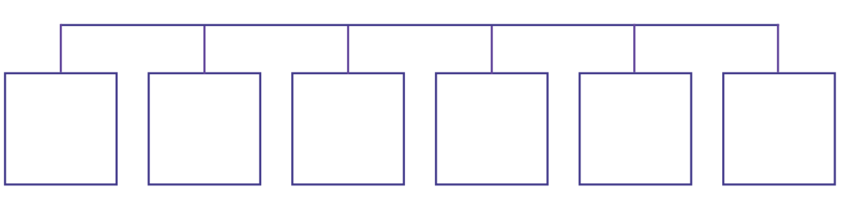

CHALLENGE

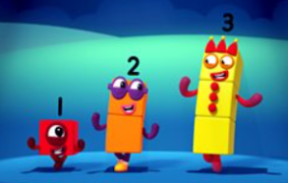
NUMBERBLOCKS
https://www.bbc.co.uk/iplayer/episode/b08bzgxx/numberblocks-series-1-three

Wednesday Phonics:
Each player needs a bingo card. Encourage your child to identify the pictures on their board.
Talk about the pictures and identify the rhyming words. Place the smaller rhyming bingo
Pictures into a bucket (ensuring you choose the ones that are on the bingo cards you are playing with) and explain the game to your child.

Pass the bucket around the circle, singing the rhyme:
Take the bucket and pass it round, pass it round, pass it round
Take the bucket and pass it round, stop- it’s your turn now.
When the rhyme ends, whoever is holding the bucket chooses a card and looks to see if it matches a picture on their board. If it does, they place the card onto their board and say the word. If it doesn’t match their rhyme family then they put the card into the middle of the circle.

(Pictures for your bucket)
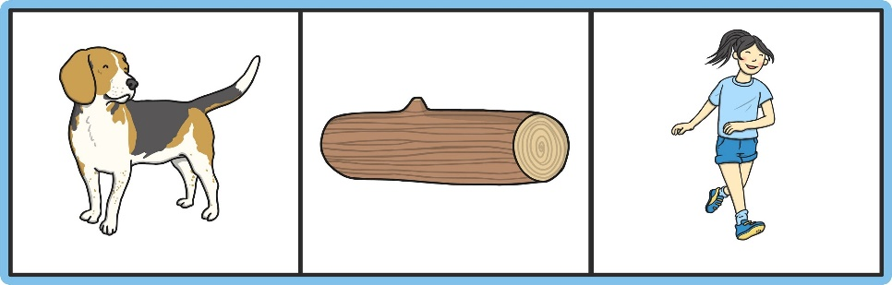

Wednesday Literacy

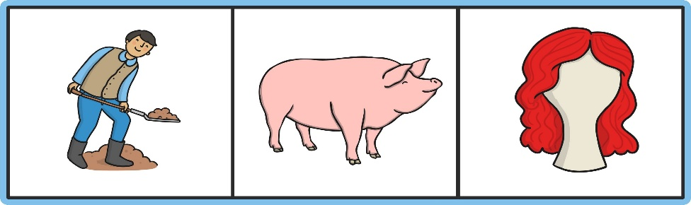

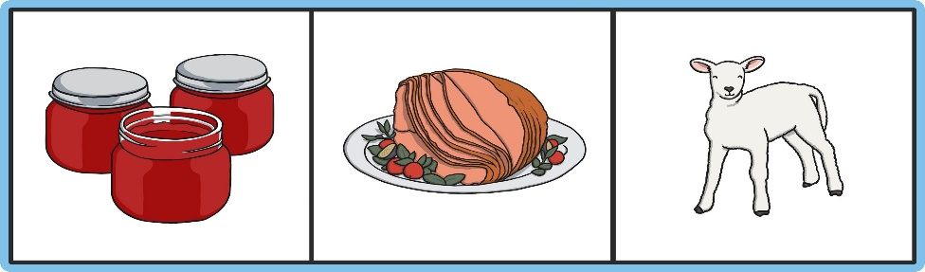

(Bingo Playing Mats)
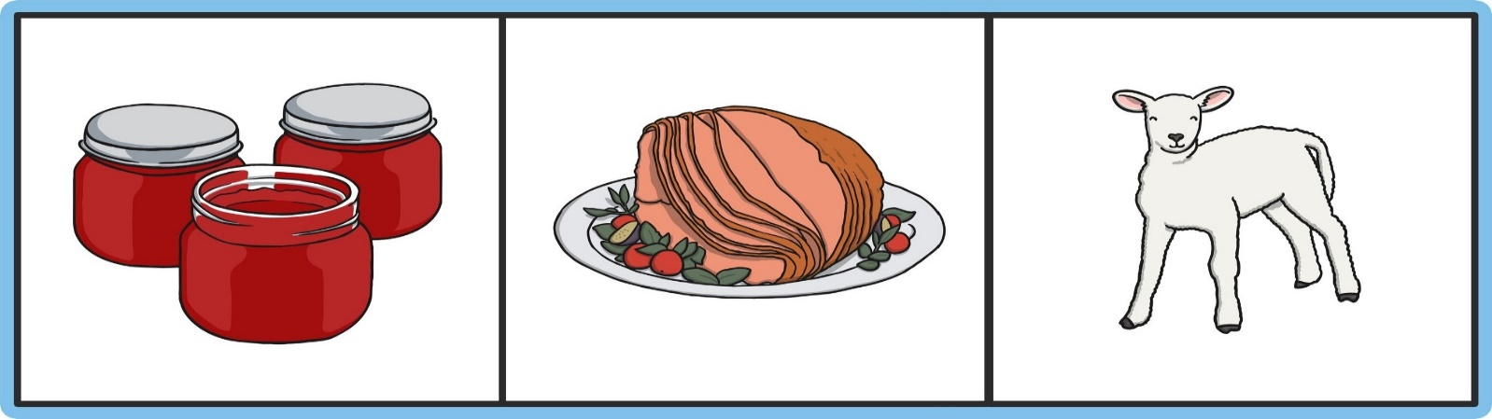

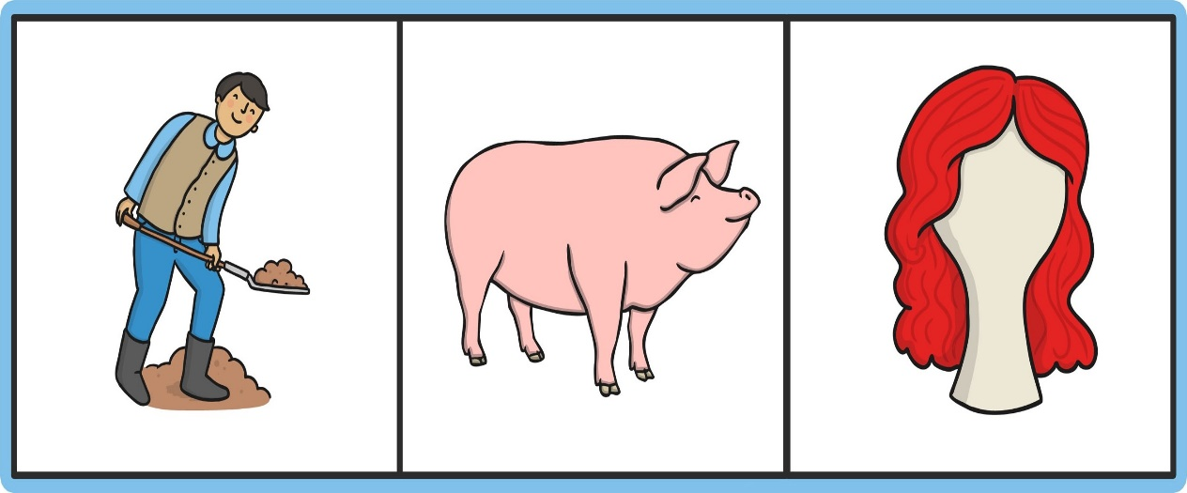

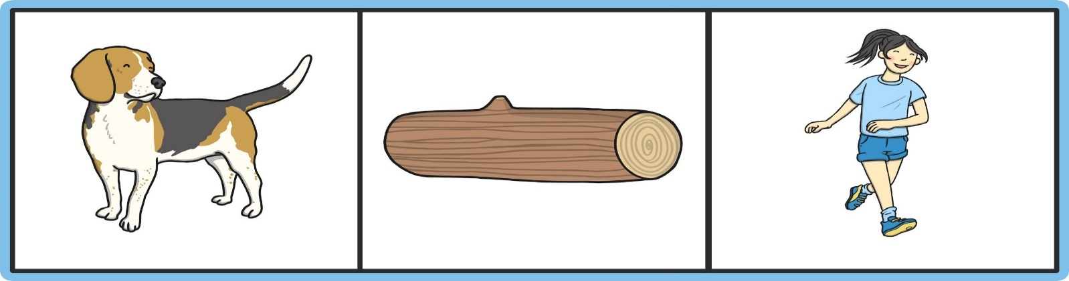

Wednesday- Literacy:
Diary writing
I would like you to start a diary with your child. Today I would like you to write about what you did on Tuesday? Can you write about it and draw a picture. I wonder what you had for lunch and where you went on your walk. Maybe you spoke with a family member on the phone.
I appreciate your child can not write a sentence however allowing them to mark make for a purpose is a great way to allow them to share their own thoughts, feelings and ideas. Let your child mark make and then ask them to tell you to read back what they have written and you can scribe.
Questioning throughout is key i.e. Where did we walk to? What was your favourite part of the day? How did it make you feel? What did we see along the way? Would you like to go again? And why?

Wednesday- Creative-
Using the playdough you made on one Monday- create a magical winter wonderland with snowmen. Don’t forget to add some winter animals too
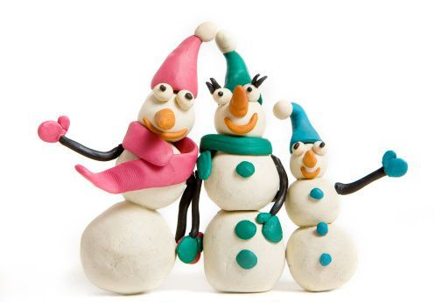
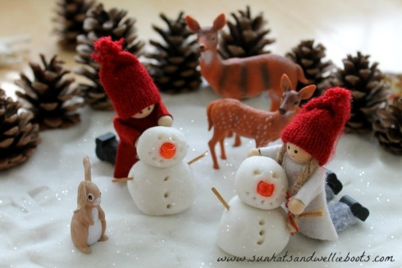
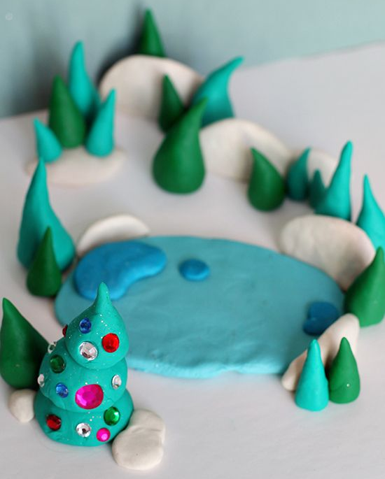

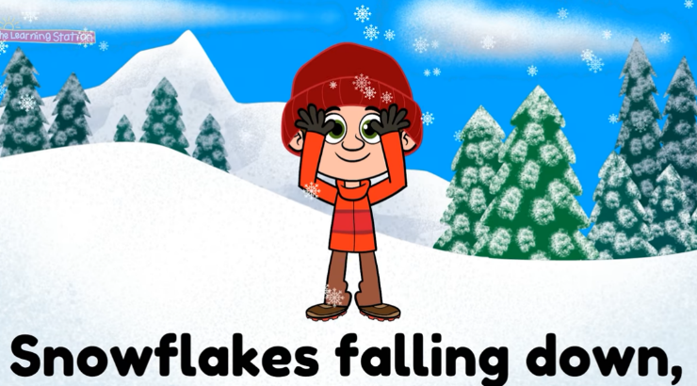
Wednesday Physical:
Dance & Brain Breaks Songs for Kids ♫ Snowflakes Song ♫ Kids Songs by The Learning Station- https://www.youtube.com/watch?v=uY3w_v6Ua9U

Thursday Maths: Number formation. Using your whiteboard and pen from your resource pack, practice writing your numbers to 5.

♪ Practice singing: https://www.youtube.com/watch?v=9ir_l7qTiZ4. Make sure you use your fingers to represent the numbers ♪

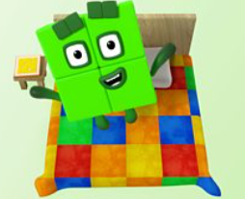
NUMBERBLOCKS:

https://www.bbc.co.uk/iplayer/episode/b08d61cv/numberblocks-series-1-four

Thursday Phonics:
Alliteration:
Make your own tongue twisters using lots of words that start with the same sound. Make sure your adults writes it down so you can share with your friends when we are back in school. Maybe you could write one using your name. Miss Hollings has done one for her children as an example for you Enjoy!
Oscar ostrich often offers olives to others
Hungry Harley had hiccups

Thursday Literacy:
Write your name using playdough. Use the playdough to create the different letters of your name. Don’t forget to take a picture.

READ, READ, READ!!
Bedtime Story: Once tucked up in bed, read your teddy a bedtime story.

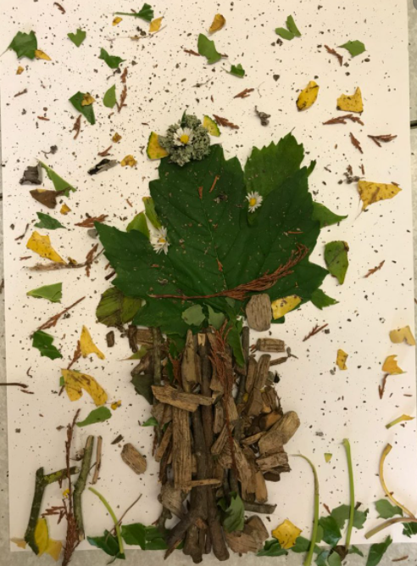
Thursday: Creative
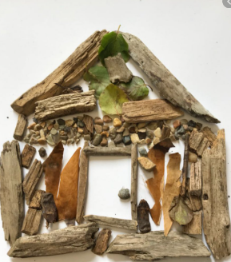
On your walk today I would like you to collect natural items along the way… stones, leaves, grass, twigs, flowers etc.

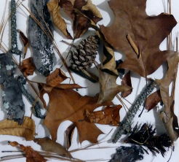
When you return home, I would like you to make me a collage using all your natural materials. Don’t forget to send Miss Hollings a picture of your picture

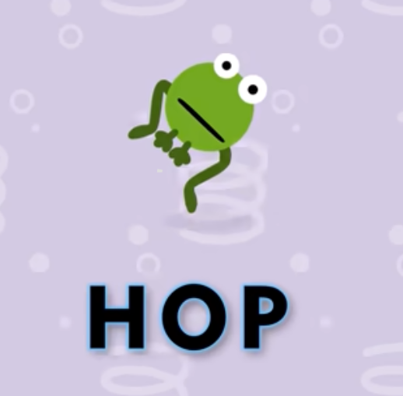

Thursday Physical:
Freeze Dance
https://www.youtube.com/watch?v=A1vdKfXlB_g
Friday Maths:
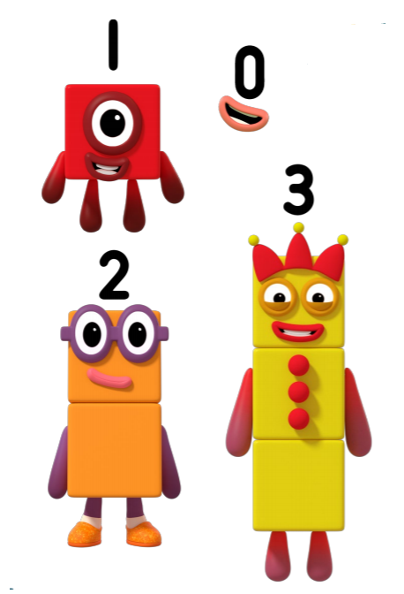
Cut out and order the numberblocks in order.

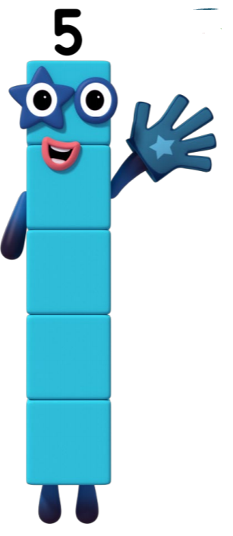

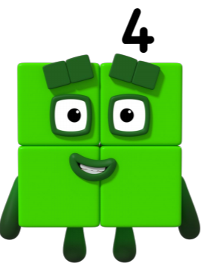

NUMBERBLOCKS
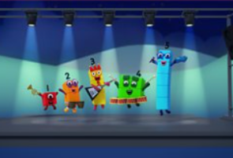
https://www.bbc.co.uk/iplayer/episode/b08d630h/numberblocks-series-1-five
Friday Phonics:
CHALLENGE!!
Ask a grown up at home if they can remember any playground clapping games from when they were at school? Can you learn one ready to show your friends when we are back in school?

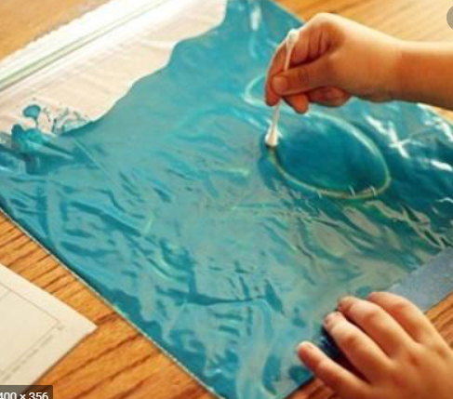
Friday Literacy:
Squishy bag
A tactile/ multisensory approach to pre-writing skills and writing skills.

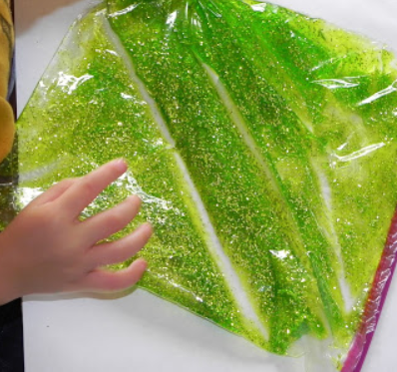
What you need:
-Gallon size Ziploc bag
-Glitter (optional)
-Food colouring
-Hair Gel/ Conditioner

Instructions: (You child can do this themselves with support)
-Squeeze in the hair gel (the entire bottle)
-Add food colouring
-Add glitter
-Mix it all together, put it on a piece of white paper, and start writing.

READ, READ, READ!
Bedtime Story- Snowball
https://www.bbc.co.uk/iplayer/episode/m0001vyb/cbeebies-bedtime-stories-678-jodie-whittaker-snowball
Friday: Creative
Chocolate Brownies (we all know how much Miss Hollings’ LOVES chocolate)!
Ingredients:
- butter 100g, chopped
- dark chocolate 200g, chopped
- eggs 4
- golden caster sugar 250g
- plain flour 100g
- baking powder 1 tsp
- cocoa 30g

BROWNIE VARIATIONS
- white or milk chocolate chunks 100g, chopped
- hazelnuts 100g, toasted, roughly chopped
- baby marshmallows 2 handfuls

Instructions:
STEP 1: Heat the oven to 180C/fan 160C/gas 4.

STEP 2: Line a 22cm square brownie tin with baking parchment. Melt the butter and chocolate together in a microwave or in a bowl set over a pan of simmering water. Cool to room temperature.

STEP 3: Whisk the eggs and sugar together until the mixture is light and fluffy.
STEP 4: Fold the chocolate mixture into the egg mixture and sift on the flour, baking powder and cocoa.
STEP 5: Fold this in to give a fudgy batter.
STEP 6: (To ramp it up, add 100g chopped white or milk chocolate chunks OR 100g toasted, roughly chopped hazelnuts or pecans OR 2 handfuls of baby marshmallows.)
STEP 7: Bake for 25-30 minutes or until the top is cracked but the middle just set. Cool completely, then lift out of the tin and cut.

Friday- Physical
https://www.youtube.com/watch?v=k71xY0hgZJU

