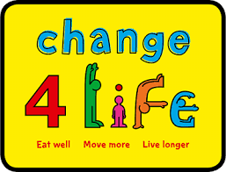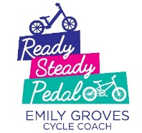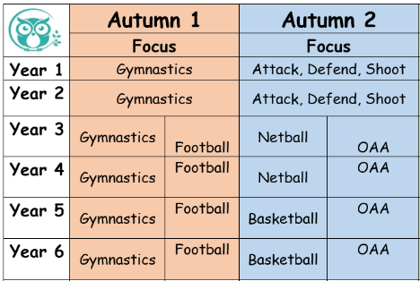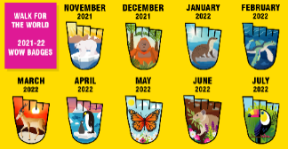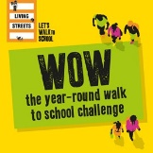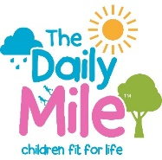

**After School Clubs!**

After school clubs will be running after October half term. All details will be send via My Ed.

**We are continuing with our ‘WOW, Walk to school’ challenge.**

**WOW – the year-round walk to school challenge is delivered by Living Streets, the UK charity for everyday walking, to help as many children as possible experience the benefits of walking to school.**

**WOW is a pupil-led initiative where children self-report how they get to school every day. If they travel sustainably (walk, cycle or scoot) once a week for a month, they get rewarded with a badge. It's that easy!**

**As a Healthy school we want to:**

* Promote a whole school approach to a healthy lifestyle
* Encourage our children, parents and staff to make informed decisions on a healthy lifestyle based on positive attitudes and information.
* Provide our children with a high quality physical education, afterschool clubs and promote physical activity.

Help our children develop greater confidence, motivation, self-esteem and have the skills, information and understanding to make important life and health choices.

**Key dates for the year:**

Cycle to school day: 5th August 2022

Mental Health week: 13-20th May 2022

Healthy eating week; June 2022

National school sports week- 18- 24th June 2022

On your feet Britain: 29th April 2022

Fitness week- January 2022

National walking month- May National Fitness day: TBC

Sport relief 2022: TBC

Race for life schools: TBC

**Ready, Steady, Pedal!**

Learning to ride a bike is not only a big milestone for children but is also great for their health, mobility and confidence.

We have recently joined forces with Ready, Steady, Pedal to provide our children with the opportunity to learn to ride.

We now have our own balance bikes and pedal bikes in school so children

can access these within provision. Miss Hollings has completed training

enabling her to fully support your children when learning to ride and

to ensure your children are safe at all times.

We cannot wait to see the children whizzing around on their bikes.

**This Autumn we will continue with the Daily Mile.**

The aim of the Daily Mile is to improve the physical, social, emotional and mental health of our

children- regardless of age,

ability or personal circumstances.

**The Daily Mile works!**

* It takes for 15 minutes, with most children averaging a mile, or more, each day
* Children run outside in the fresh air- and the weather is a benefit, not a barrier
* It’s social, non-competitive and fun
* It helps to improve fitness and achieve a healthy weight.
* Its fully inclusive; every child, whatever their circumstances, age or ability, succeeds at the Daily Mile.

**Get Nessfield Moving!**

**PE at Beckfoot Nessfield.**

PE is an integral part of our curriculum at Beckfoot Nessfield. We recognise the importance of PE and the role it has to play in promoting long term, healthy, active lifestyles. We offer our children a dynamic and varied programme of activity that ensures all children can progress physically through a broad, balanced and inclusive PE curriculum. We want to inspire our children through fun and engaging lessons that are enjoyable, challenging and inclusive to all. Enabling them to develop knowledge, skills and competence to excel in a wide range of sport and physical activities, adopt a positive growth mind-set and believe that anything can be achieved with determination and resilience.

**Curriculum Newsletter: Physical Education (PE)**