[[](https://amzn.to/3q3gURk)](https://amzn.to/3q3gURk" \t "_blank)

[[](https://amzn.to/3w2MK4g)](https://amzn.to/3w2MK4g" \t "_blank)

[[](https://amzn.to/3ig9iX4)](https://amzn.to/3ig9iX4" \t "_blank)

[[](https://amzn.to/3t6TcW7)](https://amzn.to/3t6TcW7" \t "_blank)

[[](https://amzn.to/3t7XOeN)](https://amzn.to/3t7XOeN" \t "_blank)

[[](https://amzn.to/39GAVEa)](https://amzn.to/39GAVEa" \t "_blank)

[[](https://amzn.to/3qwzI98)](https://amzn.to/3qwzI98" \t "_blank)

[[](http://amzn.to/2isXC7i)](http://amzn.to/2isXC7i" \t "_blank)

[[](https://amzn.to/2MKnwB2)](https://amzn.to/2MKnwB2" \t "_blank)

[[](https://amzn.to/3oXoZEj)](https://amzn.to/3oXoZEj" \t "_blank)

[[](https://amzn.to/3vVUEtX)](https://amzn.to/3vVUEtX" \t "_blank)

[[](https://amzn.to/37mb5HX)](https://amzn.to/37mb5HX" \t "_blank)

[[](https://amzn.to/3cYmRHV)](https://amzn.to/3cYmRHV" \t "_blank)

[[](https://amzn.to/3w35Ebw)](https://amzn.to/3w35Ebw" \t "_blank)

[[](https://amzn.to/3q0YS1O)](https://amzn.to/3q0YS1O" \t "_blank)

[[](https://amzn.to/3JlHHj7)](https://amzn.to/3JlHHj7" \t "_blank)

[[](http://amzn.to/2vt65sC)](http://amzn.to/2vt65sC" \t "_blank)

[[](https://amzn.to/3sM4jSn)](https://amzn.to/3sM4jSn" \t "_blank)

[[](https://amzn.to/3qzqxF7)](https://amzn.to/3qzqxF7" \t "_blank)

[[](https://amzn.to/3uUj2uE)](https://amzn.to/3uUj2uE" \t "_blank)

[[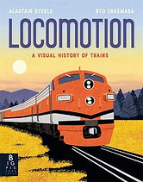](https://amzn.to/3vXcbnY)](https://amzn.to/3vXcbnY" \t "_blank)

[[](https://amzn.to/3MJKDbA)](https://amzn.to/3MJKDbA" \t "_blank)

[[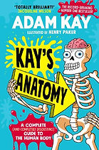](https://amzn.to/3q1Qb7r)](https://amzn.to/3q1Qb7r" \t "_blank)

[[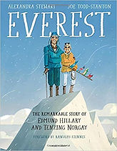](https://amzn.to/2Qs7bEW)](https://amzn.to/2Qs7bEW" \t "_blank)

[[](http://amzn.to/2xgvzLT)](http://amzn.to/2xgvzLT" \t "_blank)

[[](https://amzn.to/3w0vQDx)](https://amzn.to/3w0vQDx" \t "_blank)

[[](https://amzn.to/2ZPlaEa)](https://amzn.to/2ZPlaEa" \t "_blank)

[[](https://amzn.to/36j7SIY)](https://amzn.to/36j7SIY" \t "_blank)

[[](https://amzn.to/3tXE7DM)](https://amzn.to/3tXE7DM" \t "_blank)

[[](https://amzn.to/36eURQi)](https://amzn.to/36eURQi" \t "_blank)

[[](https://amzn.to/3mPW1pE)](https://amzn.to/3mPW1pE" \t "_blank)

[[](https://amzn.to/3wi7IfC)](https://amzn.to/3wi7IfC" \t "_blank)

[[](https://amzn.to/32gNUsT)](https://amzn.to/32gNUsT" \t "_blank)

[[](https://amzn.to/2Jwu72e)](https://amzn.to/2Jwu72e" \t "_blank)

[[](https://amzn.to/3CFIMjn)](https://amzn.to/3CFIMjn" \t "_blank)

[[](https://amzn.to/3t63kOQ)](https://amzn.to/3t63kOQ" \t "_blank)

[[](https://amzn.to/3tQFyWl)](https://amzn.to/3tQFyWl" \t "_blank)

[[](https://amzn.to/3t4bwPv)](https://amzn.to/3t4bwPv" \t "_blank)

[[](https://amzn.to/3CShDdn)](https://amzn.to/3CShDdn" \t "_blank)

[[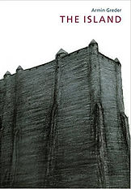](http://amzn.to/2wC8kyI)](http://amzn.to/2wC8kyI" \t "_blank)

[[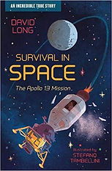](https://amzn.to/3uUhl04)](https://amzn.to/3uUhl04" \t "_blank)

[[](https://amzn.to/3djuE49)](https://amzn.to/3djuE49" \t "_blank)

[[](https://amzn.to/2U3gtHR)](https://amzn.to/2U3gtHR" \t "_blank)

[[](http://amzn.to/2xwxqeL)](http://amzn.to/2xwxqeL" \t "_blank)

[[](https://amzn.to/3tVkOfY)](https://amzn.to/3tVkOfY" \t "_blank)

[[](https://amzn.to/3MZhadL)](https://amzn.to/3MZhadL" \t "_blank)

[[](https://amzn.to/3t4YyRO)](https://amzn.to/3t4YyRO" \t "_blank)

[[](https://amzn.to/3i50u6u)](https://amzn.to/3i50u6u" \t "_blank)

[[](https://amzn.to/3CHJRHp)](https://amzn.to/3CHJRHp" \t "_blank)

[[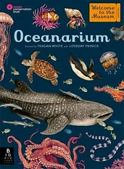](https://amzn.to/3KGFbnW)](https://amzn.to/3KGFbnW" \t "_blank)