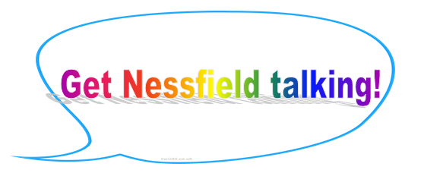

*At Beckfoot Nessfield we develop and nurture children’s own thoughts, ideas and beliefs, and teach them the skills for how to express* these.



In the summer term we introduced weekly ‘philosophy for children’ lessons in Years 1 – 6. P4C develops thinking, listening, speaking skills as well as self-esteem and confidence. Children typically sit in a circle and are given something interesting such as a story, video or image to discuss. We are teaching children valuable thinking skills and encouraging children to challenge their own and other’s ideas respectfully. We are currently taking part in the ‘Going for Gold’ award programme and hope to be awarded with our Bronze award this academic year. Watch this space for upcoming developments!

*“P4C aims to help children become more thoughtful, more reflective, considerate and reasonable individuals.”*  
**Professor Matthew Lipman, Founder of P4C**

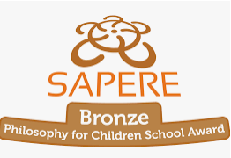

‘50 Things To Do’ is a project which worked with parents across Bradford to develop an amazing resource with 50 fun, low cost activities to support young families. Each of the ’50 things’ have been chosen to have a positive impact on learning and health.  Many of the activities can be done from your own home but there is also lots of information about accessing free and low cost activities in our local area.

**Wednesday 20th October 1 – 3 Nursery and Reception parent workshop**

*Please come along to our ’50 things’ launch – you will be able to find out more about the project, have a go at some of the activities with your child and grab some goodies! Refreshments will be provided ☺*

**Parents interested in the project who do not currently have children in Nursery or Reception please contact Mrs Cheater on class dojo for further information.**

**TALK is at the heart of our curriculum at school and we have lots of exciting initiatives to promote excellent speaking and listening skills.**



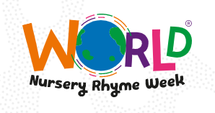

**Monday 15th November 9 – 11 Nursery and Reception parent workshop**

We are kicking off World Nursery Rhyme week with a special assembly for parents and children in **Nursery and Reception**. The children will be set exciting challenges for the week and then will get to make a special nursery rhyme prop to take home with them.

At the end of the week the children will showcase their learning to the rest of the school where they will perform nursery rhymes to the rest of the school.