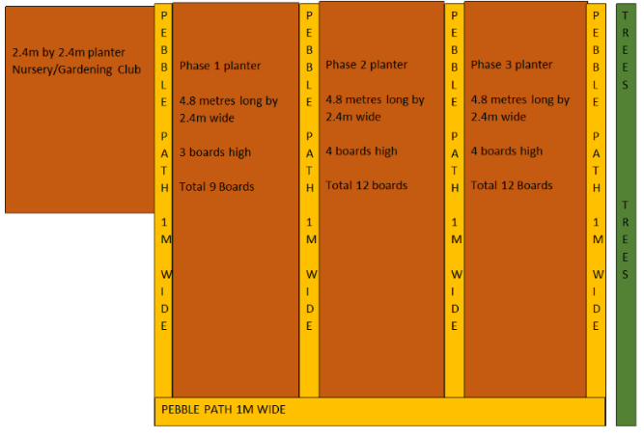

**Computing**

Over the last 12 months we have invested a lot of money into new iPads to be used across all three phases to teach the Computing curriculum. We can use these to support our work in the allotment using apps like *PlantNet*, *RHS Grow Your Own* and *VegPlotter* to monitor the seasons and keep a calendar of the best time to plant and harvest!

**Design Technology**

Once our fruit and vegetables are well established in the allotment, we will focus on the skills required to harvest what has been sown and prepare the food to eat. Our focus is the progression of food preparation skills from Nursery to Year 6, including safely chopping, blending and boiling.

**STEM TEAM NEWSLETTER**

**(Science, Technology, Engineering & Mathematics)**

**This term’s project:**

We’ve decided it’s time to give our school allotment a facelift – it’s looking rather drab!

Our aim is to overhaul the current space we used to call an allotment and turn it into a purposeful, enriching learning environment for all children to access as part of the Learning Challenge curriculum. We will extend the previous allotment space to include some huge planters (see below) and transform the old allotment into a Wildlife Garden!

To achieve this, we will require plenty of parental involvement in coming weeks and months, including some manual **‘Dig for Victory’** days, as well as donations of seeds, plants, seedlings, bulbs etc. More information on this to follow!

As time goes on, while making links with our Healthy School Initiative, we will encourage children to plant and grow their own fruit and vegetables to learn more about where their food comes from and how to reduce food waste.

**Science**

Developing the allotment/wildlife garden will mean we can learn about what plants need to survive and how important it is to take care of them. We will focus on identifying the life cycle of plants as well as the importance of food and nutrients to our own bodies.