[[](https://amzn.to/3dcxPJK)](https://amzn.to/3dcxPJK" \t "_blank)

[[](https://amzn.to/3t1H3Sg)](https://amzn.to/3t1H3Sg" \t "_blank)

[[](https://amzn.to/36dpwxm)](https://amzn.to/36dpwxm" \t "_blank)

[[](https://amzn.to/3HXymN6)](https://amzn.to/3HXymN6" \t "_blank)

[[](https://amzn.to/3I241x2)](https://amzn.to/3I241x2" \t "_blank)

[[](https://amzn.to/3dV1Uy4)](https://amzn.to/3dV1Uy4" \t "_blank)

[[](https://amzn.to/360EcgK)](https://amzn.to/360EcgK" \t "_blank)

[[](https://amzn.to/3tNyn0X)](https://amzn.to/3tNyn0X" \t "_blank)

[[](https://amzn.to/3q4ExZw)](https://amzn.to/3q4ExZw" \t "_blank)

[[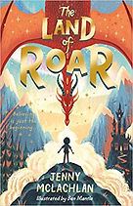](https://amzn.to/3o0yOQB)](https://amzn.to/3o0yOQB" \t "_blank)

[[](https://amzn.to/2UxuucV)](https://amzn.to/2UxuucV" \t "_blank)

[[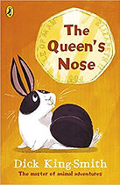](http://amzn.to/2xpY9tj)](http://amzn.to/2xpY9tj" \t "_blank)

[[](https://amzn.to/3vUY4Q5)](https://amzn.to/3vUY4Q5" \t "_blank)

[[](https://amzn.to/39Nnx14)](https://amzn.to/39Nnx14" \t "_blank)

[[](https://amzn.to/2Crm3tl)](https://amzn.to/2Crm3tl" \t "_blank)

[[](https://amzn.to/2KJ2BzW)](https://amzn.to/2KJ2BzW" \t "_blank)

[[](https://amzn.to/2U1RZib)](https://amzn.to/2U1RZib" \t "_blank)

[[](https://amzn.to/2HwnGu9)](https://amzn.to/2HwnGu9" \t "_blank)

](https://amzn.to/2KyTJN2)](https://amzn.to/2KyTJN2" \t "_blank)

[[](https://amzn.to/3iyZBSZ)](https://amzn.to/3iyZBSZ" \t "_blank)

[[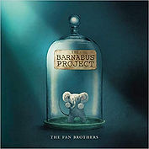](https://amzn.to/319TIEc)](https://amzn.to/319TIEc" \t "_blank)

[[](https://amzn.to/3CHdqcf)](https://amzn.to/3CHdqcf" \t "_blank)

[[](https://amzn.to/2JsypY8)](https://amzn.to/2JsypY8" \t "_blank)

[[](https://amzn.to/3dcz39a)](https://amzn.to/3dcz39a" \t "_blank)

[[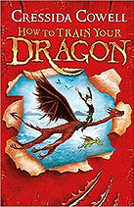](http://amzn.to/2vVIzrJ)](http://amzn.to/2vVIzrJ" \t "_blank)

[[](https://amzn.to/3Ja6ruL)](https://amzn.to/3Ja6ruL" \t "_blank)

[[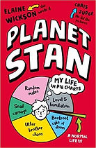](https://amzn.to/31ql2vW)](https://amzn.to/31ql2vW" \t "_blank)

[[](https://amzn.to/2Y3DElA)](https://amzn.to/2Y3DElA" \t "_blank)

[[](https://amzn.to/2LTsa1P)](https://amzn.to/2LTsa1P" \t "_blank)

[[](https://amzn.to/2Om8Ua0)](https://amzn.to/2Om8Ua0" \t "_blank)

[[](https://amzn.to/3IhTSwp)](https://amzn.to/3IhTSwp" \t "_blank)

[[](https://amzn.to/3MEuPa2)](https://amzn.to/3MEuPa2" \t "_blank)

[[](https://amzn.to/3CAJA98)](https://amzn.to/3CAJA98" \t "_blank)

[[](https://amzn.to/3IbR2sM)](https://amzn.to/3IbR2sM" \t "_blank)

[[](https://amzn.to/2TjnHTG)](https://amzn.to/2TjnHTG" \t "_blank)

[[](https://amzn.to/3i20x2O)](https://amzn.to/3i20x2O" \t "_blank)

[[](https://amzn.to/3KCzcAw)](https://amzn.to/3KCzcAw" \t "_blank)

[[](https://amzn.to/3CxWjJI)](https://amzn.to/3CxWjJI" \t "_blank)

[[](https://amzn.to/2OirBeC)](https://amzn.to/2OirBeC" \t "_blank)

[[](http://amzn.to/2xpNrTJ)](http://amzn.to/2xpNrTJ" \t "_blank)

[[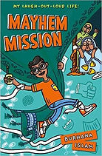](https://amzn.to/3vT9NMA)](https://amzn.to/3vT9NMA" \t "_blank)

[[](https://amzn.to/2CpRjJt)](https://amzn.to/2CpRjJt" \t "_blank)

[[](https://amzn.to/3KEhfSj)](https://amzn.to/3KEhfSj" \t "_blank)

[[](https://amzn.to/3taMO0g)](https://amzn.to/3taMO0g" \t "_blank)

[[](https://amzn.to/2Ombpco)](https://amzn.to/2Ombpco" \t "_blank)

[[](https://amzn.to/3qOHDyJ)](https://amzn.to/3qOHDyJ" \t "_blank)

[[](https://amzn.to/3uP76Mo)](https://amzn.to/3uP76Mo" \t "_blank)

[[](https://amzn.to/3KR4cgk)](https://amzn.to/3KR4cgk" \t "_blank)

[[](https://amzn.to/3w01st1)](https://amzn.to/3w01st1" \t "_blank)

[[](https://amzn.to/36ecbFn)](https://amzn.to/36ecbFn" \t "_blank)