Week Commencing 25/1/21
Hello,
I hope you are keeping well. Here we are on pack number 3. You are all doing amazing. I am so impressed with the work produced so far. Keep it up
In this pack you will find ideas, activities and resources that will help you to support and continue educating your children at home.
As you will be aware in Nursery we aim to support and develop children’s play and learning. We allow the children to develop with their own initiative and learn at their own pace. We do this through stimulating and fun activities, which promote all areas of a child’s development.
We are continuing our ‘Why is it always cold in winter’ topic. This topic will enable children to explore the natural world around them, focusing on the weather and how we can keep warm, water safety, what can we do with water and the different animals we might see in winter. This week we will be required to conduct your own research… exciting. We will also be really focusing on our fine motor skills this week and working with our number blocks.
Here are some activities for you to have a go at during your time at home. I have split them up into days and done a timetable for you to follow. Miss Hollings will also be setting daily challenges on class dojo so make sure you look out for them. .
If you need any help or advice please contact me via the class dojo. I am more than happy to help.
Useful websites:
Twinkl https://www.twinkl.co.uk/
Phonics play: https://www.phonicsplay.co.uk/
Username: March
Password: home

CBeebies: https://www.bbc.co.uk/cbeebies

BBC Iplayer: https://www.bbc.co.uk/iplayer

Youtube
Topmarks: https://www.topmarks.co.uk/
Crickweb: http://www.crickweb.co.uk/
Oxford Owl: https://www.oxfordowl.co.uk/for-home/
Letters and Sounds: http://www.letters-and-sounds.com/

Thank you
Miss Hollings

Timetable:
Elm Class
Friday:
- Maths- Measuring with unifix
- Phonics- Tongue twister
- Literacy- Instructions
- Creative – Banana bread
- Physical- Yoga- Cosmic Kids- Joybob the Polar Bear

Thursday:
- Maths- Measuring
- Phonics- I spy
- Literacy- Environmental print
- Creative – Chalk pictures
- Physical- Simon says

Wednesday:
- Maths- Dominoes
- Phonics- If you’re happy and you know it…
- Literacy- Name writing
- Creative – Salt snowflakes
- Physical- Get fit with Maurice

Tuesday:
- Maths- Roll and colour
- Phonics- I went to the farm and saw a…
- Literacy- Research hibernation
- Creative – Ice painting
- Physical- Shake your sillies out

Monday:
- Maths- Numberblocks matching
- Phonics- Can you make the same sound as…
- Literacy- Diary writing
- Creative – Starry night painting
- Physical- Frozen Yoga

Monday Maths: This week’s maths is all about Numberblocks
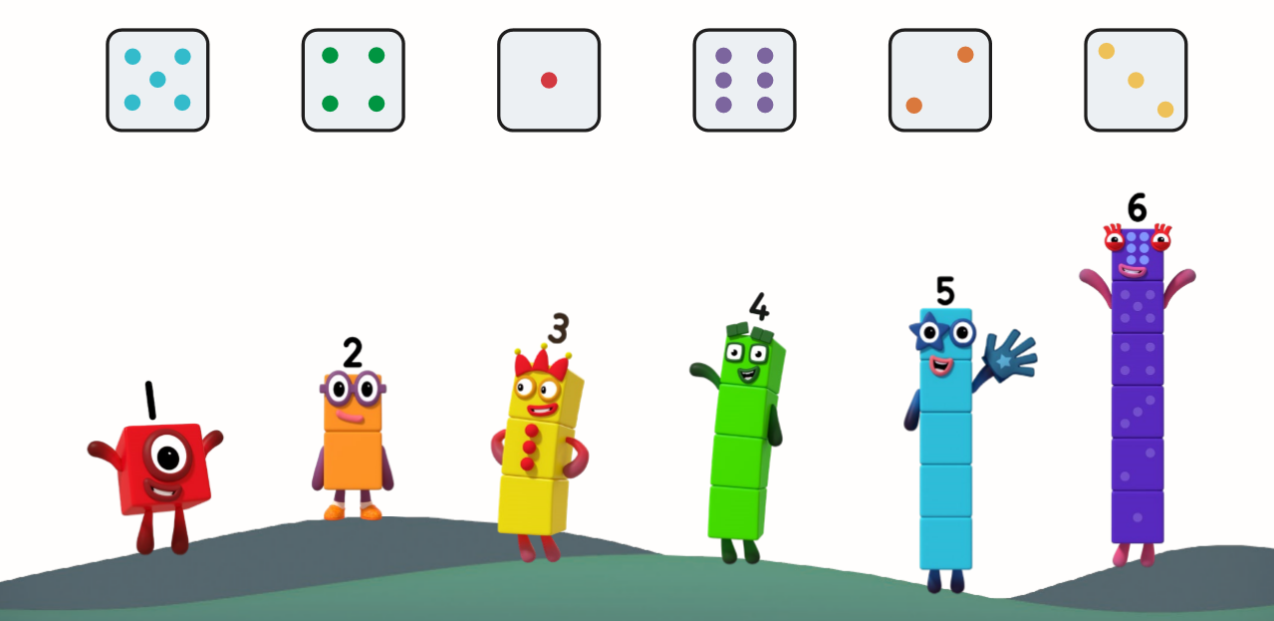
Draw a line to match the dice with the correct Numberblock.

Draw dots on the dice to match the Numberblock
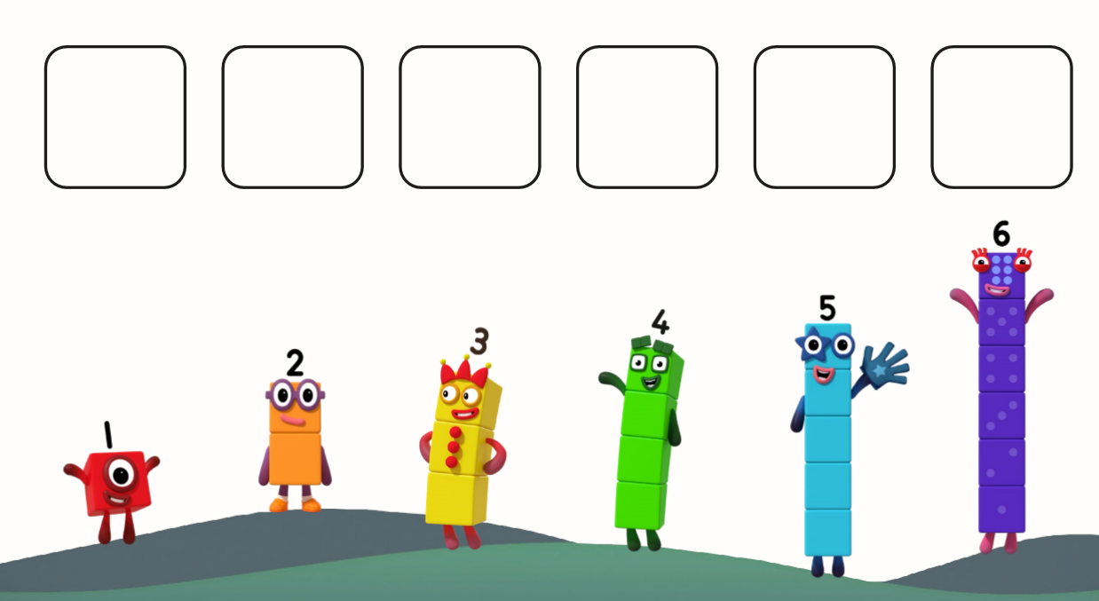

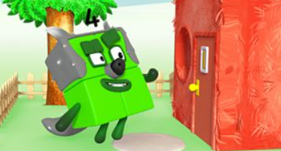
NUMBERBLOCKS!

https://www.bbc.co.uk/iplayer/episode/b08cqtk0/numberblocks-series-1-three-little-pigs

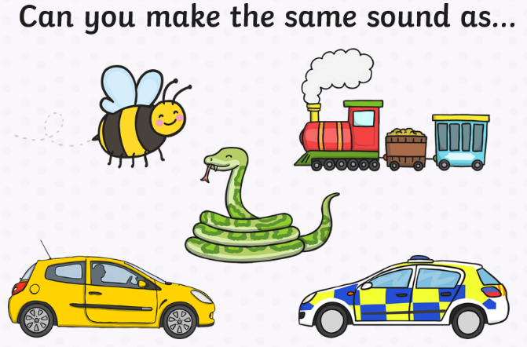
Monday Phonics:
Take a video of you making the different sounds. Can your adult guess which picture you have chosen to sound out?

Monday Literacy:
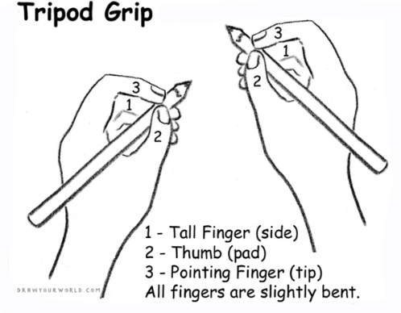
Diary Writing: Today I would like you to continue writing your daily news. Talk with your adult about what you did over the weekend. Allow your child to mark make and explain what they are writing along the way, you can then scribe for them. It is important they are given this freedom to express themselves, their ideas and thoughts through mark making. Really focus on your pencil grip, holding it between your fingers rather than full fist grip.

Questioning throughout is key i.e. Where did we walk to? What was your favourite part of the day? How did it make you feel? What did we see along the way? Would you like to go again? And why?
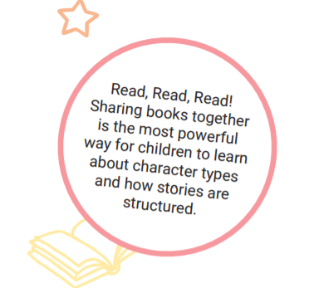
READ, READ, READ!!!!
Choose your favourite story for your adult to read to you. Once you have read the story use the pictures to retell the story to your adult.

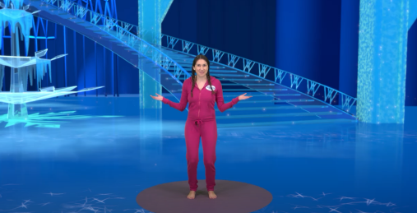
Monday Physical:
Frozen Yoga
https://www.youtube.com/watch?v=xlg052EKMtk

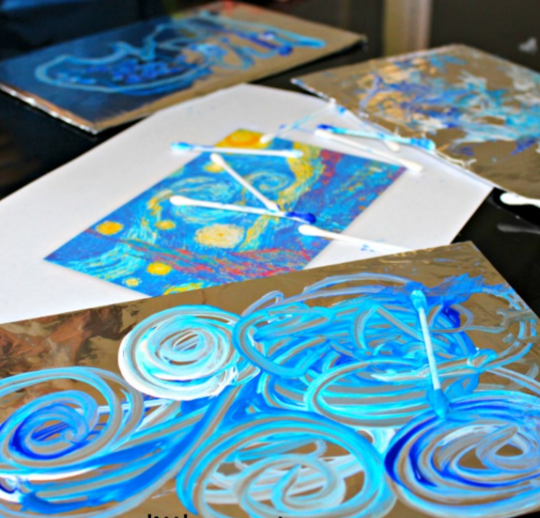
Monday Creative: Starry night painting.
Painting on foil- An easy art activity inspired by Vincent Van Gogh!
- Cardboard
- Foil
- Tape
- Cotton Buds
- Paint (use 2 shades of blue and white)
- For inspiration look at the painting 'Starry Night' by Van Gogh.

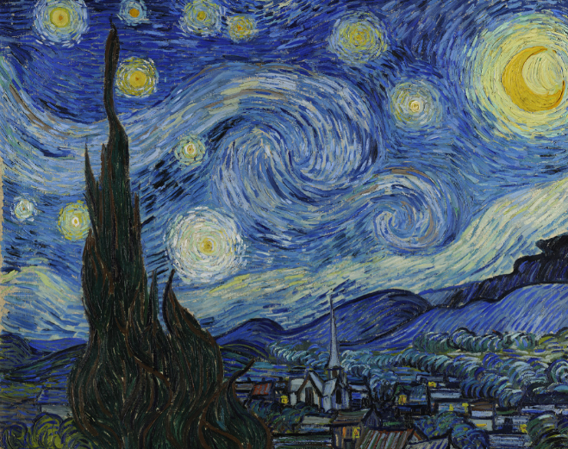
Before starting your painting, look at the art work by Van Gogh, ask your child to look at the colours, what they can see, what it looks like, how does the picture make them feel etc.
Once you are ready to paint your own, tape the foil onto the cardboard to create a solid base. Use the cotton buds to paint their picture, keep looking back to that one of Van Gogh’s. Encourage the tripod grip (like you would hold a pencil) with the cotton buds.
Tuesday Maths: Roll and colour activity
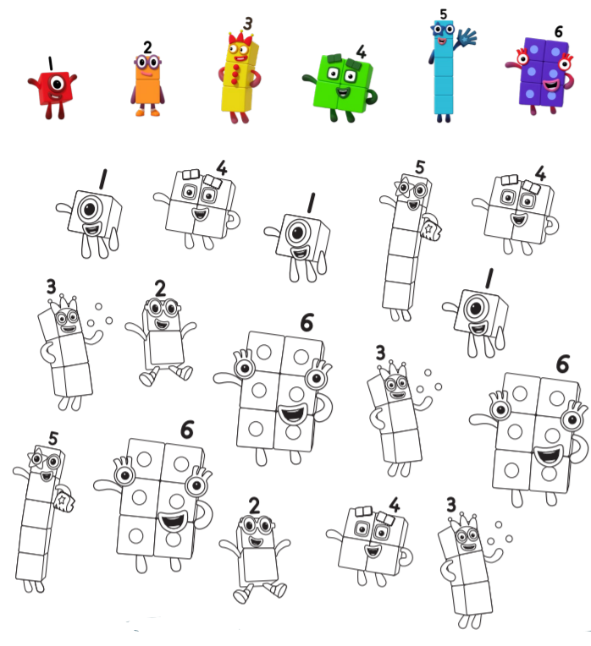
You will need a dice for this activity. Roll the dice and count the dots. Find the matching Numberblock and colour it in.

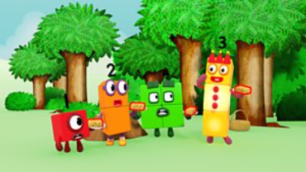
NUMBERBLOCKS: https://www.bbc.co.uk/iplayer/episode/b08cr24d/numberblocks-series-1-how-to-count

Tuesday Phonics: I went to the farm and saw…
With a grown up, play a listening game about a visit to the farm. “I went to the farm and I saw…”- instead of saying the animal name, make the sound of the animal. Can you guess which animal it is? Take a video to send to Miss Hollings.

Tuesday Literacy: Research.
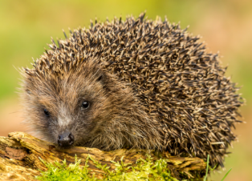
Today I would like you to conduct your own research about animals that hibernate in the winter.
Here is a little video for you to watch:
https://www.bing.com/videos/search?q=hibernation+for+children&&view=detail&mid=8A2CC1FF79A0691168168A2CC1FF79A069116816&&FORM=VDRVRV
TASK: Can you find me 3 animals which hibernate during winter?
Listen to the story: https://www.bing.com/videos/search?q=hibernation+station+read+aloud&&view=detail&mid=6AFABBE331B074E9B67F6AFABBE331B074E9B67F&&FORM=VDRVRV

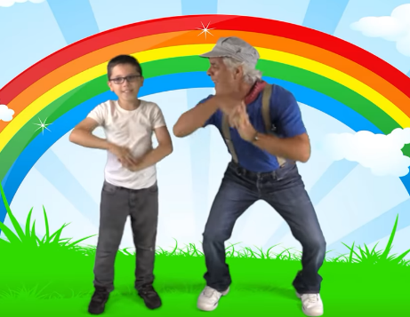
Tuesday: Physical
Shake your sillies out
https://www.youtube.com/watch?v=NwT5oX_mqS0

READ, READ, READ!!!
Please sign up to https://www.oxfordowl.co.uk/for-home/find-a-book/library-page It’s FREE!!
You will be able to access a wide range of books to read with your child. Miss Hollings uses this a lot

Cbeebies bedtime story- Wide awake Hedgehog
https://www.dailymotion.com/video/x58257i

Tuesday- Creative: Hedgehog painting
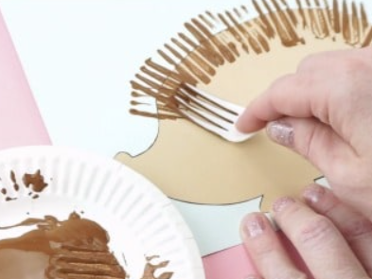
After completing your research yesterday on animals that hibernate, you will have found that hedgehog’s do indeed hibernate during the winter. Today I would like you to create your own hedgehog using a fork.
Use your fork to give the hedgehog his spikes. Don’t forget to give him eyes, mouth and nose.

!!! CHALLENGE: With your adult find me an interesting fact about Hedgehogs!!!
Wednesday Maths:
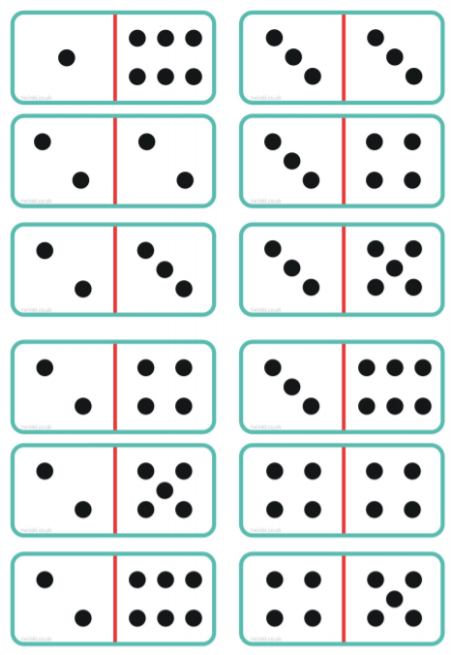

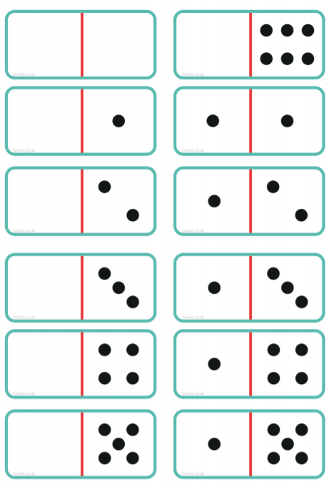

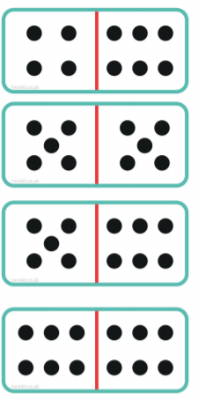
Cut out the dominoes and play with your adult/s. Encourage your child to count the dots and find one that matches. Ask your child to show you the given number on their fingers... (4 dots- can they show you 4 finger).
Have fun with it, that’s what learning is all about.

NUMBERBLOCKS
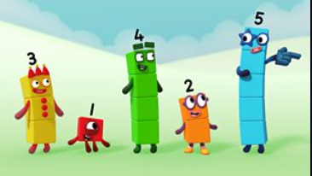
https://www.bbc.co.uk/iplayer/episode/b08cr0y7/numberblocks-series-1-off-we-go
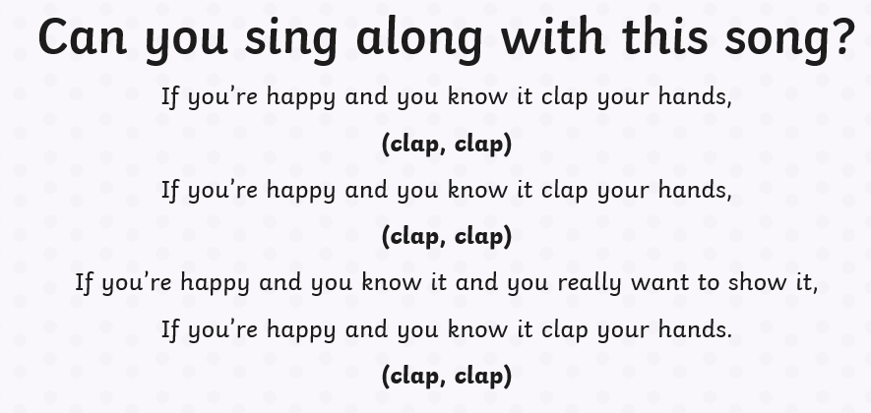
Wednesday Phonics: Sing, Sing, Sing!!!!

Wednesday Literacy

Repeat the song but using different parts of your body/ using your voice
I.e. Nod you head, stamp your feet, turn around, shout ‘aha’ etc.

Wednesday- Literacy:
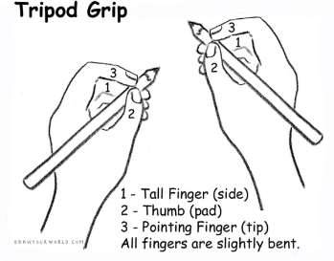
Name Writing: Please continue to recognise and practice writing your name (Please only use capitals for the first letter of each name). It is important that your child is able to recognise their own name before they begin to write it. Allow your child to use their name card to write practice writing their name. Your child’s name card is wipe-able so allow them to trace over the letters. They love using the whiteboards so let them write on them too Ensure your child is using the tripod grip.

Wednesday Physical: Get fit with Maurice.
The children absolutely love this… Adults can join in too
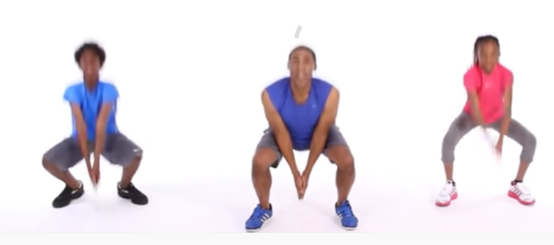
https://www.youtube.com/watch?v=L_A_HjHZxfI&t=452s

Wednesday- Creative- Salt snowflakes:
Salt, glue and painting to make snowflake art. Explore the gorgeous process art technique of salt, glue and paint to make a beautiful snowflake.

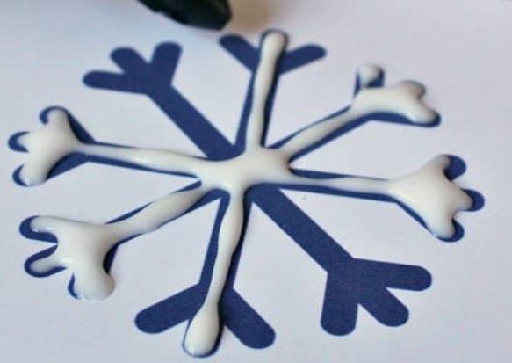
Begin with simple drawings of snowflakes on cards with your glue. Then sprinkle a layer of salt over the top of your glue snowflake. Completely cover the snowflake with salt, then gently shake off the excess salt that isn’t stuck to the glue to reveal the salt snowflake.

Apply watered down paints on top of your salt snowflake (a pipette is always good for this part). Carefully drop a little paint onto the salt of your snowflake. Watch how the salt absorbs the paint.
Keep carefully applying paint, little by little, until you have covered your whole snowflake.

You can vary the colour paint you use and make more snowflakes of different designs.
Here are some templates for you to use if you wish.

Thursday Maths: How many cubes tall are the penguins? Use the unifix cubes you received in your learning resource pack to measure how tall the penguins and Polar bears are. Write the correct number of cubes in the box.

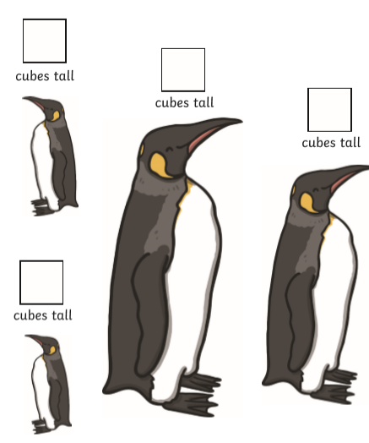

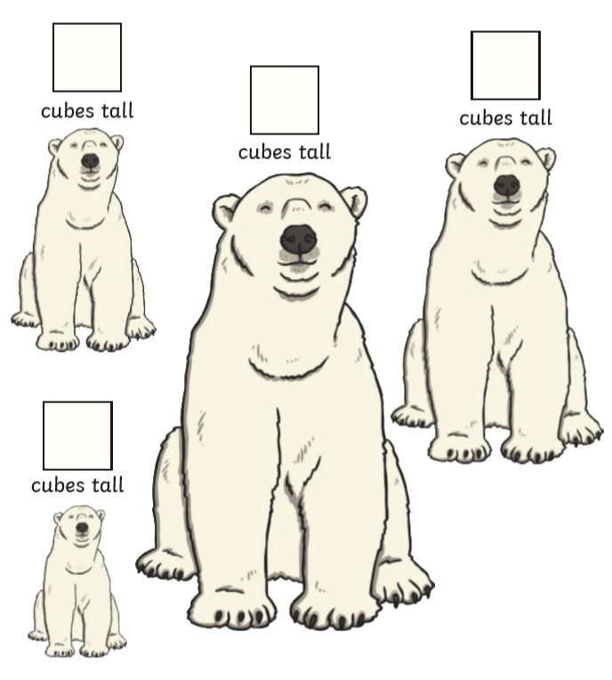

Challenge: ♪ Practice singing 5 little snowmen: https://www.youtube.com/watch?v=vrfCD9wjLUE
Make sure you use your fingers to represent the numbers ♪
NUMBERBLOCKS:
https://www.bbc.co.uk/iplayer/episode/b08dnngm/numberblocks-series-1-stampolines

READ, READ, READ!!
Bedtime Story: Once tucked up in bed, read your teddy a bedtime story.

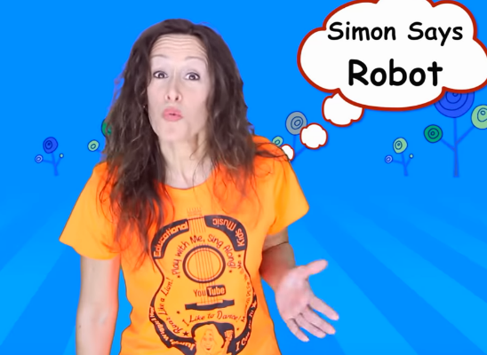
Thursday Physical: Simon Says
https://www.youtube.com/watch?v=OkO8DaPIyXo

Thursday Literacy:
Here is some familiar print. Explore them with your child… do they recognise the print? Talk about the different places/ pictures… what they know about the picture, what they like about them, what it is, what they sell, who they go there with etc.

Thursday Phonics:
I spy with my little eye
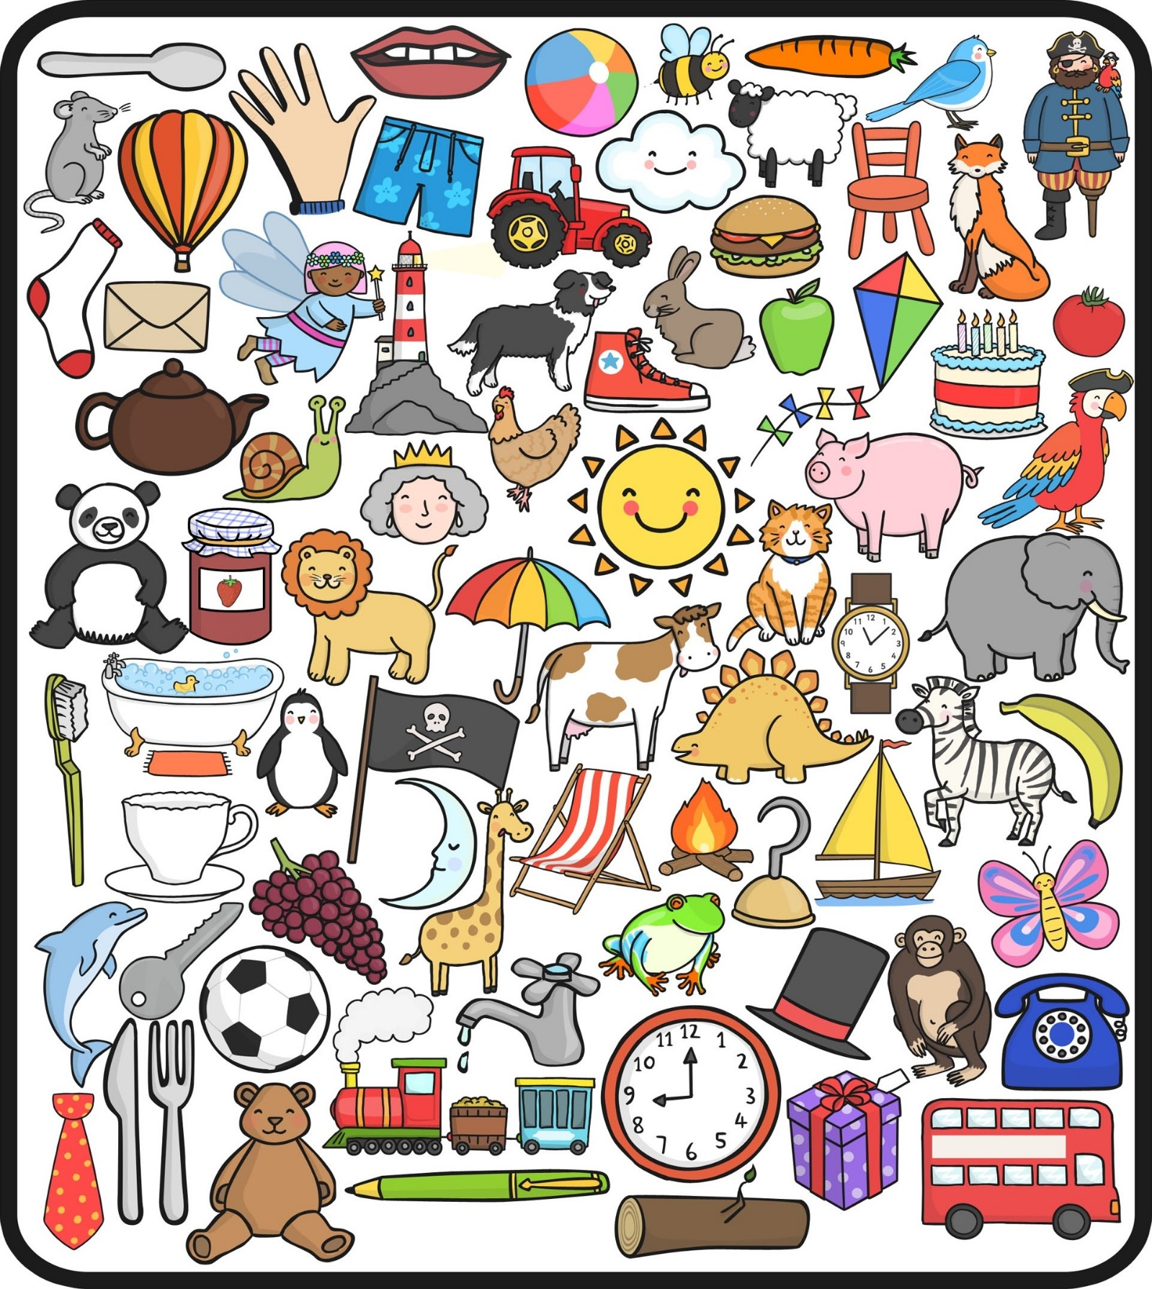

Really focus on the initial sound. Can you find the object using the initial sound?
Allow your child to say it, repeat it, and use a mirror to see what their mouth does when they are saying that sound.
Thursday: Creative
Chalk pictures: Using chalks create your own winter picture (don’t worry if you don’t have chalks, you can use crayons, paints etc)
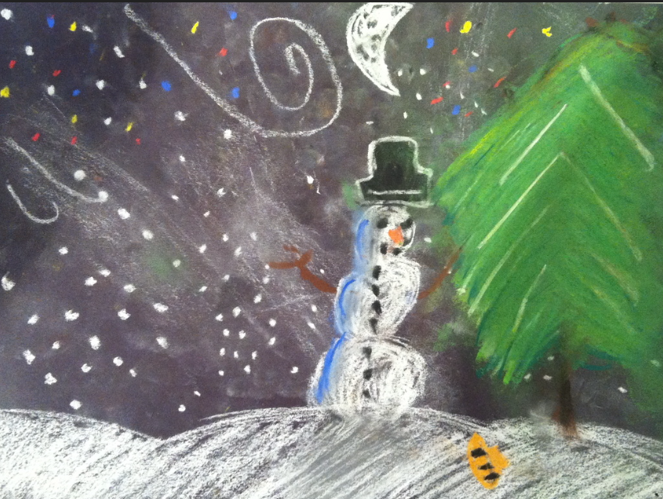
Try looking out of your window if you need help. Think about the weather we have had recently- snow, wind, wind, frost, fog etc. Use the chalks to draw your picture, then try using your fingers to rub some of the chalk to make different textures.
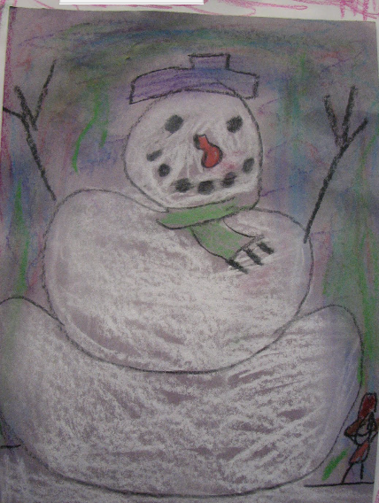
Think about the colours you are going to use, what the trees look like in winter (no leaves), what the sky looks like (dull, no blue sky) etc. Really think about the winter animals… what animals are you going to include in your picture? Have fun with it, I can’t wait to see what you do

Cbeebies bedtime story/song- The Gingerbread Man by Mr Tumblehttps://www.bbc.co.uk/iplayer/episode/m000r68w/cbeebies-bedtime-stories-771-mr-tumble-the-gingerbread-man

Friday Maths:

SUPER TRICKY CHALLENGE:
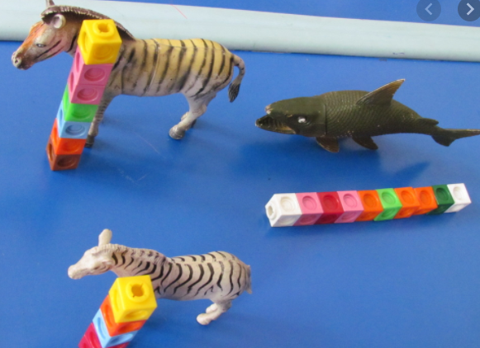
Use the unifix cubes included in your resource pack, measure items in your house/ outside. On a piece of paper ask your adult to write down the items and allow you to write the measurement (number of cubes used). Take pictures for Miss Hollings and put them on class dojo.
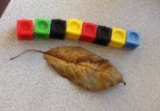

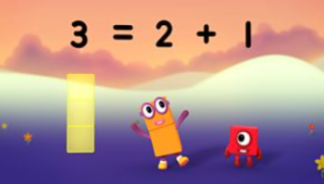
NUMBERBLOCKS

https://www.bbc.co.uk/iplayer/episode/b08dr1l3/numberblocks-series-1-the-whole-of-me
Friday Phonics: Tongue Twister (Your child will need support with this).
Children find tongue twisters hilarious and they are also great for ironing out speech and language issues, as well as being an excellent medium to teach alliteration. In Nursery we like to add actions too.
An example would be:
Little lamps are leaping! (All jump around like lambs)
Little lambs are lazy. (Lie down)
Little lambs are lonely. (All be sad)
Little lambs are lost…etc etc
Challenge: Can you think of your own tongue twisters using your name?

Friday Literacy:
Instructions: How to build a snowman.
Ask your child to tell you step by step what they need to do when building a snowman. Start with before you go outside- putting coat, gloves, hat, scarf etc. Use words such as First, next, then, after that and last.
Encourage speech and actions from your child. Question throughout. Adult to record/ write down what your child says
READ, READ, READ!
Frog in Winter by Derek Jacobi
https://www.dailymotion.com/video/x577ltf

Friday: Creative
Banana bread (another of Miss Hollings’ favourites)
Ingredients:
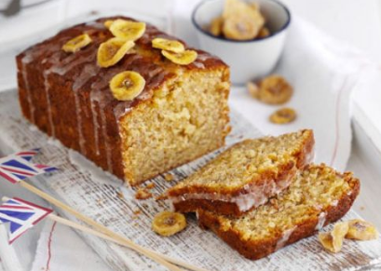
140g butter (softened)
140g caster sugar
2 large eggs, beaten
140g self-raising flour
1tsp baking powder
2 very ripe bananas mashed
50g icing sugar
Handful dried banana chips for decoration
Instructions:
- Heat oven to 180C/160C fan/gas 4.
- Butter a 2lb loaf tin and line the base and sides with baking parchment.
- Cream 140g softened butter and 140g caster sugar until light and fluffy, then slowly add 2 beaten large eggs with a little of the 140g flour.
- Fold in the remaining flour, 1 tsp baking powder and 2 mashed bananas.
- Pour into the tin and bake for about 30 mins until a skewer comes out clean.
- Cool in the tin for 10 mins, then remove to a wire rack.
- Mix 50g icing sugar with 2-3 tsp water to make a runny icing.
- Drizzle the icing across the top of the cake and decorate with a handful of banana chips.

Friday- Physical
Cosmic Kids- Joybob the Polar Bear
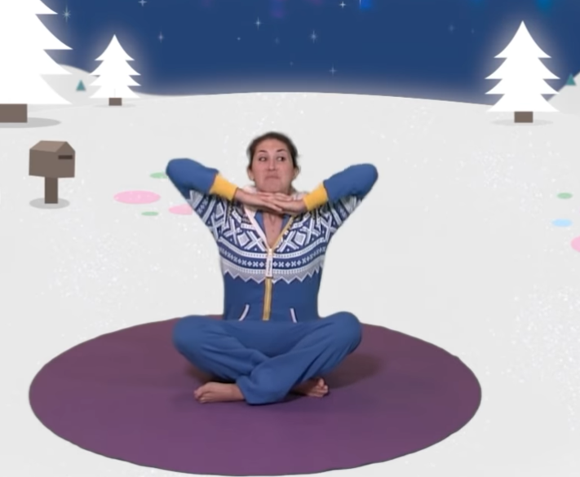

https://www.youtube.com/watch?v=DP9jd1Ug2y4

