Beckfoot Nessfield Primary School – Zoom Learning.
Signing in.
You don’t need to download the zoom app onto your devise you can access by searching Zoom on your internet browser (We would recommend Google Chrome)
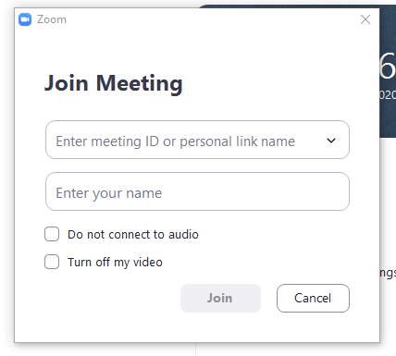
To join a meeting that you have been invited to. You may have a meeting ID and password to enter. You simply enter these when on the screen below. (These are case sensitive so make sure you include any capital letters in the password)

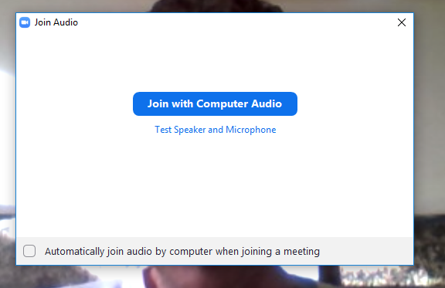
You can change the name to be seen on screen here too, please change this to your name (Your child’s first name) to help with registration and safeguarding reasons. Always select Join with Computer Audio (below centre).

It is also possible to join a meeting simply by following a link through, for example, an email. By clicking on the link you will be taken to Zoom through the internet browser:
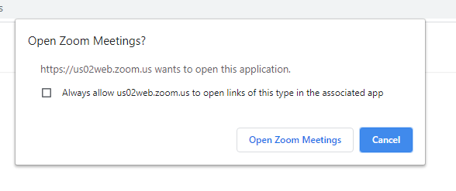

In-meeting controls
Once you have started or joined a meeting, you can access the meeting controls located at the bottom of the meeting window (you may need to move your mouse around for these to appear):
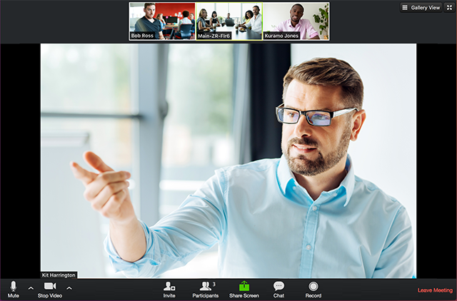

Attendees have access to these features:
- Mute/Unmute: mute or unmute your microphone
Audio Controls (click the ^ arrow next to Mute/Unmute): allows you to change the microphone/speaker that Zoom is currently using on your computer. It may be this which is sometimes the cause of sound issues within Zoom.
- Start Video/Stop Video: turns your camera on or off. This means you are still able to see other’s screens and hear what is happening in the meeting without them seeing you.
Video Controls (click the ^ arrow next to Start Video/Stop Video) allows you to select a virtual background (should you wish)
- Leave meeting: allows you to leave the meeting while it continues for other attendees.
Beckfoot Nessfield Zoom Rules
The staff of Beckfoot Nessfield would like you to follow the following simple rules in order to make our remote learning as positive and worthwhile as possible:
- Be on time – If you are more than 5 minutes late the member of staff will not admit you to the lesson as they will have already started teaching.
- Make sure your video is turned on.
- Ensure you are out of bed and suitably dressed to learn.
- Please do not bring pets or younger siblings onto Zoom with you – You are there to learn.
- Mute your microphone unless you are asked to unmute.
- Do not type messages into the chat box – this will be used by members of staff to communicate with you.
- When a member of staff shares their screen do not write or draw on their screen – This appears on every bodies screen and can be distracting.
- Parents, we appreciate that you may need to be present to supervise or support with technical issues but please do not feel you need to participate in the lesson. Remember, this is new for the teachers and the smaller the audience, the better.

